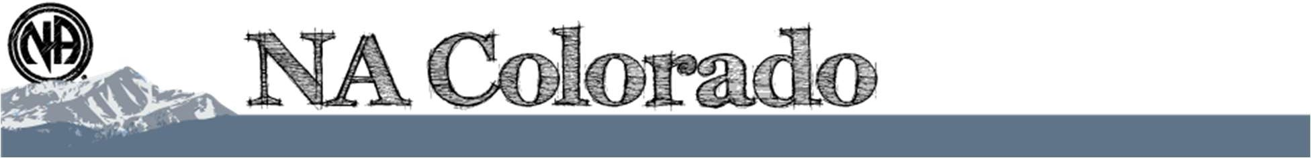

Colorado Regional Service Committee of NA
P.O. Box 1437
Denver, CO 80201 nacolorado@nacolorado.org
April 18, 2026
- Opening Serenity Prayer
- 12 Traditions of NA - Bill
- Twelve Concepts for NA Service - Steve
- Clean Time Anniversaries Valentina 8 years, Danielle 1 year, Maya 5 years
- Welcome New Members Hope BASC, Danny MHA, Isabell MHA, Christopher MHA, Banks PP, Scott MHA, Danielle WRCNA, Kat PPA, Diedra MHA
- Approval of Last Meeting Minutes – amended minutes approved
- Agree to Meeting Etiquette: Matt
  - We affirm that mutual respect and trust is paramount to the effectiveness of all Colorado Regional Service Committee activities.
  - We strive to achieve consensus whenever possible.
  - We will not separate ourselves as individuals from the consensus of the Region and will take responsibility for the decisions of the Colorado Regional Service Committee.
  - We will focus ourselves upon establishing unity, mutual respect, and trust during the meeting.
  - We will meet our stated objectives for each meeting.
  - We agree that only one person will speak at a time, and there will be no sidebar conversations.
  - We affirm that action groups (ad hoc committees) will be used at Regional meetings to identify solutions for goals and issues before the Region.
- Roll Call
- Announcements and upcoming events:
FLYERS are attached to the April 22nd email along with the AI Summary
- CO Region needs a Treasure, 5 years clean time. Anyone interested please step up.
- The Colorado delegate Team has a table to sell Alternate Merchandise at the WSC conference. They will be leaving May 1 so please contact them at rd@nacolorado.org to arrange pick up of items you want sold.
- CRCNA XL registration/hotel link
- BASC Memorial day picnic, BBQ June 28, July 4th picnic
- MHA Hiking meeting on May 10, Memorial Day BBQ on May 25th
- SUNNA Pancake breakfast May 3rd
- Rocky Mnt Zonal Forum (RMZF) will meet in Denver on July 23 and 24

Updates to Record of decision document:
- WRCNA updated guidelines ratified
- New guidelines for the Archive and Historical Display subcommittee ratified.

- To Do List
- Teresa to send amended minutes from March 22, 2026 for display on web
- Bill to update CRSC guidelines to reflect that CNAC does not have a vote at CRSC meetings and Assemblies
- CRRMCO campers please use the website to sign up to help with food, cleanup etc. at the campout.
- Groups, please discuss the importance of having your GSR at the Regional Assemblies. They occur twice a year, in April and September
- CNAC to determine the ramifications of having “cc” (childcare) listed on the meeting list.

- RD/RDA presentation on survey results (CAR/CAT)
Kathleen (RD) and Mike (RDA) gave a substantial presentation on the upcoming NA World Service Conference and a summary of the Colorado groups’ conscience that they will carry to the conference. This included a review of two documents they prepared, summarizing all input received from Colorado groups on the surveys, issue discussion topics, and motions. These two documents, totaling 21 pages, are attached to the end of these minutes and will also be provided as separate documents by email.
It is important for groups to consider the World effect of our decisions. As a worldwide organization, cultural difference are a reality. Groups are not asked to set aside their conscience, only that they consider the worldwide effects of that conscience.
The following is a summary of the in-person presentation, but please review these two documents with your groups; they include graphs for each question region-wide.
- MHA accounted for 41% of responses followed by OTW at 24%, SUNNA, Boulder at 12%, and finally Mnts West and Pikes Peak
- New literature: DRT/MAT was a strong favorite.
- Revised literature: was a tie between Behind the Wall (for prisoners) and In Times of Illness
- New and Revised Service material was not as clear; 3-way tie for electronic funds, virtual service and do nothing with a close three-way tie for second.
- Revised Service material: the group booklet was a strong favorite.
- New issue discussion topics for NAWS to focus on going forward: a very strong favorable for attracting members to service.
- Discussion question on gender-neutral language – please see multi page comments in the attached documents.
- Discussion question on asking people about taking DRT/MAT when regarding service and clean time – please see multi page comments in the attached documents.
- Motion one, to approve revised IP 21”Staying Clean in Isolation”: 100% approve.
- Motion two, to adopt the 2026-2029 NAWS strategic plan: 91.7% approval.
- Motion Three, to hold the World Convention every 5 Years: 100%
  - Amendment 1 every three years 25% yes
  - Amendment 2 let the World Board decide based on multiple changing factors that affect profitability, affordability, openness, etc.: 58.3% yes.
  - Amendment 3 every 5 years beginning in Germany …: 33.3% yes.
  - Amendment 4 replace location selection with a zonal bidding process: 33.3% yes
- Motion four, create a plan exploring obstacles and opportunities of providing book length literature to prisoners on tablets: 83.3% yes.
  - World convention already takes into consideration things like accessibility for felons, affordability, etc.
- Motion 5, direct NAWS to use AI interpreter in all meetings: 75% no.
  - Amendment one, research and trail using AI interpreter in NAWS meetings: 66.7% no
  - Amendment 2, do a feasibility study about using AI interpreters: 58.3% no.
  - NOTE: NAWS already does trials on all new tech.
- The report contains a nice graphic for the 2026-2029 Strategic plan broken into 4 key areas
  - Public Relations
  - Service support
  - Fellowship support
  - WSC structure and operation
    - Each section is broken into issues, objectives then solutions.
    - Solutions are formulated in a CAR survey.
    - The resulting input from groups worldwide is combined into project plans.
- The report also summarizes the 17 CAT motions. Those were not covered in the meeting.

- Reports
  - Regional Committee Members (RCMs)
    - Boulder Area
RCM 1 – Victoria C.
Boulder Area Report
RCM 1: Victoria C
Region 4/18/2026

-Next Boulder Area activity will be our Memorial Day BBQ in Lamont Does Park, 500 E South Boulder Rd, Lafayette, CO 80026. 5/25 11am – 5pm (see flyer)
-Our area has put together an outreach team that consists of addicts with varying lengths of clean time that get together to go to meetings that need support. (see flyer)
-Activities committee has a flyer that contains all our upcoming events for the rest of 2026. (see flyer)

No Region donation this month
Hope from Ties that bind reports they are meeting outside now.
Chris P from Primary Purpose report about 12-15 people, solid group, does a tag meeting
RCM 2 – T
Groups/GSR’s: Chris for Primary Purpose, Josh Welcome home and Saturday Survivors
    - Bringing Freedom East Area
RCM 1 – Open RCM 2 – Open
Groups/GSR’s
    - Mile High Area
    - RCM 1 – Beth
RCM Report Regional Assembly

Mile High Area is having another hiking meeting on Mother’s Day May 10 at 8:30am at the Bluffs Regional Park Trail. There’s a Memorial Day BBQ on May 25 at Progress Park Pavillion at 11am-3pm. The meeting Keeping it Clean is having a speaker event with free wings on April 22 at 6pm at 1939 Monroe St, Denver. A new writing meeting started in Aurora on Thursdays at 6:30pm. H&I is looking for panel members to go into facilities, there are quite a few locations looking to have regular meetings. Unity Day happened on March 28. There were 461 registrants with 225 of them identifying as newcomers. The next meeting on May 4 at 6pm will discuss further results from the event. Lastly, Mile High Area donated $1798.61 to region this month. Thank you for allowing me to be of service.

Beth L.

There has not been a donation from Unity Day yet because they just had it. The Men’s Spiritual Breakfast is part of MHA Activities and their donation is unknown, Beth will ask.
    - RCM 2 – Open
Groups/GSR’s: Isabelle for Out of Isolation, they have a speaker the last Monday of the month
Jaxs from Light in the dark, virtual only meeting that has lots of activities like bingo and movie nights
Brett from ADY, Jen from BYOL, Jen from Continued Deflation, Scott from Southside Survivors
    - Mountains West Area
RCM 1 – Open RCM 2 – Open
Groups/GSR’s

    - Off the Wall Area
    - RCM 1 Dave A
041826 OTW RCM1 report
Our activities SC is planning for a number of events this summer. First off, we are having a movie night on May 31st. Also, our WATEOTR group is holding its annual Memorial Day picnic in Edora Park in FtC. I have attached both flyers to this report. I would like to thank my compatriot, Dave L. for his 4 years as RCM2. Elections are held in May and hopefully, we will find a new person to serve. It has been an honor to serve with you, my friend. I would be remiss if I did not also thank our regional treasurer for professionalism and hard work. To say nothing of Matt’s efforts to keep us on track and achieving success.
    - RCM 2 – Dave L
Area is cleaning up guidelines with an emphasis on handing of Area funds. We meet the first Sunday of the month. Elections are coming up, so RCM2 should be filled soon..
Groups/GSR’s Jay for Addicts Seeking Recovery
    - Pikes Peak Area
    - RCM 1 – Beth W
Good morning,
There will be Field Day event, hosted by Pikes Peak Area Activities and Common Thread, in Canon City tomorrow from 1:00 to 4:30 PM at Centennial Park.
Our area treasurer has sent two checks to region that have not been cashed. I sent an email to the treasurer's email address located on the regional website and have not yet received a response.
Check 1805 $313.00 January 2026
Check 1810 $258.00 February 2026
For that reason, I've brought physical checks totaling $541.51 for our March and April donations.
One question our area posed was "what is the monthly cost to run region?" We want to remain fully self supporting and donate a responsible amount.
In loving service,
Beth W
The Treasurer recently retrieved the checks from the PO box and will be depositing them soon.
    - RCM 2 – Josh
Groups/GSR’s Banks, Kat Light in the Dark, Daneille Pallbearers
    - Serenity Unlimited Area
RCM 1 – Daniel A
RCM 2 – Jackson R
Groups/GSR’s Valentina

SUANA RCM Report
4/18/26

AREA TREASURER’S REPORT: 03.08.2026 – 04.12.2026

ASSET OVERVIEW
• Opening Bank Balance (03.08.2026): $401.28
• Plus Total New Deposits: +$523.00
• Minus Total Expenses: -$634.55
• Current Bank Balance: $289.73
• Plus Cash on Hand: +$0.00
• TOTAL ASSETS: $289.73

FUND ALLOCATION
• Total Assets: $289.73
• Less Prudent Reserve: -$270.00
• USABLE FUNDS: $19.73

INCOMING BREAKDOWN ($523.00)
• $124.00 Come As You Are (Literature Order)
• $118.50 Out of the Darkness (Literature Order)
• $100.00 Out of the Darkness (Area Contribution)
• $57.25 Better Late Than Never (Literature Order)
• $50.00 Come As You Are (Area Contribution)
• $50.00 High Noon (Area Contribution)
• $11.25 High Noon (Key Tags)
• $7.00 Men’s Meeting (Literature Order)
• $5.00 Medallion

OUTGOING BREAKDOWN ($634.55)
• $343.60 NAWS (Literature Order)
• $140.00 Bailey (Clean Conscience Meeting Start-up Reimbursement)
• $76.00 Logan (Little Smoke Out Barbecue Shelter Rental Reimbursement)
• $74.95 U-Haul (April Payment)

Upcoming events-

From the Lil' Smokeout - Please share with your groups:

We're in need of Sodas and Chips for the Lil Smokeout.
If your last name starts with (A-Z) Please Bring:
A-M: Soda // N-Z: Chips

NO HOME PREPARED DISHES

There will be a Raffle and Silent Auction - Proceeds will go to Unity Day.

CASH ONLY EVENT - 7th Tradition Donations Accepted

Please Announce preregistration for the tournament and let's make this a BANGER.

April 26th 11-4 pm, Tranquilo Park Shelter, Grand Junction, CO

Not included is the flyer for the SUANA Unity Day which will be held on June 7th 11-5pm at the Grand Mesa Shelter of Longs Family Memorial Park, Grand Junction, CO. Flyer will be passed around as soon as it’s approved. We will have four speakers from all over region to help us carry the message of Narcotics Anonymous.

Health of Area

The climate of service in the area is one of purpose and message. We have great turnout for members wanting to be of service and wanting to get involved in local service. We have new meetings that have started and H&I is becoming part of our Area Service. All in an effort to carry the message. We enjoy having members come to Area meetings and Subcommittee meetings to see how local service is done and get notes on things that we can improve. We are looking for a couple of service positions to be filled but are not rushing to get people into those positions. Understanding that a strong group conscious at the Area level is better equipped to serve the groups and the individual addict.

Thank you for letting me be of service,
Jackson R RCM SUANA

Groups/GSR’s
  - Regional Committee Administration – no reports
Chair – Matt D.
Vice Chair – Bill C
Secretary – Teresa
Treasurer – Angie R.
RD – Kathleen L.
Our Regional Delegates passed out a survey regarding the CAR/CAT participation. Please fill it out and email to rd@nacolorado.org

CAR/CAT Questionnaire
Did your homegroup participate in the Conference Agenda Report? Why/Why Not
__________________________________________________________________________________
Did you or your homegroup complete the Literature
Survey and the CAR/CAT motions tally sheet?
__________________________________________________________________________________
Did you feel as if you and your group were well
informed on the Surveys and Motions?
__________________________________________________________________________________
Did you or your group attend any of the Survey or CAR Workshops? If so, where? Did you find them helpful?__________________________________________________________________________________
Did you feel as if there was a disconnect in how the information was presented or sent out?
__________________________________________________________________________________
How would you like to have the process changed or presented to feel more involved and informed?
___________________________________________________________________________________________________________________________

Post Assembly Report- NOTE: the 125 page Conference Report is attached to the email not the minutes
Hello!
Thank you to everyone who participated in the Assembly yesterday and for the CRSCNA committee for all their service to our Region. And the food was great! Thanks xoxo

Attached is the Conference Report from the World Board and it's chalked full of info.
In this report you'll find:
- Outcomes for the surveys
- Region, Area, Group, and Meeting numbers
- Lots of great info on the WSC, graphs, charts with H&I, Outreach, and Fellowship Development
- Regional Reports starting on pg 66
  - Colorado is mentioned on pg 72
- Conference Reports 123
  - Colorado has a page and a half report starting on page 124 (the only region to submit a conference report!)
Please check these out

Thanks again - you guys rock!

ILS,
Kath

RDA – Mike H.
RDA Report to Colorado Regional GSR Assembly - 04-18-2026

I would like to thank our region for asking me to serve as the alternate delegate. This is a great learning opportunity for me and I am very grateful to be able to serve our fellowship. I am excited to be able to attend the World Service Conference in a couple of weeks and help carry the voice of our region there.

Rocky Mountain Zonal Forum
At the last CRSCNA meeting there was a proposal to begin financially supporting the RMZF and its effort to define a budget and financial guidelines. This could cover their website, hosting 2 yearly zonal meetings, and travel and lodging expenses for the zonal contacts to attend service meetings. As presented at the last CRSCNA meeting these are questions we would like guidance on from the groups.

RMZF Budget & Treasurer decisions for group conscience discussion

Decisions | Options / Questions | Group Conscience Notes
Should RMZF have a budget? | Yes / No / Limited Trial
Should RMZF have a Treasurer? | Yes / No
Annual Budget Cap | $
Zonal Contact Travel Support? | Yes / No / Capped  Amount
Host Zonal Meetings? | Yes / No / Partial
Website  Reimbursement? | Yes / No
Bank Account Structure | Independent / Under  Region / Other

I am submitting a reimbursement request for renting this facility for $350.
I have been inviting people interested in becoming the next RDA / AD to get involved. If you or someone you know is interested or you think would be a good fit, please reach out to myself or Kathleen.

Proposed Zonal Budget (Draft with 2‑Year Projection)
This draft budget reflects known expenses and preliminary funding concepts for the RMZF. Figures are estimates intended for planning purposes and may be refined as financial processes and roles are established.
Estimated Annual Expenses (Baseline)
Expense Item | Estimated Amount
Zonal Contacts Travel (2 meetings per year, approx. $1,000 per contact per meeting) | $4,000
Domain Registration (5-year cost $105 ≈ $21/year; paid in 2024, not included in first-year budget) | $21 (covered)
In person RMZF hosting (2 meetings): | $700/ mtg Total $1400
Estimated First-Year Total Expenses: | Approximately $5400
Two‑Year Projected Budget
Category | Year 1 (Estimated) | Year 2 (Estimated)
Travel / Zonal Contacts | $4,000 | $4,000
Domain (annualized equivalent) | $21 | $21 (approx.)
In person RMZF hosting (2 meetings): | $700/ mtg Total $1400 | $700/ mtg Total $1400
Total Estimated Expenses | $5,421 | $5,421 (approx.)
Suggested Regional  Contributions (6 regions) | $903.50 each | $903.50 each
Current Revenue Streams
At present, no formal revenue streams are established.
Funding Ideas Under Discussion
- Fundraisers coordinated at the zonal or regional level
- Voluntary donations
- Contributions from the six member regions
- If divided equally, approximately $903.50 from each of six regions would cover a $5,421.00 annual budget
- In years when domain registration or other periodic costs occur, a small additional contribution may be needed
Purpose of the Budget Structure
The purpose of this structure is to reduce financial barriers to service participation, strengthen the ability to remain fully self-supporting, increase transparency, and provide continuity in financial documentation while maintaining the minimal necessary structure aligned with the Twelve Traditions and Twelve Concepts.
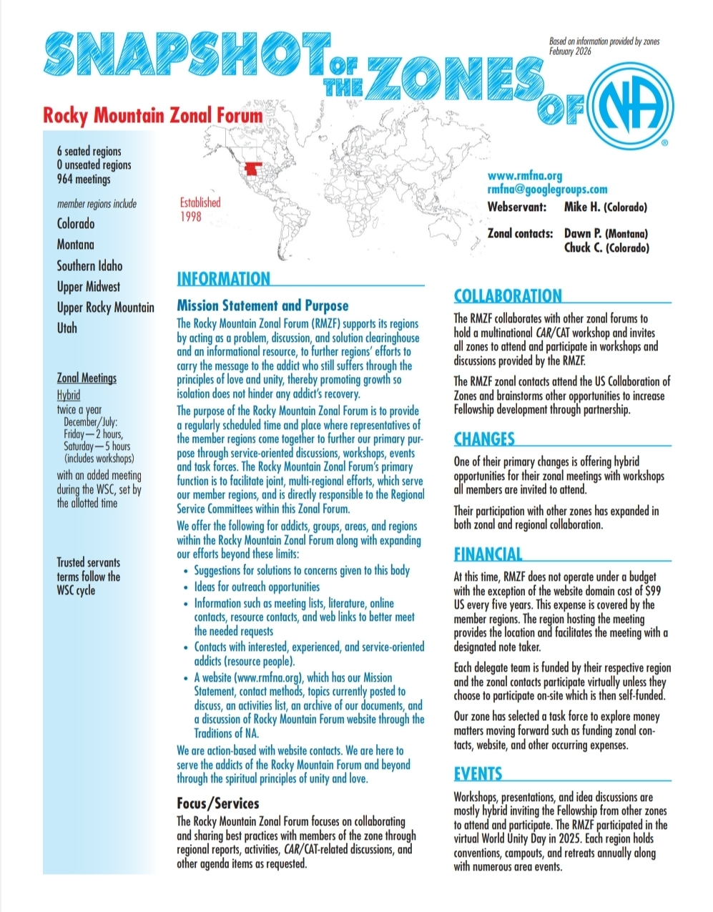

Thanks for asking me to serve our region
Mike H - rda@nacolorado.org

RD/RDA Zonal Forum Questions

Mike gave an overview of the Rocky Mnt Zonal Form (RMZF). They try to meet twice a year in person, with a zoom option. The six seated Regions generally pay to send their RD’s to the meeting. However, the RMZF does not have a budget, so the two RMZF Contacts have to pay for their own travel. There is an effort to change that by starting a budget contribution from the 6 regions and a set of guidelines to assign responsibility for those funds.
Assembly’s input on the 5 RMZF questions from above report:
- Support the budget of about $5000,00 annually for travel, websites and misc.? We voted mostly yes
- Should they have a treasurer? We all voted yes
- An annual budget cap? There was very little support for a cap. It was reiterated that the travel funds remove financial restraints from the RMZF Contact positions.
- Should we support travel for Contacts? We all voted yes
- Should RMZF pay to host their own meetings? Currently the Regions take turn with that expense. We voted yes
- RMZF Website reimbursement? We voted yes
- RMZF Bank Account structure. We agreed they should get their own account as opposed to piggy backing on one of the Regions.
There was additional discussion about the history of Zones and when they might become the voting structure for NAWS. There is no timeline for that right now.

CNAC -Steve
Steve K gave a presentation on what CNAC is and how it benefits the Region. The primary tasks are to:
Sign all NA contracts
Manage the insurance policy
Manage the tax filings. CNAC is non-profit but we file with the IRS annually regarding the roughly $150,000.00 annual money flow. There are additional State and occasional sales tax filings.
Most importantly, it protects individual addicts from liability by having CNAC on all contracts instead of an individual’s name. If there were a lawsuit, they would be going after a broke ass entity.
All CRSC groups and events can take advantage of these benefits. Please use the NA Colorado web site to obtain contract forms (if facilities do not have one) and contact CANC members to get things signed.
CNAC is a 401c3 non-profit business with a Board of Directors. The Board consists of a Chair, Vice Chair, Secretary, Financial Officer and up to three Members at Large. They meet quarterly with representatives from CRCNA, CRRMCO and WRCNA.
CNAC is always looking for people with business and legal backgrounds to fill positions.
An example of CNAC at work is regarding childcare at a meeting. CNAC did all the research, and this is the bottom line:
IF YOUR MEETING OFFERS CHILDCARE, YOU ARE NOT COVERED. YOU ARE TAKING A PERSONAL FINANACIAL RISK
There are a number of laws you must have covered to legally offer childcare. There is no language or parental consent form that will free you from the liability. If something happens in that room, you are not covered and are on your own. That said, you can choose to take the risk.
Someone brought up the “cc” note on meeting lists that indicate childcare. Folks will be looking into that.
Regional Subcommittees -
  - PR Chair – Chris F
We continue to supply literature. There are 8 High Schools in BFE that are asking for literature. Miraculous Mondays picked up the IL prisons but still is not in CO. Next PR meeting is May 7th, Monday
H&I Chair – Erica
DOC is getting the word out about the writing program. We still need a Coordinator for the men’s writing program.
PI Chair – Russ absent
Web Chair – Dave A.
041826 Web report to CRSCNA
Have had a few issues with the BMLT server. First, we had an old version of the app which Zach helped me update from 3.0.1 to 4.2. Then we found out that the 4.0 version had a bug that needed fixed so asked for help from the administrators in getting that patched. I may need to go in and verify that the meeting codes are correct. Other than that I tried to keep up with requests that came in. Archives needed to set zoom mtgs so I gave them the PR zoom info and they used that. I also zoomed into the bi-monthly PR meeting last Monday but was the only attendee.

Archives (waiting on elections) report from Celeste
Archives Subcommittee Report
Hello to all from the Archive and Historical display subcommittee. I am an addict my name is Celeste and I have been designated as the archive subcommittee representative. We had our official kickoff meeting on Sunday 4/12. At this meeting we talked about ways to get more people involved and what the initial tasks of the subcommittee seemed to be of most importance.
We decided that moving forward we will meet on a hybrid format, virtual/in person. This will allow trusted servants from other areas to join the subcommittee. Our next meeting will take place on Sunday 5/10 at noon at 1510 Glen Ayr in Lakewood and we will have a virtual option for those who want to join and cannot make the trip to the clubhouse. The link to this meeting will be available soon, we hope we can use the regional account for this virtual meeting.
The first task we will undertake is to start organizing and categorizing the items we have in our storage unit. To begin this lengthy process, we will be meeting on Sunday 4/26 at the storage unit on 3800 Monaco from 11 AM to 1 PM. You are welcome to participate. This process will probably take several months to complete.
Our next task is to begin collecting historical information about groups and areas. This project will include history about the groups, for example when they started, what format they had, who were the founding members, stories about the group, etc. We have a questionnaire that is open be filled up by any group who would like to be a part of this project.
Lastly, I understand that one of the archive subcommittee members was planning to nominate me as chair for this subcommittee. I understand that because I am not able to be present today (I work on Saturdays), that I cannot be named chair, but I do want to state that I accept the nomination and will be present In September to go through this process.
Thank you for allowing me to serve.
Celeste F

  - Colorado Regional Convention of NA (CRCNA) XL Chair – Tiffany S*
Our budgets are in for approval. We are still looking for an H&H and F&E Chair, however everyone is pitching in to get the work done.
Vice Chair – Jen (no report)
Treasurer – JR (no report)
  - Colorado Regional Rocky Mountain Campout of NA (CRRMCO) XIII
Chair – Coy P
4/18/26
CRRMCO XII Chair Regional Report: Coy P.
Campout Date: June 12-14th 2026 @ Turquoise Lake
Vice Chair: Grant P
Treasurer: Open
Secretary: Open
The committee met on April 12th with 4 in attendance. Speakers have been selected and members of the committee will be reaching out to those who were selected. We are working on the schedule of events for the campout and have also discussed a sign up for volunteers to assist at the campout.

Thank you for letting me serve.

Coy P.
There will not be water at the campsite. We will make it clear to everyone to bring their own.
Vice Chair – Grant P (no report)
Treasurer – Open

  - Women’s Retreat of Colorado NA (WRCNA) XIII
Chair – Nohnie*
Hello!
Please see the below report for WRCNA XIII

The Retreat will be held in Lyons, CO Peaceful Valley Ranch Aug 21-23.
We've had 1 F&E event in Boulder and have the following events coming up: Bingo (Mile High) 4/25 @ 5p - 8p, BBQ (Pikes Peak) 6/20 @ 1p - 4p, Poker (Mile High) 7/18 @ 4:30p - 8pm.

The Webite is live for Registration, Merchandise and Scholarships. Flyers attached.

As of 4/17/26:
21 Full Registration @ $210
13 Payment Plans ($52.50x4)
14 Scholarship applicants
$123 Merchandise sales

All budgets and timelines are on track!

Requesting Guidelines be ratified.

Thank you for allowing me to be of service.

In Loving Service,
Nohnie A
WRCNA XIII - Chair
Scholarships close in July. Verified that we will be sharing Queen beds and you choose who you share with when you register
Vice Chair – Maya (no report)
Treasurer – Karen (no report)
Hello Every One,

So far Registration we have brought in $4,410.00
So far Scholarship Donation brought in $803
Chance to Win $280.00
Payment Plan $1,047.00
So we brought in a total of $6,540.00

For the first event Spaghetti Dinner We brought in $1,460.00
our expense for the Spaghetti Dinner was $297.98.

For Merchandise so far we have brought in $166.00

Print & Display
We have Spent $239.19 for Flyers & Banner.

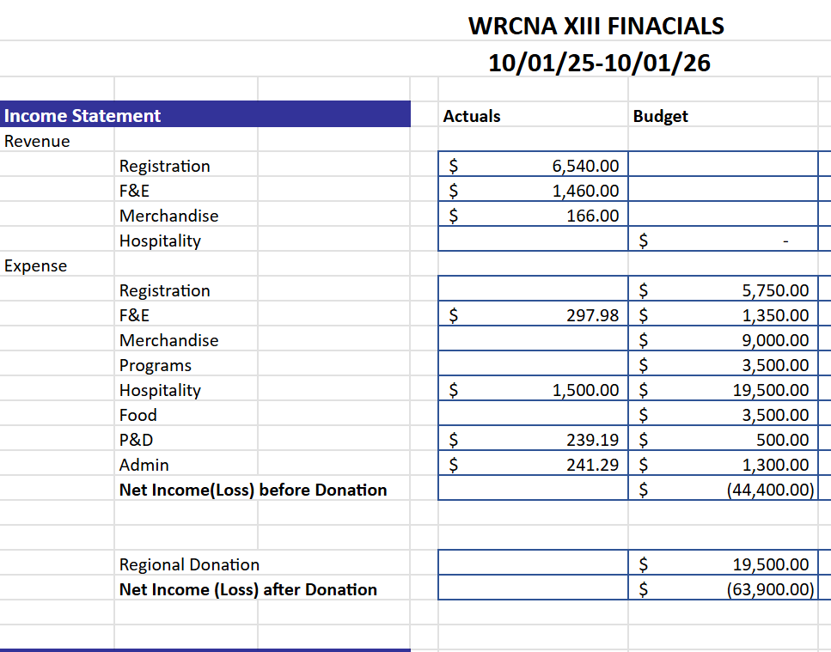
I hope this is all that you are needing. Thank you for letting me be of survice.

Karen Shakin
WRCNA Treasurer
Archive and Historical display subcommittee
Archives Subcommittee Report
Hello to all from the Archive and Historical display subcommittee. I am an addict my name is Celeste and I have been designated as the archive subcommittee representative. We had our official kickoff meeting on Sunday 4/12. At this meeting we talked about ways to get more people involved and what the initial tasks of the subcommittee seemed to be of most importance.
We decided that moving forward we will meet on a hybrid format, virtual/in person. This will allow trusted servants from other areas to join the subcommittee. Our next meeting will take place on Sunday 5/10 at noon at 1510 Glen Ayr in Lakewood and we will have a virtual option for those who want to join and cannot make the trip to the clubhouse. The link to this meeting will be available soon, we hope we can use the regional account for this virtual meeting.
The first task we will undertake is to start organizing and categorizing the items we have in our storage unit. To begin this lengthy process, we will be meeting on Sunday 4/26 at the storage unit on 3800 Monaco from 11 AM to 1 PM. You are welcome to participate. This process will probably take several months to complete.
Our next task is to begin collecting historical information about groups and areas. This project will include history about the groups, for example when they started, what format they had, who were the founding members, stories about the group, etc. We have a questionnaire that is open be filled up by any group who would like to be a part of this project.
Lastly, I understand that one of the archive subcommittee members was planning to nominate me as chair for this subcommittee. I understand that because I am not able to be present today (I work on Saturdays), that I cannot be named chair, but I do want to state that I accept the nomination and will be present In September to go through this process.
Thank you for allowing me to serve.
Celeste F

- Old Business
CNAC re-presented a motion that has been discussed at the last three CRSC meetings.
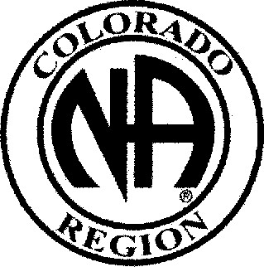
CRSC PROPOSAL FORM
09/26/2025 Date:

Proposal:

To include CNAC in the Colorado Regional Service Committee as part of the Administrative Committee with the ability to give a report, have input on topics on the floor, and be a voting member of this service body.
Intent
To be part of our Regional Committee adding an expertise in venues, banking, insurance, and other fianacial discussions the corporation can assist with. To support Regional events, Groups, and Areas.
Maker: Steve K. Colorado Narcotics Anonymous, In, Board of Directors Chairperson
Tradition. concept or spiritual principle on which it is based:

Spiritual principle of unity through our service structure being part of the solution
Seventh concept of service
Disposition:
Consensus Yes No X
Blocked Yes No
Blocked based on:

CRSCNA -PO BOX 1437 — Denver CO 80201 email: nacolorado@nacolorado.org

Points of discussion:
CRSC guidelines are ambiguous. One place indicates they get to vote another indicates they do not have a vote.
The motion has been discussed at three CRSC meetings, so the groups have already had a chance for input
It was noted that NAWS does not have a vote at WSO meetings
Also noted that many Regions do it differently. Some have a vote for all participant others limit votes.
They shouldn’t have a vote because they do not represent a group
Is it possible to have different members vote on different items? No real support for that
Concept 7 is perfectly clear they are a member of this body and should be allowed to fully participate
There were 8 stand asides of 21 voting members which means the motion fails without 2/3 consent – you know cause concepts are silly
  - WRCNA Guideline changes – ratify changes
Passes with no objections
  - Display and Archives Guidelines – ratify guidelines
Passes with no objections

  - Elections – Open Positions
- CRMCCO Treasurer – no takers

- New Business/Proposal
Dan discussed the ongoing process to find locations for CRCNA making sure every area is involved in the process. The first decision is to only sign a 1 year contract to avoid being “stuck” at a place that doesn’t work well
They did decide to have the next CRCNA at the Pueblo Convention Center and contracts with the two surrounding hotels. There will be substantial savings with the AV costs.
  - CRSCNA amendment to current guidelines - missed
  - CNAC ratify new Member at Large missed
  - CRSCNA Elections
Chair – Matt nominated, qualified and elected for a second term
Vice Chair- Bill nominated, qualified and elected for a full term
Treasurer – help please
Secretary Isabelle nominated, qualified and elected implying we waved the 3 year clean time to 2
- Open Forum
Dave A wanted to point out it has become increasingly popular to change the NA readings to be gender or HP neutral. While he fully agrees with the underlying need to be all inclusive, it is in defiance of the long standing belief that all NA literature be read exactly as printed. This is both a matter of respect and it implies individuals have the ability to change literature to their liking.
He notes there is only one reading he will do because he will not read “exclusive” verbiage. More importantly, NAWS has been gathering worldwide input on this for many years. Their recommendation is to continue reading literature as written, but if your groups finds them exclusive, PLEASE change what selections your group is reading not the words. There is a list of commonly used neutral readings at https://na.org/gender-neutral-readings/

It was mentioned again that GSR are supposed to attend the 2 Regional Assemblies held each year. It would helpful if everyone brings this issue to your GC. Make sure new GSRs understand it is part of the commitment. More importantly it is how your home group can pass their ideas to WSC
- Closing Treasurer Report
  - $20127 opening
$ 1798 in donations received
$ 21135 left after expenses paid
$ 1806 above annual budgeted expenses
There was a large DOC literature expense and the Assembly was over budget
Proposed sending $1800 to WSO
Someone suggested sending half the extra
Noted that Areas are historically very generous and we are not likely to need the extra money
Approved motion to send $1800 to WSO
$19300.00 ending ballance

Attachment 1: RD/RDA summary of CO survey and discussion questions

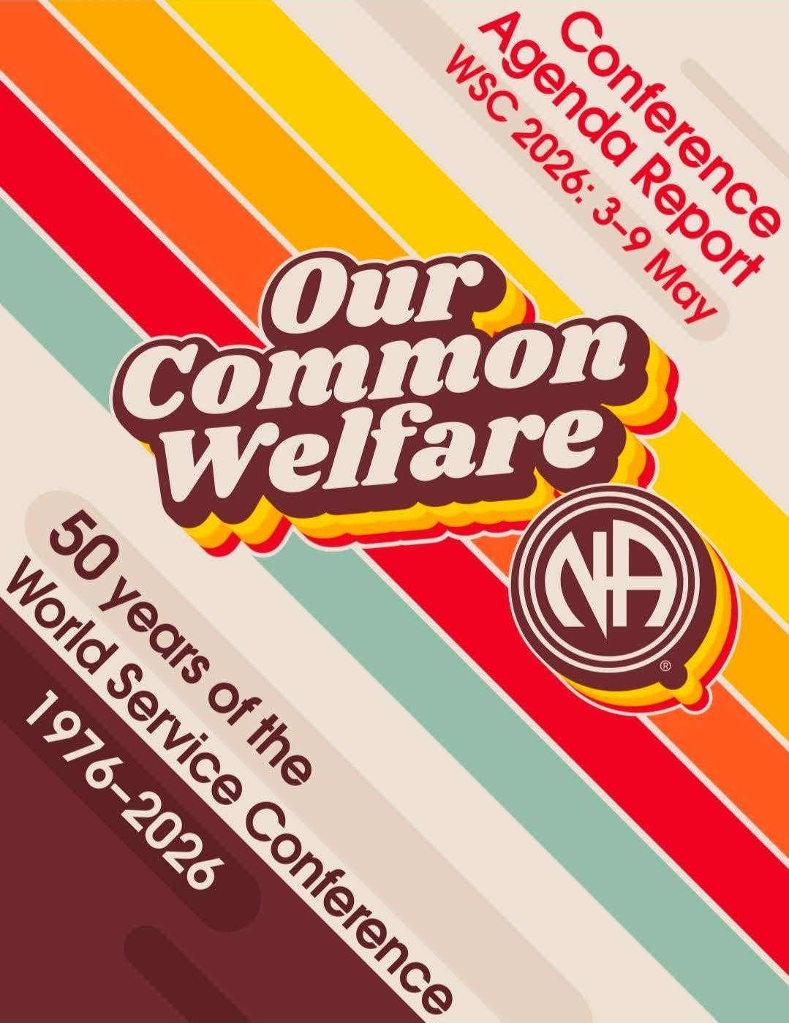

Colorado Region

Survey & Discussion
Questions

WSC 2026
Literature, Service Material, and
IDT Survey
Colorado Region

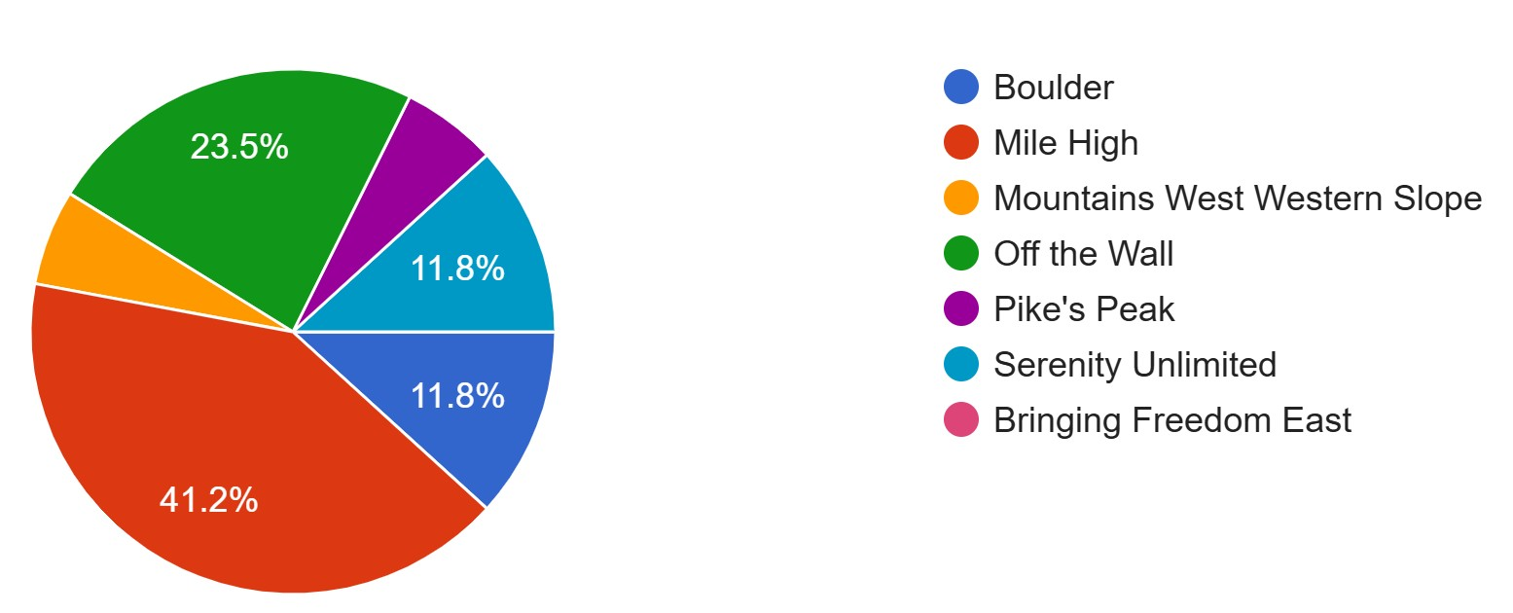

NAWS surveys are opportunities for members to share their views and help shape the projects planned for future conference cycles.

The CAR (Conference Agenda Report) also contains essays with important relevant content. The CAR along with Summary videos and the Group Collection Sheet are available at World Service Conference - Narcotics Anonymous World Services (na.org/conference) and are very informative.

During the World Service Conference (WSC) 2026, conference participants (Regional Delegates, Zonal Delegates, World Board Members) will spend time discussing these issues.

Thank you for participating in the 2026 World Service Conference Agenda Report!

For more information, please email rd@nacolorado.org or rda@nacolorado.org

New and Revised Recovery Literature
Please select up to two of the options in each category to help the WSC set priorities for the future work/project plans and for the Colorado Regional Delegates to best carry our member's voice. We have divided the recovery literature material section into ideas for new pieces and ideas for revisions, as we did for the service material in the next section. Please select up to two (2) options in each category.

New Recovery Literature

- Disruptive and Predatory Behavior. Ideas include how to identify behavior and create a safe environment.
- Virtual Recovery. Ideas include getting clean on the screen, group booklet for online meetings, virtual membership and service basics, guidance for online meeting behavior.
- Study guide: 12 Concepts. Ideas include Concepts Working/Study Guide, Guiding Principles for Service Committees.
- DRT/MAT. Ideas include looking for a stand or position that is clear, defining clean or abstinence, clarifying who can serve, labeling this as an outside issue, saving lives and helping members take root, including personal experience, PR and MAT, other medical treatments—medical marijuana/psychedelics for therapy.
- Women in Recovery. Ideas include carrying the message in male-dominated communities, women-centric issues such as motherhood, menopause, sharing experience.
- Step Guide: Focused for more experienced members.
- Welcoming Newcomers and Helping Them Stick and Stay. Ideas include what to do as a newcomer and how to treat the newcomer.
- No new recovery literature.
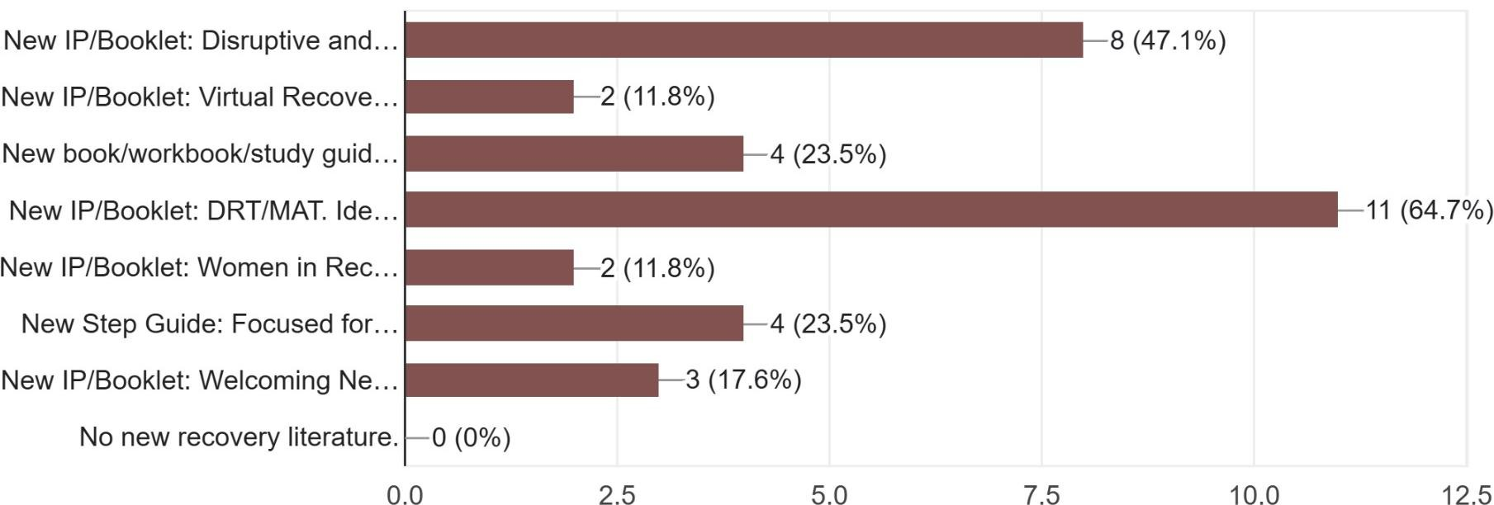
1.

2.
3.
4.
5.
6.
7.
8.
Comments:
We fill that it is very important to have literature for Women in Recovery, and Welcoming Newcomers, and Getting Clean on the Screen.
We also would like to see "Welcoming newcomers and helping them sick and stay."
Page 1

Revised Recovery Literature

- Update the booklet Behind the Walls (1990). Ideas include adding services available and staying clean on the outside.
- Revise Tradition Eleven to include “social media.”
- Update the Booklet In Times of Illness (2010). Ideas include add information on medical marijuana, therapeutic use of psychedelics, and clarity around prescribed medications.
- Gender-neutral language. Investigate changes and/or additional wording to NA literature from gender-specific language to gender-neutral and inclusive language.
- Revise the Step Working Guides. Ideas include fewer leading questions, fewer questions in Step One, more questions in Step Four, more encouragement to journal, streamline the process, and number the questions.
- Update IP #26 Accessibility for Those with Additional Needs (1998). Ideas include acknowledging current technologies and adding something about nonvisible disabilities.
- Replace references to God with Higher Power throughout our literature.
- Update IP #24 Money Matters (2010). Ideas include adding information on zonal forums and digital contributions.
- No revisions to recovery literature.

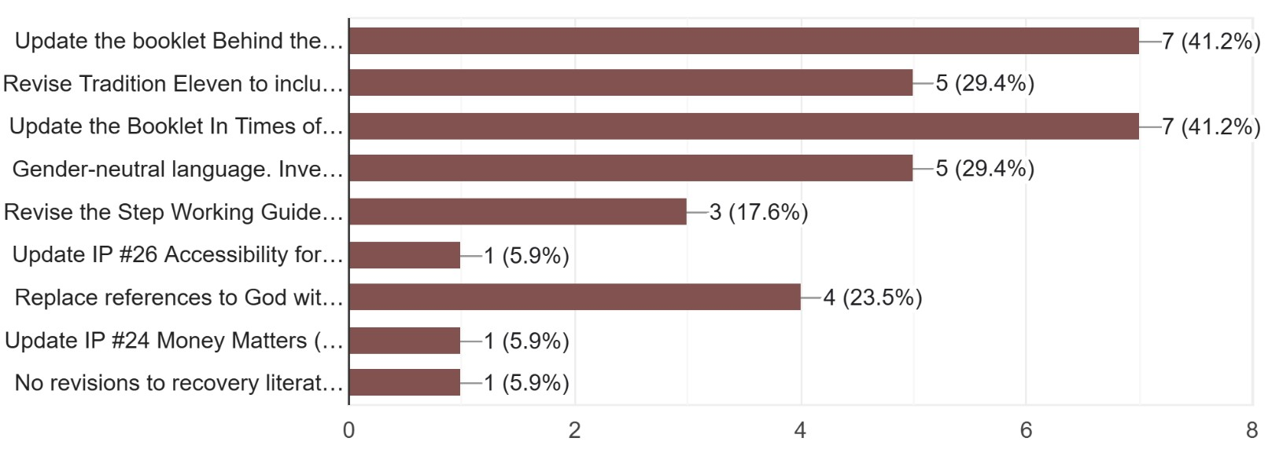
1.

2.
3.
4.
5.

6.
7.
8.

9.

Comments:
Just number the step guide questions please.
Step Working Guide, Replacing God with Higher Power, and Gender-Neutral Language

Page 2

New and Revised Service Material
The fourth 2023-2026 Issue Discussion topic was Reimagining and Revitalizing Service Committees. Fellowship input on the topic seems to point to updating Planning Basics, a suggestion that came up repeatedly.

New Service Material

- Mentorship in Service. Ideas include practical training and how to implement mentorship in service bodies.
- Fellowship Development. Ideas include best practices for outreach, what FD is, and guidelines for committees.
- Virtual Service. Ideas include guidelines for virtual platform, public relations, virtual areas and regions, connecting virtual groups to the service structure, virtual or hybrid service meetings.
- Social Media. Ideas include use of AI to do public relations work and application of the Traditions in social media.
- GSR Orientation/Workshop Guide.
- Group Inventory/ Group Pamphlet to Do Annual Review.
- Area Service Basics.
- Tools for Managing Electronic Funds for Groups and Service Bodies.
- Trusted Servant Development.
- PR Tools for Government/Criminal Justice.
- Service Collaboration at All Levels.
- Rotation and Continuity in Service.
- No new service material.
1. 2. 3. 4. 5. 6. 7. 8.
9.
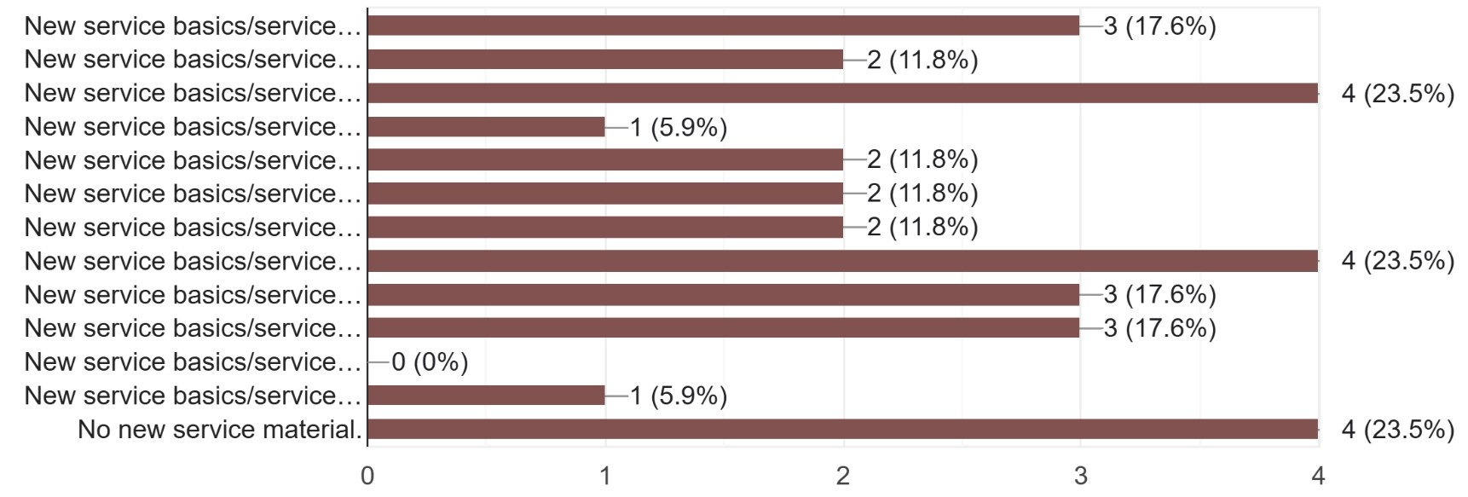
10.

11.
12.
13.
Comments:
Trusted Servant Development, Collaboration at All Levels, and PR Tools for Government/ Criminal Development, Rotation and Continuity in Service

We would like to see "GSR Orientation/workshop guide."

Revised Service Material

- A Guide to Local Services. Ideas include create a contemporary set of service tools to replace A Guide to Local Services, delete outdated information, add information on rural/remote areas and regions, add information on zones, add more best practices.
- The Group Booklet. Ideas include adding information on addressing predatory behavior, how to make members feel welcome, virtual NA, the importance of Traditions and Concepts study meetings, common needs meetings, expanded information on trusted servant roles.
- SP Disruptive and Violent Behavior. Ideas include adding section on predatory behavior, addressing online meetings, adding text from the IDT.
- SP Social Media. Ideas include adding information about online meetings, updating social networking guidance, including information on PR and H&I.
- H&I Handbook.
- PR Handbook.
- Planning Basics.
- No revisions to service material.
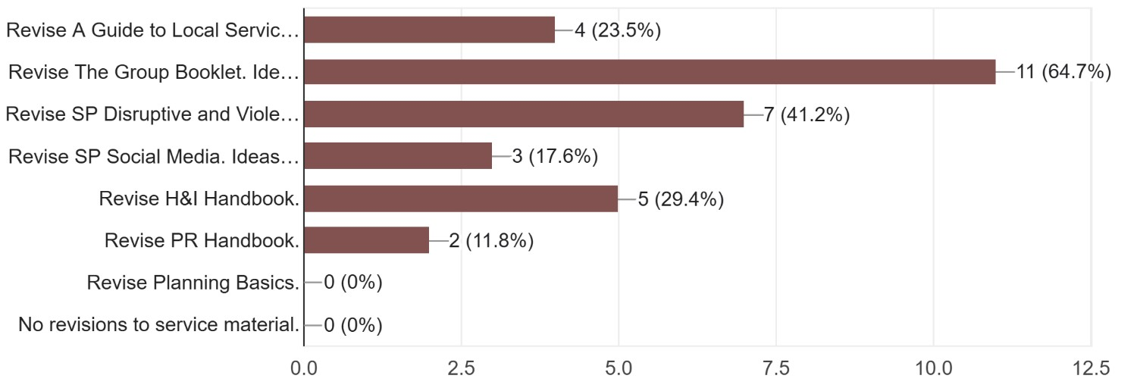
1.
2.
3.
4.

5.
6.
7.

8.

Comments:
A Guide to Local Services, Predatory and Disruptive Behaviors.

Revise Guide to Local Service.

Issue Discussion Topics
The Issue Discussion Topics are just that - issues that are discussed throughout the Fellowship in the time between conferences. The results of those discussions can contain some of NA’s best practices and have created the foundation for several service pamphlets and other tools and literature, including the Building Strong Home Groups worksheet, service pamphlets such as Principles and Leadership in NA Service and Disruptive and Violent Behavior, the Money Matters IP, and more.

- Attracting Members to Service.
- Decision Making/Delegation—Ideas include consensus-based decision making and responsibility and authority over NA services.
- Disruptive & Predatory Behavior—Ideas include safeguarding policies, aggression at service meetings, racism, sexual predation, creating a safe and inclusive environment, the line between legal and group decisions, use of cell phones, and children in meetings.
- Unity—Ideas include maintaining NA unity despite external politics.
- Helping Addicts Find Us—Ideas include use of technology to connect addicts with meetings and each other.
- Use of Funds, Fund Flow, and Fundraising—Ideas include 50/50 raffles, blockages in the flow of funds, anonymity in electronic funds.
- Social Media—ideas include group use and social media as a PR tool.
- Retaining Oldtimers.

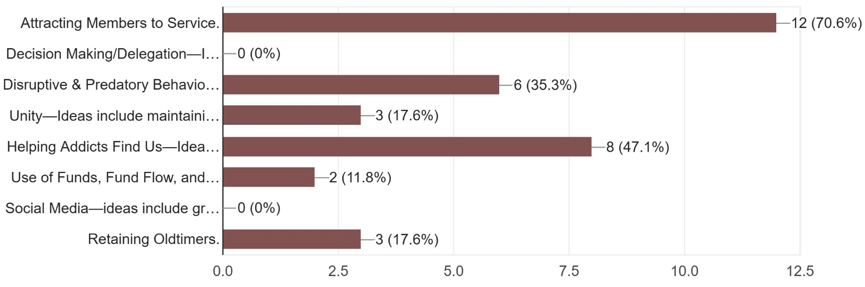
1.
2.

3.
4.

5.
6.

7.
8.

Comments:
Unity, Retaining Oldtimers, Decision Making/Delegating

Discussion Questions

The Conference Agenda Report also contains essays with important relevant content. Summary videos of the CAR are available at World Service Conference - Narcotics Anonymous World Services (na.org/conference) and are very informative.

During the World Service Conference (WSC) 2026, conference participants (Regional Delegates, Zonal Delegates, World Board Members) will spend time discussing these issues and will be sharing your input.

Discussion Question 1

Gender-Neutral and Inclusive Language
For more information on this topic, see page 30 of the CAR

For the purposes of these questions, we intend to focus on gender-neutral language in NA literature as described in the CAR essay - changes in the language that describes people (members and potential members), not language that describes a Higher Power. These changes in wording - from “men and women” to “people,” for instance - don’t change the meaning of the message in our literature; they allow more people to identify with it. Issues of the wording of our Steps and Traditions are for a future discussion.

Given that we all want to provide a safe, welcoming inclusive Fellowship where everyone can recover (regardless of . . . ), are we willing to explore these types of changes in our literature in order to carry the message more effectively? If not, why not?

Some areas I don't want changed would be talking about God and Higher Power, changing the language to people and our would be ok.

Focusing on the similarities and not the differences, as a newcomer finding any rationalization to walk away.

In agreement to focus on similarities and not differences, making it as inclusive as we can, saving the still suffering addict, whatever lengths we need to go to, too many people die, and don't want to see anyone else die.

I'm for it, those opening readings once we are in the literature and going into things your already in the program and giving it a shot, but those opening readings are the door, and that door should be open to anyone, whoever it is, that is our message any addict can stop the desire to use every reading says some form of those, if you can find the
Page 6
inclusion in that part and then you're willing to stick around and hear the message. I think that the opening readings are where ya got to hook em!

In the Living Clean you really don't notice it.

When it's like that, I'm not personally affected but if it said, only straight people, it would be like oh this isn't for me.

Using the word him forever, even when referring to women, even though women get offended by it, as a newcomer it's the same feeling.

In we do recover- for the first time in man's entire history- for the first time our entire history!

The people we are trying to reach aren't the people who have been here forever it's about welcoming more people in, if they have never heard it as man's entire history, they would be like this is for me I am our, I am a person, I am we, no matter how you identify yourself we are a person, we are people.

I think NA does a pretty fantastic job of being really progressive about being inclusive. I am proud of that.

When you hear our entire history it flows so nicely, I've been in meetings where it's changed in slides to person not man's/woman's.

Various opinions about this question, not so much experience in this area. See some of the potential value but feel the time, costs and results may not be worth it. It was thought by several that the literature says “any addict”, “regardless of sexual identity” and other identities, numerous references meant to be inclusive. Concern that some may be experiencing some “terminal uniqueness” in this area and that can be deadly. Sponsors and members with similar experiences have always been the vehicle for identification and understanding of how this applies to individuals. The personal stories in the back of the book can also be used to help with some of these experiences. Having conversations at various area, region and world levels may be a more realistic approach.

YES AND NO Using "people" or "humans" instead of "men" is a good idea. But we do not want to move towards gender-neutral pronouns as that could be considered political.

No. We worry this would exclude other countries like Russia and other conservative areas. We are concerned this is pushing a U.S. philosophy on other cultures. Do don't think we need to change what is already working.

Page 7
I am not a fan of changing our language, I feel that the percentage of addicts who feel "offended" by the language is extremely low compared to the fellowship as a whole and should use the standard approach one would use when the word "GOD" offended them, talk to your sponsor and mentally change the wording to suit your own needs or beliefs. Our language in our literature has been speaking to addicts successfully for over 70 years. The question for me is where do we draw the lines? If we cater to this small percentage of addicts, who else do we change things for, until the message is blurred and it becomes more exclusive than inclusive.

Yes, we are willing to explore these types of changes in our literature.

Yes we are willing to explore these types of changes in our literature.

Yes, this would help be apart of and feel included with gender neutral language.

Discussion Question 2A

DRT/MAT in NA: Helping Members Take Root
For more information on this topic, see page 33 of the CAR

In the process of asking how we help members take root in NA, we confirmed something vital: Our roots are already deep and intertwined. When “all manifestations of the recovering person” come together in unity, our symbol tells us, “The greater the base, (as we grow in unity in numbers and in fellowship) the broader the sides of the pyramid, and the higher the point of freedom.”

We are grateful, in a moment when there is so much polarization around us, to be together in a Fellowship that has demonstrated such a powerful ability to stand together with all our differences. We look forward to continuing this conversation, acknowledging the unity we are already demonstrating and building on that to create a wider door, a broader base, and a greater understanding of how we grow from here.

Does your group or area ask members if they’re on MAT when they step up to celebrate or to serve? What do you do next?

Over 10 years ago at CRCNA there was a panel teaching old dogs' new tricks, one of the questions was this "how do we feel about DRT/MAT?" We all get here differently the most important part is that we get here and that we stick and stay. Clean time is personal, sometimes at some point if someone is on DRT or MAT they'll (I hate to say ‘they’, and do not feel that way, we are all one and all in this fellowship together) trust that it's going to be ok without it, but how will that ever happen if we are against it and say you are not clean. Our homegroup has a service position and spot for every single
Page 8
person. We have a spot for you, there are positions that have a clean time attached to them, and some for individuals who have the desire to stay clean.

I remember, two years ago a member who is very precious, she was struggling to come off her medication, and was shot down from doing service, and is no longer around. It broke my heart, she was literally heartbroken because she wanted to do service, I believe she was capable, we say we have a service position for everyone, but is key tags enough for someone.

I think each member is a different situation, different uniqueness, I think each one should be taken in their uniqueness I don't think we should ever put everyone who is on MAT in one boiling pot, because you're on this you can't do this. For one it promotes dishonesty, for an addict who wants to be a part of service, and for an addict to step up and be honest and be shot down, when they just want to be a part of. This is a very painful and hard subject.

I think everyone should be taken individually because they are individuals. There is more we can do to create something that anyone has the desire is able to step up and do the service. It's different when we are in person to do service than when we’re on the screen. It's much more difficult.

Just be here just serve with us.

When it comes to this I strongly agree with what has been said with what has been said, there is a difference about abuse and prescribed, in our literature it talks about being clean and abstinent we have people on medication for mental health, or that alter their state they are not intentionally seeking it to alter their state of mind, they do it to be the best person they can be, and we do not question them about it, if we are not questioning every person on medications we should be looking at it the same way. if they are taking medications that they are prescribed by a doctor they should be eligible to be of service.

I believe that someone who is being medically monitored by a doctor and taking medications exactly as they are prescribed, then they are clean on the first day that they didn't use. Not only that, but it is also none of my business. I could use tonight and come to a meeting tomorrow and take a black and gold, no one would know, but I would know. And maybe one day I tell on myself, and maybe I don't. But that's no one's business but mine, my sponsor, and my higher power. How is someone going to find recovery if a doctor is telling them this will help you and we are telling them that's not good enough? EVERY ADDICT has paid for the right to be here with their PAIN.

At our homegroup, we do not ask members if they are on DRT/MAT when they step up for clean time or when there are elections, or during Group Conscience when individuals step up other service positions. If there ever has been talk about it, I have
Page 9
not been aware of it, until this topic was brought up. I agree with what others have said, if we do not question everyone who is on a prescription, and put limitations on what they can and can't do. I believe the definition of clean is one thing -it's not your clean if this, and clean if that, but ONLY if this.

If a member is using DRT/MAT and using it irresponsibly then when they get voted on for a service position, they probably won't get voted in. Not because they are using that but because of their actions and behaviors. It talks about how there is a lack of new members this could be something that helps with that.

No, it is felt that this is a personal discussion between a member and their sponsor, if they have one, if not, of course it is the member. Several members felt that it is a “program of total abstinence” and people should not hold positions if on DRT/MAT, one felt that it could be position dependent. Of course, how do you know if you don’t ask? Is it outlined in some written guideline and shared, then the member is left to choose how to proceed? Though this addresses DRT/MAT, how is this different than other addictive substances that members may use to treat medical conditions?

Discussion about “getting off” DRT/MAT. Individual member’s choice, they decide when it is right for them. Sponsors and other members need to do their own step work, inventory to respect the rights of others.

My home group strongly believes that this is an outside issue. We rely on the trust that the addict has with their sponsor to discuss what their role is in service or in divulging their participation in a DRT or MAT program. We foster trust and understanding but also acknowledge that it is an outside issue. None of our business. We do not ask.

We do not ask members if they are on MAT when they step up to celebrate or to serve at our group meetings.

Not that I know of. Our area does not take a stance on mat

No we do not ask members about their medical background when they are celebrating or being of service.

Yes when they serve only and no when they celebrate. We tell them to keep coming back if they're taking MAT.

Not when they celebrate- but we refrain from allowing members on MAT serve.

Discussion Question 2B - DRT/MAT in NA: Helping Members Take Root For more information on this topic, see page 33 of the CAR

Page 10
How can we foster unity and respect members’ recovery process given our differences? How do we get past our personal reservations and help newer members take root in our local communities?

We welcome them and say glad you’re here and make a suggestion to find a sponsor. This is a personal issue between them and their higher power and their sponsor.

We believe we foster unity by remembering that recovery is not one-size-fits-all. People arrive in NA from many different circumstances, with different histories, barriers, and needs, and the way they stabilize their lives may not look the same for everyone. What matters most is that someone made it through the doors of NA and wants a new way to live.

If a member is following medical guidance and using DRT or MAT responsibly, that does not change their sincerity or their desire to recover. It’s simply part of how they got here. For me, unity grows when we practice compassion before opinion. When we listen more than we judge. When we remember how terrified we were when we were new, and how badly we needed someone to welcome us instead of analyzing us. We get past our personal reservations by putting the newcomer first—by giving them a chance to take root, no matter how they arrived, and by focusing on the similarities in our pain instead of the differences in our treatment plans. If we keep our hearts open and stay focused on the primary purpose—carrying the message to the addict who still suffers—we make space for every recovering addict to feel safe, supported, and loved. And that’s how unity grows.

No one should be excluded from participating or being of service.

We do a good job of keeping with tradition three and five go with only a desire to stop using and that any addict can stop using and so on.

We believe that someone who is being medically monitored by a doctor and taking medications exactly as they are prescribed, then they are clean on the first day that they didn't use. Not only that, but it is also none of my business. I could use tonight and come to a meeting tomorrow and take a black and gold, no one would know, but I would know. And maybe one day I tell on myself, and maybe I don't. But that's no one's business but mine, my sponsor, and my higher power. How is someone going to find recovery if a doctor is telling them this will help you and we are telling them that's not good enough? EVERY ADDICT has paid for the right to be here with their PAIN.

When it comes to this I strongly agree with what has been said with what has been said, there is a difference about abuse and prescribed, in our literature it talks about being clean and abstinent we have people on medication for mental health, or that alter their state they are not intentionally seeking it to alter their state of mind, they do it to be the best person they can be, and we do not question them about it, if we are not
Page 11
questioning every person on medications we should be looking at it the same way. if they are taking medications that they are prescribed by a doctor they should be eligible to be of service.

I think each member is a different situation, different uniqueness, I think each one should be taken in their own uniqueness I don't think we should ever put everyone who is on MAT in one boiling pot, because you're on this you can't do this. For one it promotes dishonesty, for an addict who wants to be a part of service, and for an addict to step up and be honest and be shot down, when they just want to be a part of. This is a very painful and hard subject, I think everyone should be taken individually because they are individuals. There is more we can do to create something that anyone has the desire is able to step up and do the service. It's different when we are in person to do service when were on screen it's much more difficult.

All seemed to agree that it is important for members to work their own program and be clear about the message they are carrying. One is unwilling to sponsor someone on MAT/DRT as sponsor role is to work steps, another feels that there are elements of the program that can be learned even while on MAT/DRT that I sponsor can assist. Several mentioned the importance of practicing honesty, open mindedness and willingness in this area with newer members, understanding that there is more than one way to engage new members. One member expressed that “if I have a problem with someone I should look at myself first”. Several expressed the need to remain flexible, NA is not, one size fits all.

As a general rule, medication under medical supervision is ok, whereas recreational use is not. We have concerns around "medical marijuana" that could be considered recreational. We also recognize marijuana and its derivatives can be an important treatment in certain medical circumstances and it should not be up to the group to determine when it's appropriate.

Home group members can talk directly with them. Suggest they get a sponsor and support them in this effort. Share our own experiences with getting clean and DRT/MAT if we have that. Direct personal approach.

This all comes down to sponsorship. If the sponsor is traditions and concepts knowledgeable, and display the NA way of living, then we rely on the sponsor / sponsee relationship to mentor the addict the NA way. If the majority of sponsors in the NA community are based in the spiritual principles and rely on our traditions and concepts to support their sponsees, then the NA community is healthy, then personal reservations do not overtake the community and unity and respect are already there.

If we had updated literature to refer to base on DRT/MAT. If someone is on MAT it is up to that person to decide where they are at in their recovery, and not to run with it.

Page 12
We consider this an outside issue. People’s medical treatments are their business and we do not condone or deny them the right to recovery.

Work the steps and traditions. If someone is on MAT/DRT it is between that person, their higher power, their sponsor and their doctor.

We are willing to discuss this at the Regional Assembly with the conscience of the Region.

By meeting them where they are at.
Follow the Traditions.
Mutual respect.
Be as accepting as we can.

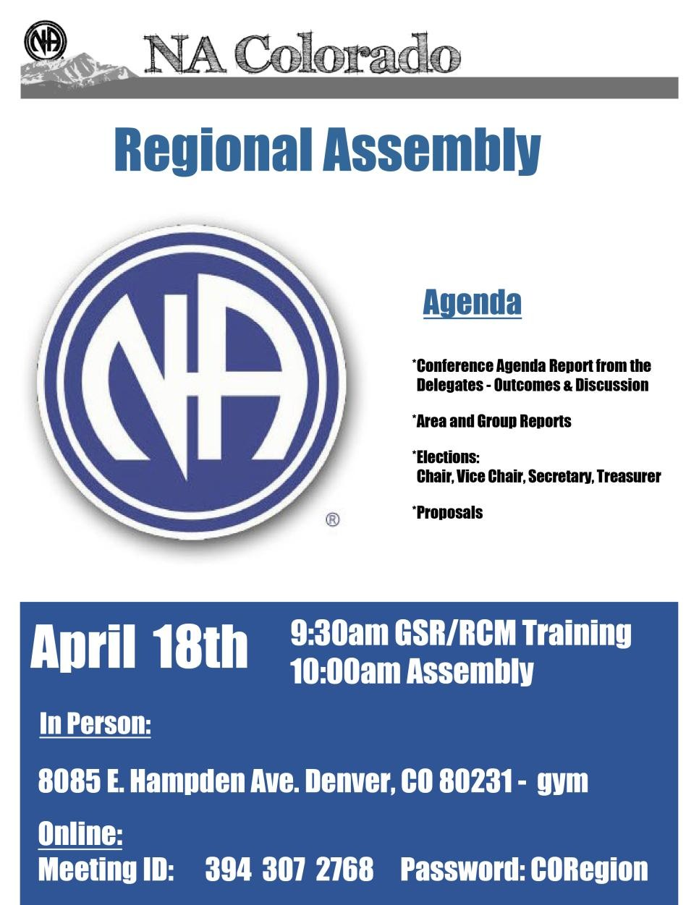
Page 13

Attachment 2: RD/RDA summary of CO CAR-CAT responses

Colorado Region

CAR/CAT Motions

WSC 2026
CAR - Conference Agenda Report
CAT - Conference Approval Track
Colorado Region

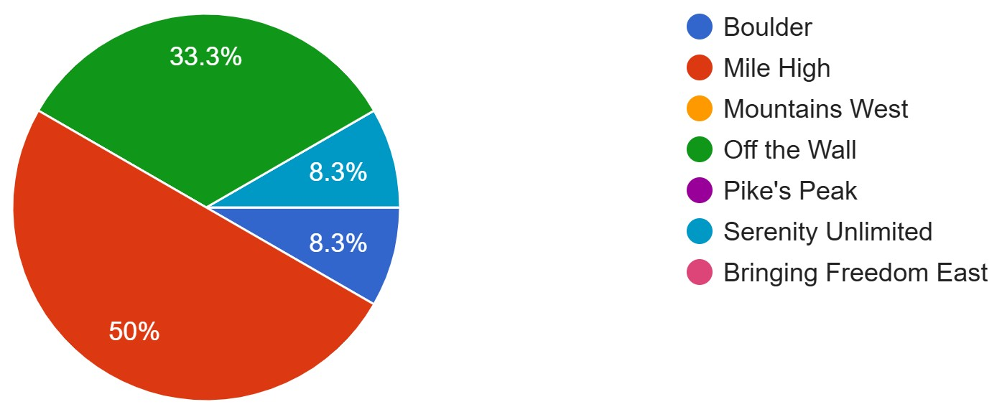
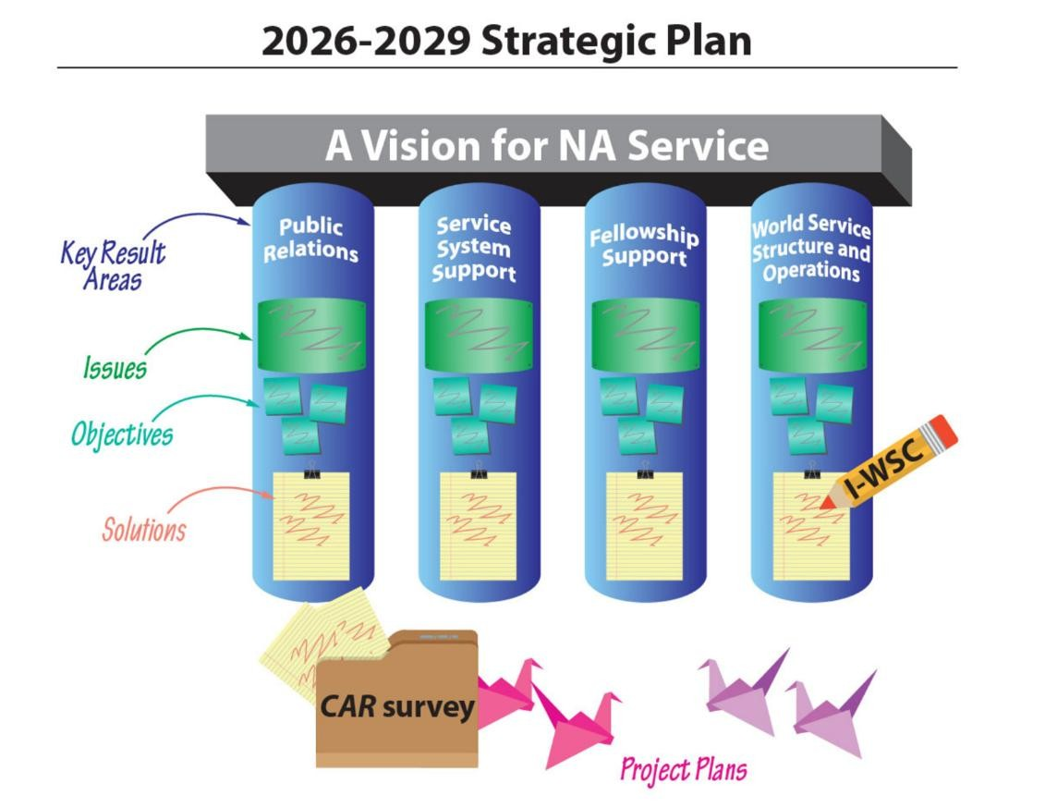

World Service Conference - WSC

Conference Agenda Report Materials
- Literature projects
- Service projects
- Issue Discussion Topics

Conference Approval Track Materials
- Motions
- 2026–2029 proposed project plans
- 2026–2029 proposed budget and budget explanation
- WSC seating report with requests from regions and a report from the WB
- Proposed processes for WSC
- 2026–2029 travel reimbursement policy
- A regional idea for consideration

*Several amendments have been made to some of the motions below and are quite lengthy. Please see the most up to date motions lists from NAWs na.org/conference for all details for the amendments to Motions: 3a-3, 3-a4

Note: Motions with amendments will ask you to vote on BOTH the original motion and the proposed amendments.

The Colorado Regional Service Committee’s Regional Delegates created this electronic tally sheet to collect responses on the Conference Agenda Report motions.

The CAR is available for download from the conference webpage:
na.org/conference

In addition to the motions and survey, the CAR contains essays with important, relevant content.

Summary videos of the CAR will be available at na.org/conference shortly after each release.

Page 1

CAR – Conference Agenda Report

Motion 1: Approve the revised IP #21, Staying Clean in Isolation, contained in Addendum A, as Fellowship-approved recovery literature to replace the current IP #21, The Loner - Staying Clean in Isolation.
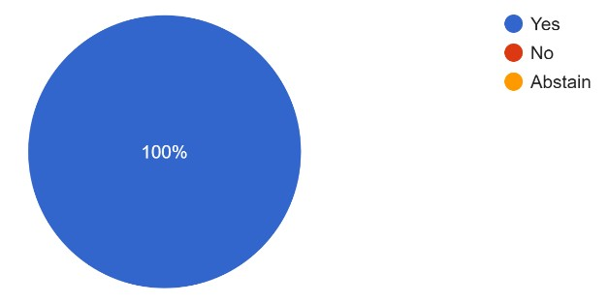

Motion 2: To adopt the collaboratively created 2026 - 2029 NA World Services Strategic Plan contained in Addendum B.

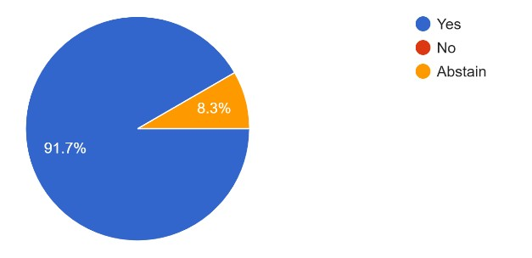

Motion 3: To hold the World Convention of Narcotics Anonymous (WCNA) every 5 years, beginning in 2028. The location to be determined by the World Board based on fiscal and geographic considerations that lend themselves to, at a minimum, a revenue-neutral event. (The specific changes to the WCNA Guidelines in GWSNA are shown in Addendum C.)
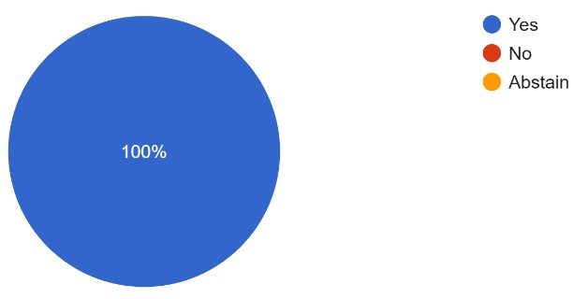

Motion 3-a1: To hold the World Convention of Narcotics Anonymous (WCNA) every 3 years, beginning in 2028. The location to be determined by the World Board based on fiscal and geographic considerations that lend themselves to, at minimum, a revenue-neutral event. (The specific changes to the WCNA Guidelines in GWSNA are shown in Addendum C.)

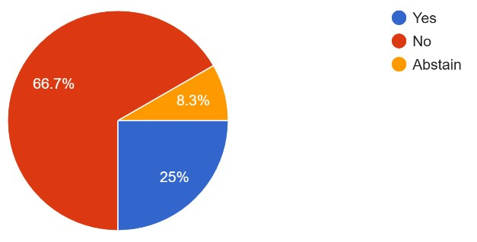

Page 2
Comments:
Our Fellowship is being reborn every day. With the growth and change of our newcomers along with our Fellowship, we're not getting 'older', we’re getting younger! Five-year span will help our newcomers be able to attend a world convention. We're here to save lives and be all inclusive with our newcomers and younger members.

Motion 3-a2: In planning the World Convention of Narcotics Anonymous (WCNA), the World Board will seek to incorporate, whenever feasible, scalable financial planning and contracting practices in order to mitigate financial risks and support the goal of holding the event at least in a revenue-neutral manner. Planning decisions related to event capacity, contractual commitments, and the allocation of resources should be guided by realistic participation projections and confirmed registration data, consistent with prudent financial management and with NA’s principle of self-support.
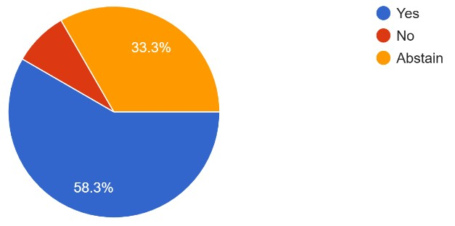

Comments:
The RD should vote as they think best with strong weight given to the World Board Response We feel this is very thought out and feels all inclusive. Supports NAWS and our Fellowship as a whole, both Spiritually and Financially.

Motion 3-a3: To hold the World Convention of Narcotics Anonymous (WCNA) every 5 years, beginning in 2028 in Frankfurt/Germany. Future locations to be determined by the World Board based on fiscal and geographic considerations that lend themselves to, at minimum, a revenue neutral event. Consideration should also be given to the linguistic, cultural, historical, and, above all, financial capabilities of the members in the part of the world where the WCNA is taking place. Ideally, the respective zone will be involved in the decision. A cap on the number of participants should be imposed only as necessary.
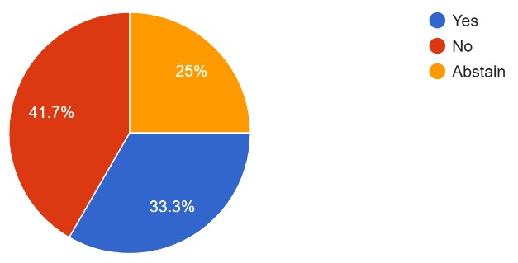

Motion 3-a4: To amend CAR Motion 3 to replace the proposed location selection process with a zonal bidding process as defined in updated Addendum C guidelines (see below).
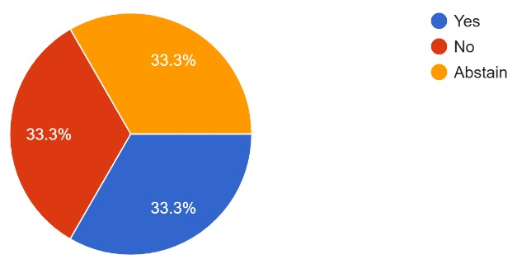

Page 3
Comments:
The RD should vote as they think best with strong weight being given to the World Board Response

Motion 4: To direct the World Board to create a project plan for consideration at WSC2029 to research and explore the opportunities and obstacles of providing book length pieces of literature to the incarcerated, on tablets, in addition to the IPs and audio version of the Fifth Edition Basic Text that already exist on inmate tablets.
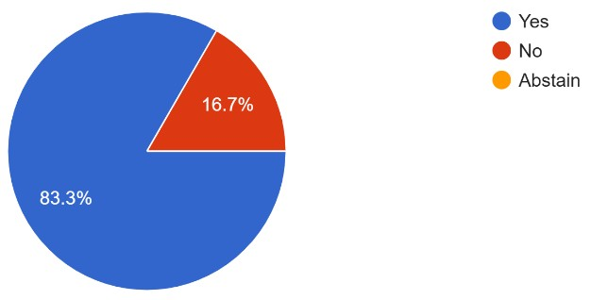

Comments:
We would like to have this information from NAWS/WB as it develops and be able to view the progress with all the obstacles and benefits. And we would like to know the difference between the project the WB is working on and this motion. Where can we find the information and progress the WB has in place at this time. The working document. This is a very hard motion to say 'no' to but we respect the work of NAWS/WB.

Motion 5: To direct the World Board to implement artificial intelligence (AI) interpretation solutions for WSC meetings (both in-person and virtual) to replace the current human live language interpretation.
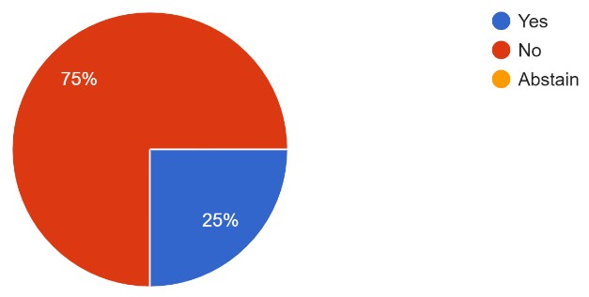

Motion 5-a1: To direct the World Board, to research and then trial simultaneous language interpretation, including AI and other emerging technologies, at some point during the 20262029 conference cycle, as additional(optional) support for Conference Participant webinars. Before any trials, research must include safeguards that protects confidentiality and that ensures data ownership remains private and managed by NA World Services.

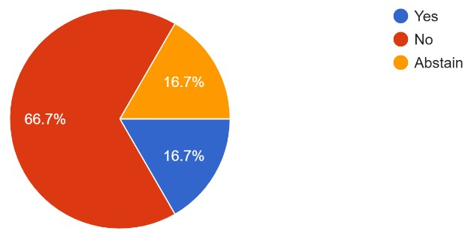

Page 4
Motion 5-a2: To direct the World Board, to do a feasibility study about the use of artificial intelligence (AI)-based language interpretation to support interpreters at Interim World Service Conferences and in-person World Service Conferences held after 2029.
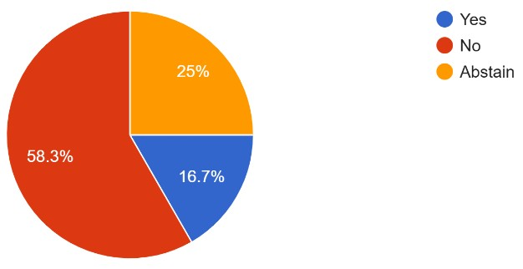

CAT – Conference Approval Track (optional)

Motion 6: To approve the project plan for Fellowship Awareness and Engagement with PR Service.
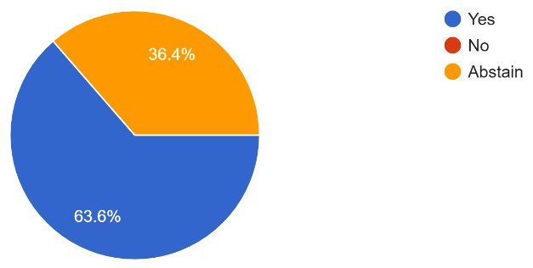

Motion 7: To approve the project plan for Raising Public Awareness of NA.
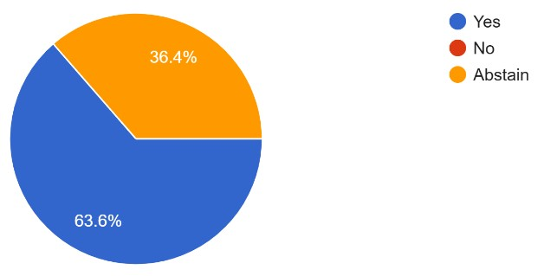
Motion 8: To approve the project plan for New Recovery Informational Pamphlets.
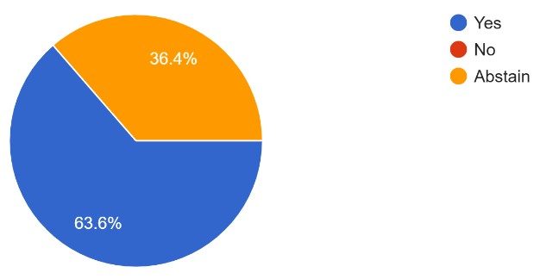

Motion 9: To approve the project plan for Revising Existing Recovery IPs
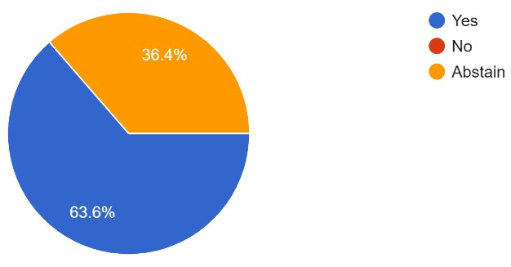

Page 5
Motion 10: To approve the project plan for Issue Discussion Topics (IDTs).
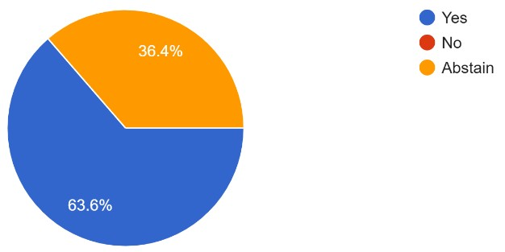

Motion 11: To approve the project plan for New and Revised Service Tools.
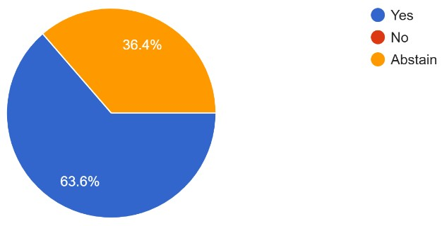
Motion 12: To approve the project plan for Safety and Belonging/Gender-Neutral Language.
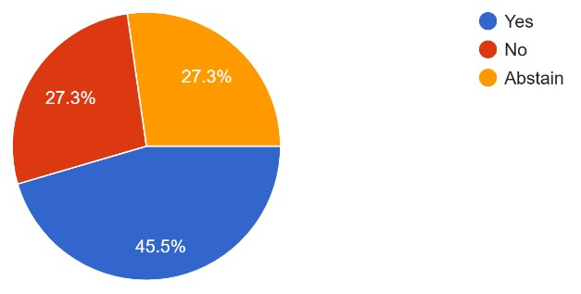

Motion 13: To approve the project plan for DRT/MAT—Helping Members Take Root.
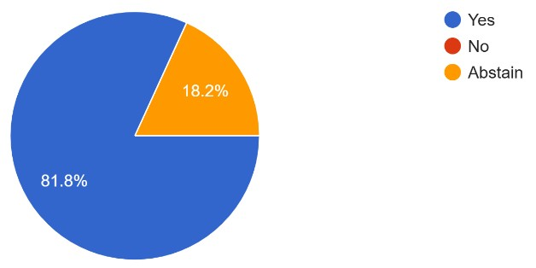

Motion 14: To approve the project plan for Generational and Cultural Diversity.
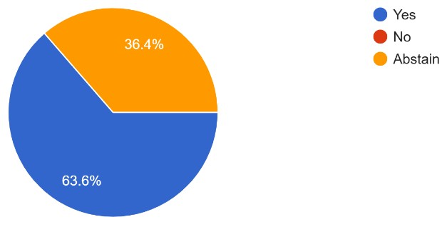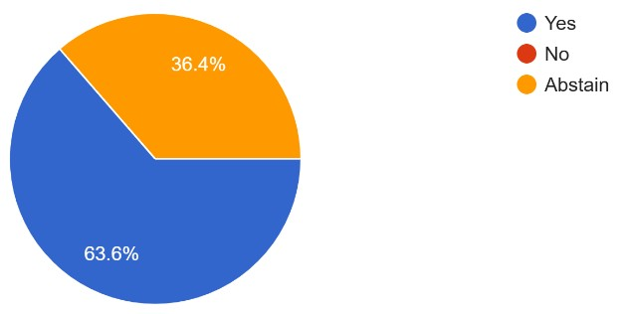 Page 6 Motion 16: To approve the 2026–2029 Narcotics Anonymous World Services, Inc., Budget.

Motion 15:

To approve the project plan for Three
-
Year Conference Cycle.

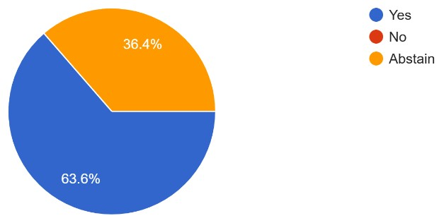

Note: The World Board is not making any recommendations about seating for WSC 2026, but is offering the following two motions to assist the WSC in conference decisions. Please see the WSC Seating Report section of the CAT for further explanation.

Motion 17: To seat Afghanistan Region
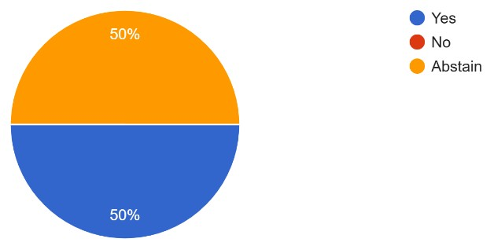

Comments:
RD should vote as they think best

Motion 18: To seat Region 10 Brazil
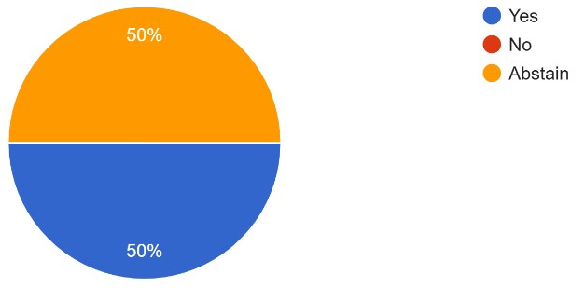

Comments:
RD should vote as they think best

Note: Motions 19 and 20, while CAT motions, will be offered at the beginning of the CARRelated Discussion and Decisions session of the WSC, as is typical of process motions that take effect immediately. That way, if the motions pass, the processes will be in place for decision making throughout the WSC.

Motion 19: To reflect current practice by removing “roll call votes” from GWSNA (pg. 68) beginning WSC 2026.

Roll call vote - Any member can request a roll call vote. Upon recognizing the request, the facilitator will ask the body. If the decision is in support of a roll call vote, the facilitator calls the name of each participant registered at the most recent roll call. When called, the participant responds by stating either “yes,” “no,” “abstain,” or “present and not voting.”
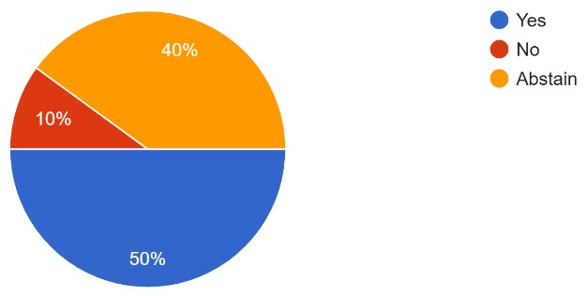 Page 7 Comments:
Roll Call for approval of literature can be a spiritual experience

Motion 20: To add the following language to GWSNA under WSC processes (pg. 67) as an option for reconsidering a decision, beginning WSC 2026:

12. A participant may request a decision to be reconsidered, during the same business session (CAR-related decisions, CAT-related decisions, etc.), provided that the participant was on the side reflected in the final decision and new information has been brought that was not available in the original discussion of the item for decision. The decision to reopen discussion on the item in question is at the discretion of the Co facilitators.
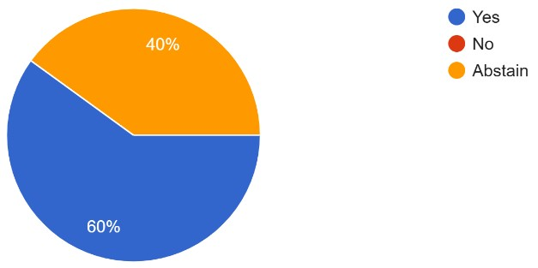

Motion 21: To adopt the 2026–2029 Reimbursement Policy.
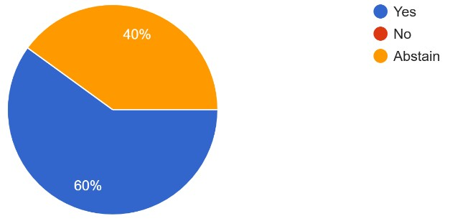

Motion 22: To approve the 2025 Interim World Service Conference minutes.
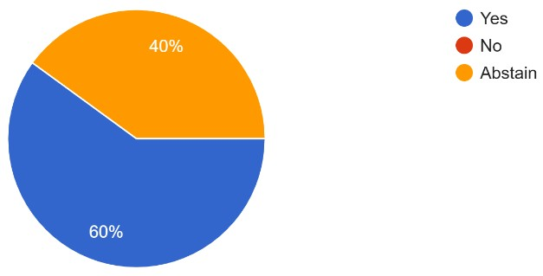

Virtual Events during the World Service Conference
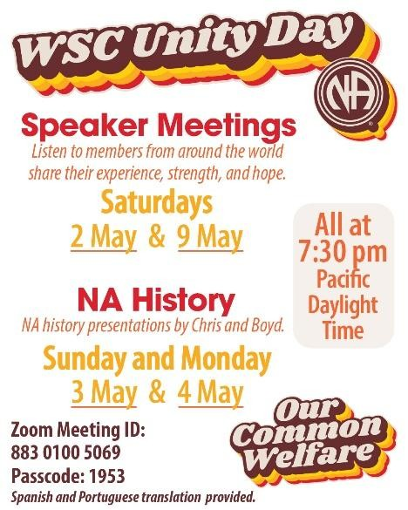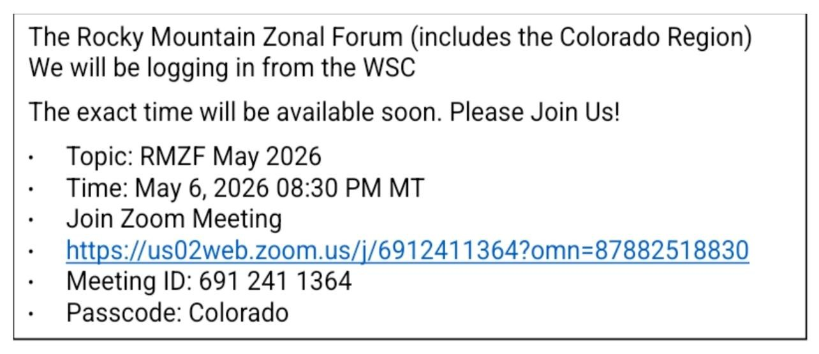

Page 8

