
Colorado Regional Service Committee of NA
P.O. Box 1437 Denver, CO 80201
nacolorado@nacolorado.org

March 22, 2026
- Opening Serenity Prayer -Matt
- 12 Traditions of NA - Maya
- Twelve Concepts for NA Service -Tiffany
- Clean Time Anniversaries: Erica 8 yrs; Steve 39 yrs; Carly 7 yrs
- Welcome New Members; Carly; Victoria; Eric; Josh
- Approval of Last Meeting Minutes - approved
- Agree to Meeting Etiquette: - Matt

  - We affirm that mutual respect and trust is paramount to the effectiveness of all Colorado Regional Service Committee activities.
  - We strive to achieve consensus whenever possible.
  - We will not separate ourselves as individuals from the consensus of the Region and will take responsibility for the decisions of the Colorado Regional Service Committee.
  - We will focus ourselves upon establishing unity, mutual respect, and trust during the meeting.
  - We will meet our stated objectives for each meeting.
  - We agree that only one person will speak at a time, and there will be no sidebar conversations.
  - We affirm that action groups (ad hoc committees) will be used at Regional meetings to identify solutions for goals and issues before the Region.

- Roll Call - All present except Jackson R, Chris F, Russ, Grant, and Nohnie

- Announcements and upcoming events:
FLYERS are attached to the March 23rd email along with the AI Summary
- April Assembly, April 18th, 10:00am (9:30 for GSR/RCM training) at 8085 E. Hampden Ave
  - Final Review of CO CAR/CAT consensus
  - CO Region elections of Chair, Vice Chair, Treasurer and Secretary.
  - We need a Treasure, 5 years clean time. Anyone interested please step up. The Secretary position will also be open.
  - Ratify WRCNA updated guidelines and Archive’s new guidelines
- CAR/CAT – deadlines to participate are approaching
  - na.org/conference is the NAWS link to everything CAR
  - The CO Region tally sheet for the CAR/CAT motions is due on April 17
  - Final discussion and CAR/CAT tally will be at the April 18th Regional Assembly
- The Colorado delegate Team has a table to sell Alternate Merchandise at the WSO conference. They will be leaving May 1 so please contact them at rd@nacolorado.org to arrange pick up of items you want sold.
- CRCNA XL registration/hotel link
- WRCNA Bingo night on April 25th
- MHA Hiking meeting on April 4th, Men’s Spiritual Breakfast on April 11th , Wingding on April 22nd, Memorial Day BBQ on May 25th
- SUNNA has 3 new meetings:
  - Tuesdays, Montrose, 19 S. Park Ave, 6:30 pm
  - Saturday, Montrose, 19 S. Park Ave, 3:00pm
  - Wednesday, Olathe, 115 Main St, 7:00pm

Updates to Record of decision document:
- CRCNA and CRRMCO budgets approved
- New Guidelines for the Archive subcommittee were passed.
- Passed a motion calling for CRSC to support the creation of, and eventual financial support for, the Rocky Mountain Zonal Forum treasure.
- Passed a motion to change the voting procedure to requiring 2/3 majority to pass instead of the current 90% threshold

- To Do List
- CRRMCO to check on the water situation for this year’s campout
- Vice Chair to make some adjustments to the Archives Guidelines
- CNAC Chair to contact Financial Officer to try and have forms at the Assembly to speed up the transfer of the CRSC bank account.
- CRCNA Treasure to add last years actuals to the proposed budget before sending it to the CRSC secretary

- Reports
- Regional Committee Members (RCMs)
    - Boulder Area
RCM 1 – Victoria
The meetings are going well
Our regular game night has been thriving
We are having a pancake breakfast
RCM 2 – Open

    - Bringing Freedom East Area
RCM 1 – Open
RCM 2 – Open

    - Mile High Area
RCM 1 – Beth
Mile High Area RCM Report March 22

Registration for Unity Day has begun, check out UnityDayColorado.com $30 tickets if register before the event, tickets $40 at the door. March 28th 2915 High St 10am-7pm

Men's Spiritual Breakfast will be April 11 at Mile High Church in Lakewood. Tickets will be set aside for newcomers.

The area storage unit got broken into. PA was stolen. They filed a police report with the Treasurer and submitted an insurance claim for $500 for a new one.

There will be a hiking meeting at 9am April 4th in Boulder at Marshall Trail

There’s a speaker event with free chicken wings on April 22 with details in the flier
There will be a Memorial Day BBQ at progress Park from 11-3pm on May 25th. RAW meeting shut down. Meetings that have asked for support: ALOHA, Smells like Clean Spirit, Queer Recovery Now

    - RCM 2 – Carly – gave an oral report, information in above report

    - Mountains West Area
RCM 1 – Open
RCM 2 – Open

    - Off the Wall Area
RCM 1 – Dave A

OTW RCM1 Dave A 03/22/26
OTW had a visit from a former RCM from BFE who brought $20 and a bank money bag with some odd pieces of paper. The phone line is answered occasionally, or so we were told. Do with that info what you will. Two mtgs in Sterling are active and are on the regional mtg list. Various mtgs in the area were visited by a man that has been bothering women by pinching them or asking them to get in his car, etc. He was followed out of at least two mtgs and told he was trespassing at one due to the church’s request. There was lots of yelling in the hall but he has not returned. At a different mtg he was followed into the parking lot and told that he needed to stop bothering women to which he responded by yelling and taking pictures of the member and threatening to post them on social media. He also harassed the members verbally and the Loveland police were called. They arrived and told the troublesome person to leave which he did. The Area donated $300.00 to Region.
    - RCM 2 – Dave L
Dave L reported on changes to meeting formats, added safety language and a general unity among the fellowship to address the problem. Area is updating guidelines regarding money handling procedures and activity planning timelines. We have 34 meetings including a new one in Ft Collins.

    - Pikes Peak Area
RCM E – Beth W
Good morning,

I'm unsure of the amount, but we did donate to region this month.

PR is working on going into more H&I facilities, which will require more commitment from members to volunteer. Activities is working on events in April, May, and June, but final details are not yet available. The Proud to Be Clean meeting will be co-hosting an event in June for Pride month.

We're considering increasing our area prudent reserve to account for increasing costs and additional budget requests. No proposals have been made, but it was highly discussed.

Beth W
PPA RCM-E

    - RCM O – Josh – We have a new LGBTQ meeting “Proud to be Clean”

    - Serenity Unlimited Area
RCM 1 – Daniel A
There are 2 new meetings in Montrose. The Area financially helped a meeting get started in Olathe. There is a men’s BBQ in April. We lowered the Prudent Reserve for the Area. We started phone line training and an Area Inventory.
RCM 2 – Jackson R

  - Regional Committee Administration
Chair – Matt D.
Vice Chair – Bill C
Secretary – Teresa
Treasurer – Angie R.
Opening balance 20,127.15: budget amount 22,790.94: received the CRRMCO donation of $1417.65. Insurance for storage is costing us $5.00/month/unit (x2)
RD – Kathleen L.
Delegate Report for March 22, 2026

2026 World Service Conference and CAR/CAT Tasks:
- Conference Approval Track Area Review
  - Our Delegate team attended all 5 Areas twice with CAR information and initial survey and discussion topic eTally sheet
  - We facilitated the Regional CAR workshop
  - At this time we have 8 groups who have responded to the Survey eTally
  - The CAR/CAT amendments are in and the motions eTally sheet is being edited to reflect these amendments
  - We’ll touch base with the Areas in the next couple of weeks
  - Links to both eTally sheets will be available on the Regional website
  - CAR survey and discussion questions are due March 29, 2026
  - CAR/CAT motions are due April 17, 2026
  - We also facilitated an Area Disruptive and Predatory Behavior workshop
- Annual Reports sent to NAWS & WB
  - Colorado Regional Report
  - RMZF Snapshot
  - Conference Report
  - Each report highlights the strengths of our Regional PR/H&I committees, our 3 Regional events, and our website
- The Initial Straw Poll ePoll is April 18, 2026 – the Delegate Teams will have 72 hours to respond. During the April Assembly noon to 1:30pm
- The 2026 WSC is May 1, 2026 thru May 10, 2026 in Woodland Hills, CA
- We have a table during the NA World Market May 2nd and May 9th and will have previous Regional merchandise available

Conference Agenda Report Links, Surveys, and Videos:
- Conference Agenda Report, Conference Approval Track, Motions List
World Service Conference - Narcotics Anonymous World Services
- Motion 1 – Revising IP 21 Staying Clean in Isolation
Revising IP 21 The Loner – Staying Clean in Isolation - Narcotics Anonymous World Services
- CAR Survey and Discussion Questions
NAWS Projects and Surveys - Narcotics Anonymous World Services
- CAR Workshop Materials and Videos
CAR Workshops - Narcotics Anonymous World Services
- Fellowship Intellectual Property Trust (FIPT)
Fellowship Intellectual Property Trust (FIPT) - Narcotics Anonymous World Services

Other Important Links
- Audio Literature Recordings Introductory Guide and Basic Tex
Basic Text Audio - Narcotics Anonymous World Services
- Service Materials
Service Material - Narcotics Anonymous World Services
- Updated Guide to World Services GWSNA
2023-2026-GWSNA.pdf
- H&I Basics Revision – The 3rd component available for review and input soon
Revising H&I Basics - Narcotics Anonymous World Services
- Share recovery pictures and videos
Please share your NA event photos and videos!

We would like to invite any members interested in being on the Delegate Team to please contact Mike or myself. This would be an Alternate Delegate 2 (AD2) or Delegate In Training (DIT) spot for someone interested in being an AD nominee at the September Assembly. This person can attend the Zonal Forums in May and July and view with the 2026 WSC throughout the week online. This will be in preparation for the upcoming WSC cycle.

ILS,
Kathlee L.
RD Colorado

2026 Delegate Budget

 | Tier 1 | Tier 2 | Tier 3 |  | Approved |  | Actual | Variance
REGIONAL DELEGATE TEAM (RD/RDA)
Miscellaneous Supplies & Expenses | $  50.00 | $ 100.00 | $ 400.00 |  |  |  |  | $
Regional Assembly Travel/Lodging April | $  100.00 | $  100.00 | $  100.00
2026 World Service Conference RD/AD | $  5,200.00 | $  5,200.00 | $  5,200.00
Rocky Mountain Zonal Forum July – RD/AD Travel/Lodging  Hosting Cost | $  700.00 | $  700.00 | $  1500.00 |  |  |  |  | $
September 2026 Assembly Travel/Lodging/Supplies | $  0 | $  100.00 | $  100.00
Rocky Mountain Zonal Forum Dec - RD Travel/Lodging  URMRNA – Cody, WY | $  0 | $  1,000.00 | $  2500.00 |  |  |  |  | $
Regional Delegate Team Total | $  6,200.00 | $  7,200.00 | $  9,800.00 |  |  |  | $ - | $

Expenses as of March 22, 2026 $_0.00_____

We have purchased our plane tickets for the WSC.
I will be submitting an advanced funds request at the Assembly for the WSC.

RDA – Mike H.
RDA Report to CRSCNA Mar 22, 2026
Kathleen and I have participated in and facilitated multiple in person and online CAR / CAT workshops for the Rocky Mountain Zonal Forum (RMZF), the Colorado Region, and the areas in the Colorado Region over the past few months.
Submit your group conscience for our regional tally. There are two forms to fill out for our region. This first is already available and due by March 29th
2026 Survey And Discussion sheet
The second form for the motions and amendments will be available after and is due before April 18th.
Additional NAWS Conference Agenda Report resources
na.org/conference
The 2026 Conference Agenda Report
https://na.org/wp-content/uploads/2025/11/2026-CAR-11-12-25.pdf
Videos and Power Point presentations about the CAR
https://na.org/conference/car-workshops
Individuals and groups can also submit their input on the CAR surveys directly to NAWS at
https://na.org/naws-projects-and-surveys - Open the first section ‘Current Surveys’
Rocky Mountain Zonal Forum
Kathleen and I have begun planning for the July RMZF meeting here in Denver as well as the April Assembly, also here in Denver. We have secured the gymnasium and kitchen at 8085 E Hampden for the Regional Assembly on Saturday Apr 18, 2026 .
The RMZF financial work group has prepared proposed financial policies and a budget for the zone. Primarily the proposed budget would be to cover the website, hosting 2 yearly zonal meetings, and travel and lodging expenses for the two zonal contacts to attend the two yearly zonal meetings. If this proposal is adopted, the delegate team I will request an out of budget expense of about $903 this year. Future yearly contributions we expect to be less than the initial amount. These could be included in future Regional Delegate budgets. Our regional conscience, along with the conscience of the other regions will direct how the zone decides on this at our meeting at the World Service Conference in May. Attached with my report are the proposed treasurer guidelines, proposed zonal budget, and group conscience discussion question. These questions are as follows

RMZF Budget & Treasurer decisions for group conscience discussion Decisions | Options / Questions |  | Group Conscience Notes
Should RMZF have a budget? |  | Yes / No / Limited Trial
Should RMZF have a Treasurer? |  | Yes / No
Annual Budget Cap |  | $
Zonal Contact Travel Support? |  | Yes / No / Capped Amount
Host Zonal Meetings? |  | Yes / No / Partial
Website Reimbursement? |  | Yes / No
Bank Account Structure |  | Independent / Under Region / Other
Rocky Mountain Zonal Forum (RMZF)
Budget Framework & Treasurer Role
Prepared for Group Conscience Consideration
I. Proposal Summary
That the Rocky Mountain Zonal Forum (RMZF):
1. Establish a modest annual budget to support clearly defined shared expenses.
2. Create and elect a Treasurer trusted servant position.
3. Adopt minimal safeguards to ensure responsible financial stewardship.
4. Require transparent reporting at each RMZF meeting.
II. Purpose
The purpose of this structure is to reduce financial barriers to service participation, support the principle of being fully self-supporting, increase transparency, and provide continuity in financial documentation while maintaining the minimal necessary structure aligned with the Twelve Traditions and Twelve Concepts.
III. Budget Scope
The annual budget shall not exceed an amount adopted by group conscience.
The budget may include:
- Zonal Contact travel support (as defined and capped by RMZF).
- Website/domain expenses.
- In person hosting expenses.
- Other shared service expenses approved by RMZF
All expenditures must fall within the adopted annual cap.
IV. Revenue Model
Revenue structure, if any, shall be determined by group conscience. Participation in RMZF is not contingent upon financial contribution.
V. Treasurer Role Description
Purpose:
The Treasurer serves as a trusted servant responsible for the stewardship, tracking, and transparent reporting of RMZF funds.
Authority:
The Treasurer operates only within the authority granted by RMZF group conscience and within the limits of the adopted budget. The Treasurer does not set financial policy.
Core Responsibilities:
- Maintain accurate financial records.
- Receive, safeguard, and disburse funds as directed.
- Provide a written financial report at each RMZF meeting.
- Maintain continuity documents for transition to incoming Treasurer.
VI. Safeguards
If RMZF holds funds, safeguards shall include appropriate financial accountability measures as defined by group conscience. These may include two people with access, spending limits, and required documentation for reimbursement. The Treasurer shall not have unilateral spending authority outside the RMZF approved budget.
VII. Accountability
The Treasurer is directly accountable to the Rocky Mountain Zonal Forum and provides financial reports at each meeting.
VIII. Biennial Review
RMZF shall review the Treasurer role biennially to ensure continued alignment with the RMZF’s primary purpose and service needs.
IX. Implementation
Upon adoption, RMZF will:
1. Determine banking and account structure.
2. Elect a Treasurer.
3. Adopt the first annual budget.
4. Formalize a treasurer’s job description including term length
5. Document adopted decisions in RMZF guidelines.

RMZF Budget & Treasurer Decision Matrix
For Group Conscience Discussion Decision Area | Options / Questions |  | Group Conscience Notes
Should RMZF have a budget? |  | Yes / No / Limited Trial
Should RMZF have a Treasurer? |  | Yes / No
Annual Budget Cap |  | $________
Zonal Contact Travel Support? |  | Yes / No / Capped Amount
Website Reimbursement? |  | Yes / No
Revenue Model |  | Equal / Voluntary / Hybrid / None
Bank Account Structure |  | Independent / Under Region / Other
EIN Needed? |  | Yes / No
Safeguards Required |  | At least two people with access to the account

Proposed Zonal Budget (Draft with 2‑Year Projection)
This draft budget reflects known expenses and preliminary funding concepts for the RMZF. Figures are estimates intended for planning purposes and may be refined as financial processes and roles are established.
Estimated Annual Expenses (Baseline)
Expense Item
Estimated Amount
Zonal Contacts Travel (2 meetings per year, approx. $1,000 per contact per meeting)
$4,000
Domain Registration (5-year cost $105 ≈ $21/year; paid in 2024, not included in first-year budget)
$21 (covered)
In person RMZF hosting (2 meetings): $700/ mtg Total $1400
Estimated First-Year Total Expenses: Approximately $5400
Two‑Year Projected Budget
Category
Year 1 (Estimated)
Year 2 (Estimated)
Travel / Zonal Contacts
$4,000
$4,000
Domain (annualized equivalent)
$21
$21 (approx.)
In person RMZF hosting (2 meetings):
$700/ mtg Total $1400
$700/ mtg Total $1400
Total Estimated Expenses
$5,421
$5,421 (approx.)
Suggested Regional Contributions (6 regions)
$903.50 each
$903.50 each
Current Revenue Streams
At present, no formal revenue streams are established.
Funding Ideas Under Discussion
● Fundraisers coordinated at the zonal or regional level
● Voluntary donations
● Contributions from the six member regions
● If divided equally, approximately $903.50 from each of six regions would cover a $5,421.00 annual budget
● In years when domain registration or other periodic costs occur, a small additional contribution may be needed
Purpose of the Budget Structure
The purpose of this structure is to reduce financial barriers to service participation, strengthen the ability to remain fully self-supporting, increase transparency, and provide continuity in financial documentation while maintaining the minimal necessary structure aligned with the Twelve Traditions and Twelve Concepts.

There was some discussion about money. It would be used for travel, the website and hosting meetings. Currently individual addicts are paying their own way so it’s limiting, however it is available on zoom.
Also, some discussion about the voting, CO guidelines currently call for 90% for approval while WSO uses 2/3.

CNAC
CNAC Report to CRSCNA
March 22, 2026

Since our last meeting, The Colorado Narcotics Anonymous Convention Inc. has reviewed and signed contracts and initiated Certificates of Insurance for the following events:
Unity Day
Sponsor/Sponsee Breakfast
Men’s Spiritual Breakfast
Boulder Bingo
April Regional Assembly

We are in the process of compiling financial data for the Federal Tax Return. We have received information for WRCNA, CRCNA and CRSCNA. We are awaiting data from CRRMCO. We should have that this week and hope to have all the data to our CPA before the Regional Assembly in April.

We submitted a proposal last Region regarding the relationship between CRSCNA and CNAC. Unfortunately, I was not able to attend, but I know there was lively discussion regarding the proposal. I would like to table that discussion and continue it at The Regional Assembly, as to include GSR’s who will be in attendance.

The next CNAC Board Meeting is Saturday April 4th.

In Loving Service,
Steve K
CNAC Chair

  - Regional Subcommittees
PR Chair – Chris F
H&I Chair – Erica
Colorado Regional H&I NA Report – CRSCNA Meeting January 2026

- Open positions: ASSISTANT DOC COORDINATOR & MEN’S WRITING BEHIND THE WALLS COORDINATOR
- Writing behind the walls program – has been slow. We get maybe 1-2 letters a week. Sometimes none.
  - I know the Women’s writing behind the walls program wants her own mail key/mailbox but what would that look like realistically? Changing the address for all the people who already write in?
- We have not used any of our funds for the year but we intend to make an order soon and we will get with Angie. $3500 remains of our literature budget.

PI Chair – Russ
Web Chair – Dave A.
Web Servant Report 03/22/26
Trouble was reported with the phone version of the website. The CRCNA link was missing. I worked with the previous web servant and that was fixed. Please report any issues if you find them. Thanks! I added the CRRMCO 2026 logo and opened up the registration link. Got an updated mtg list from Serenity Unlimited and made those changes. Again, if anyone notices an issue with the regional mtg list let me know. Some duplications were found because of meetings being listed on both hard copies of Serenity Unlimited and Mountains West.

  - Colorado Regional Convention of NA (CRCNA) XL
Chair – Tiffany S –
Met live this month. We still need F&E, P&D and H&H Chairs. However, it is wonderful how everyone else is stepping up to fill those tasks. The Pancake breakfast was a great success, especially the sponsor/sponsee matchup that happened. Merchandise sold a ridiculous amount. The new squares worked wonders. Thanks to great committee.
Vice Chair – Jen
Treasurer – JR
Presented the proposed budget for the year. There was an overall decrease of $480; F&E was down; Merch is up $6000; P&D and H&I are up slightly and Admin remained the same.
Budget was approved with no objections or stand asides.

  - Colorado Regional Rocky Mountain Campout of NA (CRRMCO) XIII
  - Chair – Coy P –
Annual Budget submitted for review
3/21/26
CRRMCO XII Chair Regional Report: Coy P.
Campout Date: June 12-14th 2026 @ Turquoise Lake
Vice Chair: Grant P
Treasurer: Open
Secretary: Open
The committee met on March 8th with 4 in attendance. We selected a logo which needs some small tweaks but will be added to the website once completed. We still need to elect a treasurer.
We have also submitted a budget for approval. Very similar to the prior year budget.

Thank you for letting me serve.

Coy P.
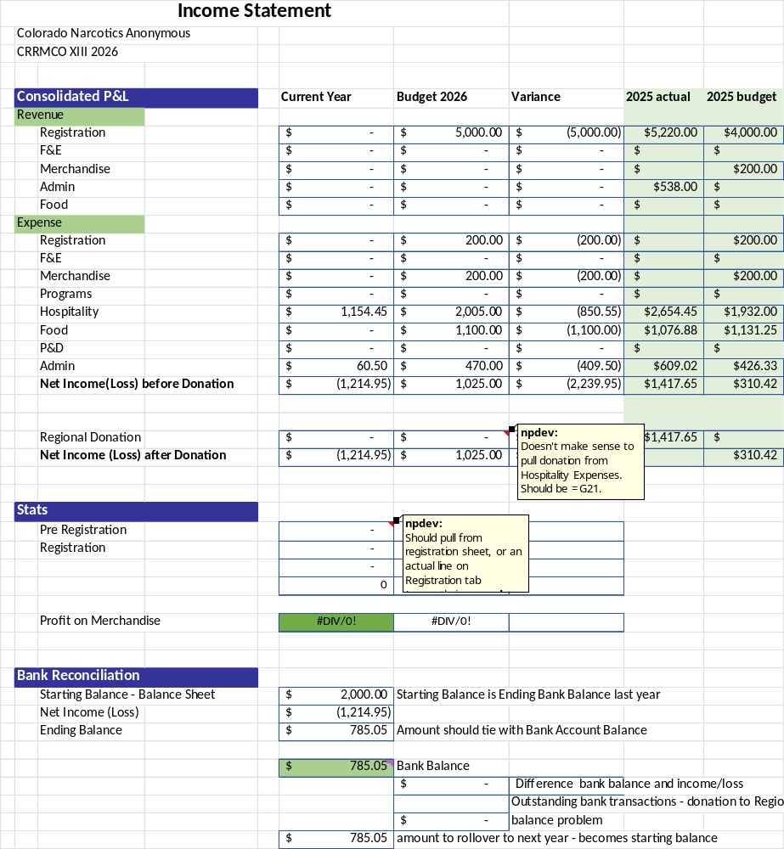

Budget passed with no objections or stand asides. Will check on water availability for this year.

Vice Chair – Grant P
Treasurer – Open

  - Women’s Retreat of Colorado NA (WRCNA) XIII
Chair – Nohnie
Hello!

I had a question about the guidelines for Archives: Does the Vice Chair fill in any vacant positions? Just presenting this thought; is the required clean time for the Dinosaur limiting for the number of members who may be able to participate - in the spirit of rotation? AND... Great work on these, they are AWESOME!

Here's my March Report:
WRCNA Kick off Fundraiser, the Spaghetti Dinner was a huge success. Huge shoutout to all of the folks who came out to support this event!
Upcoming dates and events for WRCNA F&E are: Bingo (Mile High) [date] @ 5p - 8p, BBQ (Pikes Peak) 6/20 @ 1p - 4p, Poker (Mile High) 7/18 @ 4:30p - 8pm. We will have fliers for these as they get a little closer and will announce specific locations and get on the Regional calendar.
We have made a lot of adjustments to the Square in order to create reports and track finances.
The Speaker Submission deadline has been extended until April 15th. Speakers will be selected at Programs meeting in May
Registration and Scholarship applications are open and live on the website.
The Merchandise Webstore is set to open in the next couple of weeks!
WRCNA is at the Pancake Breakfast and will be at Unity Day.

Thanks for allowing me to be of service!
See you at the Assembly!

In loving service,
Nohnie A
WRCNA XIII - Chair

Vice Chair – Maya
Treasurer – Karen
Hello,
So far we have collected $4,504.00 for Registration.
For the Spaghetti Event we spent $297.98 on supplies, Venue Rental & 50/50 chance to win.
We have made our deposit for our retreat $1,500.00.
I have also included my last back statement if needed.

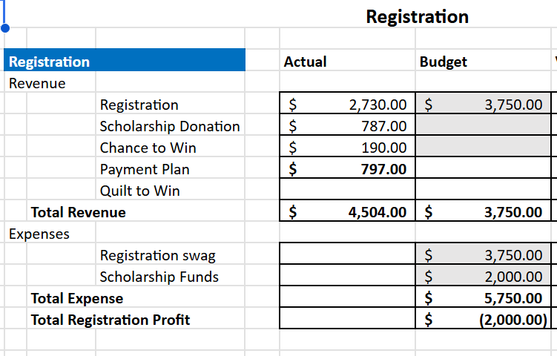

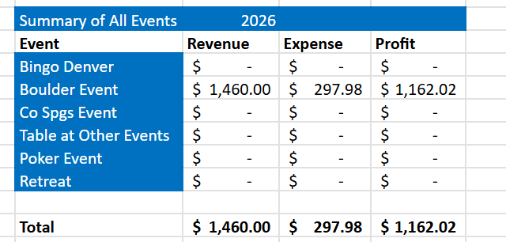

- Old Business
  - Adhoc committee for guideline changes
    - Archives
The Vice Chair presented the proposed guidelines for the new Archives subcommittee. Discussions included the clean time requirement for the Dinosaur position, how are request for displays handled, how are positions filled, and how do they coordinate with CRCNA guidelines. All these issues were determined to be addressed in the guidelines. The following items were added/modified: clarified voting members, clarified Vice Chair responsibilities, and added a section to ensure the subcommittee meets other subcommittee deadlines for displays.
It was mentioned it could be beneficial for an Archives representatives to go on hotel walk through with CRCNA.
Guidelines passed with no stand asides or objections.
The final Guidelines are at the bottom of these minutes
  - Digital storage
  - Elections – Open Positions – no nominations
  - PO Box – Does H&I need their own PO Box or should we get extra keys – Noone appeared to support them having their own PO Box, the key was left in the air, decided to continue as is for now.

- New Business/Proposals
  - CRSCNA amendment to current guidelines
  - Motion from Mike (RDA to change CRSC voting to be in line with the WSO and our own elections threshold. The guidelines are to be changed to reflect a 2/3 majority to pass instead of 90%.
  - The motion passed with no objections or stand asides

  - Motion from Mike (RDA) regarding support for Rocky Mountain Zonal Forum (RMZF). See his report for several supporting documents. He gave a history of financing the RMZF and how this will make it more in line with traditional NA funding


CRSC PROPOSAL FORM

Date: 3/22/2026

Proposal: The Colorado Region will express support for the creation of a Zonal Treasurer
and a Zonal Budget as described in the attached documents. Total initial financial commitment would be $903 from the

Colorado Region to be accounted for as an out of budget expense of the delegate team. In future years this expense would

be expected to be lower and should be accounted for as a planned budgeted expense.

Intent:
The purpose of this structure is to reduce financial barriers to service participation, support the principle of being fully

self-supporting, increase transparency, and provide continuity in financial documentation while maintaining the minimal

necessary structure aligned with the Twelve Traditions and Twelve Concepts

Maker: _{Mike H - Alternate Delegate}

Tradition, concept or spiritual principle on which it is based:

Disposition:
Consensus Yes X |  | No
Blocked Yes |  | No
Blocked based on:
Motion was passed with no objections or stand asides

CRSCNA – PO BOX 1437 – Denver CO 80201 email: nacolorado@nacolorado.org

- Open Forum

- Closing Treasurer Report
- Closing balance $21,135 leaving us $2,313 short of our proposed budget.

CRSCNA 2026 Budget Approved
Tier Year
 | Tier 1 | Tier 2 | Tier 3 |  |  | APPROVED Tier 2 |  | Actual | Variance
ADMINISTRATION (ADM)
Administration Contingency Fund | ($ 100.00) | ($ 100.00) | ($ 100.00) |  | ($ | 100.00) |  | ($ - ) | ($ 100.00)
Bank Fees | ($ 100.00) | ($ 100.00) | ($ 100.00) |  | ($ | 100.00) |  | ($ 8.00) | ($ 92.00)
Regional Assembly Expenses | ($ 1,000.00) | ($ 1,000.00) | ($ 1,000.00) |  | ($ | 1,000.00) |  | ($ - ) | ($ 1,000.00)
Regional Post Office Box Rental (2026) | ($ 340.00) | ($ 340.00) | ($ 340.00) |  | ($ | 340.00) |  | ($ 332.00) | ($ 8.00)
Regional Storage Shed Rental (2026) Unit 2130 | ($ 2,700.00) | ($ 2,700.00) | ($ 2,700.00) |  | ($ | 2,700.00) |  | ($ 675.00) | ($ 2,025.00)
Regional Storage Shed Rental #2 (2026) Unit 2128 | ($ 1,524.00) | ($ 1,524.00) | ($ 1,524.00) |  | ($ | 1,524.00) |  | ($ 423.00) | ($ 1,101.00)
TrackFone | ($ 125.00) | ($ 125.00) | ($ 125.00) |  | ($ | 125.00) |  |  | ($ 125.00)
Liability Insurance (Due in January) | ($ 1,600.00) | ($ 1,600.00) | ($ 1,600.00) |  | ($ | 1,600.00) |  | ($ 1,468.00) | ($ 132.00)
Administration Total | ($ 7,489.00) | ($ 7,489.00) | ($ 7,489.00) |  | ($ | 7,489.00) |  | ($ 2,906.00) | ($ 4,583.00)
REGIONAL DELEGATE TEAM (RD/RDA)
Miscellaneous Supplies & Expenses | ($ 50.00) | ($ 100.00) | ($ 400.00) |  | ($ | 100.00) |  | ($ - ) | ($ 100.00)
Regional Assembly Travel/Lodging April | ($ 100.00) | ($ 100.00) | ($ 100.00) |  | ($ | 100.00) |  | ($ - ) | ($ 100.00)
2026 World Service Conference RD/AD | ($ 5,200.00) | ($ 5,200.00) | ($ 5,200.00) |  | ($ | 5,200.00) |  | ($ 308.80) | ($ 4,891.20)
RMZF July - RD/AD Travel/Lodging Hosting Cost | ($ 700.00) | ($ 700.00) | ($ 1,500.00) |  | ($ | 700.00) |  | ($ - ) | ($ 700.00)
Sept 2026 Assembly Travel/Lodging/Supplies | ($ - ) | ($ 100.00) | ($ 100.00) |  | ($ | 100.00) |  | ($ - ) | ($ 100.00)
RMZF Dec - RD Travel/Lodging URMRNA – Cody, WY | ($ - ) | ($ 1,000.00) | ($ 2,500.00) |  | ($ | 1,000.00) |  | ($ - ) | ($ 1,000.00)
Regional Delegate Team Total | ($ 6,050.00) | ($ 7,200.00) | ($ 9,800.00) |  | ($ | 7,200.00) |  | ($ 308.80) | ($ 6,891.20)
CNAC
Accountant | ($ 1,300.00) | ($ 1,300.00) | ($ 1,300.00) |  | ($ | 1,300.00) |  | ($ - ) | ($ 1,300.00)
Attorney | ($ 500.00) | ($ 500.00) | ($ 500.00) |  | ($ | 500.00) |  |  | ($ 500.00)
Copies & Miscellaneous | ($ 100.00) | ($ 100.00) | ($ 100.00) |  | ($ | 100.00) |  |  | ($ 100.00)
CNAC Total | ($ 1,900.00) | ($ 1,900.00) | ($ 1,900.00) |  | ($ | 1,900.00) |  | ($ - ) | ($ 1,900.00)
PR ADMIN
Print / Literature | ($ 1,000.00) | ($ 1,000.00) | ($ 1,000.00) |  | ($ | 1,000.00) |  |  | ($ 1,000.00)
Travel - Either PR Admin or H&I Chair | ($ - ) | ($ - ) | ($ 1,000.00) |  | ($ | - ) |  |  | ($ - )
PR ADMIN TOTAL | ($ 1,000.00) | ($ 1,000.00) | ($ 2,000.00) |  | ($ | 1,000.00) |  | ($ - ) | ($ 1,000.00)
H&I SUBCOMMITTEE
DVDs/Tech | ($ 500.00) | ($ 500.00) | ($ 500.00) |  | ($ | 500.00) |  | ($ - ) | ($ 500.00)
Travel for WSLD - Two Members | ($ - ) | ($ 1,300.00) | ($ 1,300.00) |  | ($ | 1,300.00) |  | ($ - ) | ($ 1,300.00)
DOC Literature | ($ 2,500.00) | ($ 3,500.00) | ($ 4,000.00) |  | ($ | 3,500.00) |  | 0 | ($ 3,500.00)
Inmate Writing Program / Outlying Areas | ($ 400.00) | ($ 500.00) | ($ 600.00) |  | ($ | 500.00) |  | ($ - ) | ($ 500.00)
H&I SUBCOMMITTEE TOTAL | ($ 3,400.00) | ($ 5,800.00) | ($ 6,400.00) |  | ($ | 5,800.00) |  | ($ - ) | ($ 5,800.00)
WEB SUBCOMMITTEE
Technolgy (e.g. Zoom Accounts) | ($ 1,000.00) | ($ 1,000.00) | ($ 1,000.00) |  | ($ | 1,000.00) |  | ($ - ) | ($ 1,000.00)
Domain Fees | ($ 450.00) | ($ 450.00) | ($ 450.00) |  | ($ | 450.00) |  | ($ - ) | ($ 450.00)
WEB SUBCOMMITTEE TOTAL | ($ 1,450.00) | ($ 1,450.00) | ($ 1,450.00) |  | ($ | 1,450.00) |  | ($ - ) | ($ 1,450.00)
PI SUBCOMMITTEE
Travel | ($ 600.00) | ($ 800.00) | ($ 1,000.00) |  | ($ | 800.00) |  | ($ - ) | ($ 800.00)
Literature/Printing | ($ 500.00) | ($ 625.00) | ($ 750.00) |  | ($ | 625.00) |  | ($ - ) | ($ 625.00)
Mailings | ($ 300.00) | ($ 400.00) | ($ 500.00) |  | ($ | 400.00) |  | ($ - ) | ($ 400.00)
PI SUBCOMMITTEE TOTAL | ($ 1,400.00) | ($ 1,825.00) | ($ 2,250.00) |  | ($ | 1,825.00) |  | ($ - ) | ($ 1,825.00)
PR ADMIN TOTAL | ($ 1,000.00) | ($ 1,000.00) | ($ 2,000.00) |  | ($ | 1,000.00) |  | ($ - ) | ($ 1,000.00)
H&I TOTAL | ($ 3,400.00) | ($ 5,800.00) | ($ 6,400.00) |  | ($ | 5,800.00) |  | ($ - ) | ($ 5,800.00)
WEB TOTAL | ($ 1,450.00) | ($ 1,450.00) | ($ 1,450.00) |  | ($ | 1,450.00) |  | ($ - ) | ($ 1,450.00)
PI SUBCOMMITTEE TOTAL | ($ 1,400.00) | ($ 1,825.00) | ($ 2,250.00) |  | ($ | 1,825.00) |  | ($ - ) | ($ 1,825.00)
PR SUBCOMMITTEE COMBINED TOTAL | ($ 7,250.00) | ($ 10,075.00) | ($ 12,100.00) |  | ($ | 10,075.00) |  | ($ - ) | ($ 10,075.00)
GRAND TOTAL | ($ 24,089.00) | ($ 26,664.00) | ($ 33,539.00) | ($ | ($ | 26,664.00) | ($ | ($ 3,214.80) | ($ 23,449.20)
Non-Budgeted Items |  |  | Approval Date |  | Approved Amount |  |  | Actual | Variance
CRCNA Donation to WSO Per Guidelines |  |  |  |  |  |  |  | ($ 1,008.67) | ($ - )
Total Non-Budgeted |  |  |  |  | ($ - ) |  |  | ($ 1,008.67) | ($ - )
 |  |  | Grand Total |  | ($ 26,664.00) |  |  | ($ 4,223.47) | ($ 23,449.20)

CRSCNA 2026 Budget Approved
Tier Year
 | Tier 1 | Tier 2 | Tier 3 |  |  | APPROVED Tier 2 |  | Actual | Variance
ADMINISTRATION (ADM)
Administration Contingency Fund | ($ 100.00) | ($ 100.00) | ($ 100.00) |  | ($ | 100.00) |  | ($ - ) | ($ 100.00)
Bank Fees | ($ 100.00) | ($ 100.00) | ($ 100.00) |  | ($ | 100.00) |  | ($ 8.00) | ($ 92.00)
Regional Assembly Expenses | ($ 1,000.00) | ($ 1,000.00) | ($ 1,000.00) |  | ($ | 1,000.00) |  | ($ - ) | ($ 1,000.00)
Regional Post Office Box Rental (2026) | ($ 340.00) | ($ 340.00) | ($ 340.00) |  | ($ | 340.00) |  | ($ 332.00) | ($ 8.00)
Regional Storage Shed Rental (2026) Unit 2130 | ($ 2,700.00) | ($ 2,700.00) | ($ 2,700.00) |  | ($ | 2,700.00) |  | ($ 675.00) | ($ 2,025.00)
Regional Storage Shed Rental #2 (2026) Unit 2128 | ($ 1,524.00) | ($ 1,524.00) | ($ 1,524.00) |  | ($ | 1,524.00) |  | ($ 423.00) | ($ 1,101.00)
TrackFone | ($ 125.00) | ($ 125.00) | ($ 125.00) |  | ($ | 125.00) |  |  | ($ 125.00)
Liability Insurance (Due in January) | ($ 1,600.00) | ($ 1,600.00) | ($ 1,600.00) |  | ($ | 1,600.00) |  | ($ 1,468.00) | ($ 132.00)
Administration Total | ($ 7,489.00) | ($ 7,489.00) | ($ 7,489.00) |  | ($ | 7,489.00) |  | ($ 2,906.00) | ($ 4,583.00)
REGIONAL DELEGATE TEAM (RD/RDA)
Miscellaneous Supplies & Expenses | ($ 50.00) | ($ 100.00) | ($ 400.00) |  | ($ | 100.00) |  | ($ - ) | ($ 100.00)
Regional Assembly Travel/Lodging April | ($ 100.00) | ($ 100.00) | ($ 100.00) |  | ($ | 100.00) |  | ($ - ) | ($ 100.00)
2026 World Service Conference RD/AD | ($ 5,200.00) | ($ 5,200.00) | ($ 5,200.00) |  | ($ | 5,200.00) |  | ($ 308.80) | ($ 4,891.20)
RMZF July - RD/AD Travel/Lodging Hosting Cost | ($ 700.00) | ($ 700.00) | ($ 1,500.00) |  | ($ | 700.00) |  | ($ - ) | ($ 700.00)
Sept 2026 Assembly Travel/Lodging/Supplies | ($ - ) | ($ 100.00) | ($ 100.00) |  | ($ | 100.00) |  | ($ - ) | ($ 100.00)
RMZF Dec - RD Travel/Lodging URMRNA – Cody, WY | ($ - ) | ($ 1,000.00) | ($ 2,500.00) |  | ($ | 1,000.00) |  | ($ - ) | ($ 1,000.00)
Regional Delegate Team Total | ($ 6,050.00) | ($ 7,200.00) | ($ 9,800.00) |  | ($ | 7,200.00) |  | ($ 308.80) | ($ 6,891.20)
CNAC
Accountant | ($ 1,300.00) | ($ 1,300.00) | ($ 1,300.00) |  | ($ | 1,300.00) |  | ($ - ) | ($ 1,300.00)
Attorney | ($ 500.00) | ($ 500.00) | ($ 500.00) |  | ($ | 500.00) |  |  | ($ 500.00)
Copies & Miscellaneous | ($ 100.00) | ($ 100.00) | ($ 100.00) |  | ($ | 100.00) |  |  | ($ 100.00)
CNAC Total | ($ 1,900.00) | ($ 1,900.00) | ($ 1,900.00) |  | ($ | 1,900.00) |  | ($ - ) | ($ 1,900.00)
PR ADMIN
Print / Literature | ($ 1,000.00) | ($ 1,000.00) | ($ 1,000.00) |  | ($ | 1,000.00) |  |  | ($ 1,000.00)
Travel - Either PR Admin or H&I Chair | ($ - ) | ($ - ) | ($ 1,000.00) |  | ($ | - ) |  |  | ($ - )
PR ADMIN TOTAL | ($ 1,000.00) | ($ 1,000.00) | ($ 2,000.00) |  | ($ | 1,000.00) |  | ($ - ) | ($ 1,000.00)
H&I SUBCOMMITTEE
DVDs/Tech | ($ 500.00) | ($ 500.00) | ($ 500.00) |  | ($ | 500.00) |  | ($ - ) | ($ 500.00)
Travel for WSLD - Two Members | ($ - ) | ($ 1,300.00) | ($ 1,300.00) |  | ($ | 1,300.00) |  | ($ - ) | ($ 1,300.00)
DOC Literature | ($ 2,500.00) | ($ 3,500.00) | ($ 4,000.00) |  | ($ | 3,500.00) |  | 0 | ($ 3,500.00)
Inmate Writing Program / Outlying Areas | ($ 400.00) | ($ 500.00) | ($ 600.00) |  | ($ | 500.00) |  | ($ - ) | ($ 500.00)
H&I SUBCOMMITTEE TOTAL | ($ 3,400.00) | ($ 5,800.00) | ($ 6,400.00) |  | ($ | 5,800.00) |  | ($ - ) | ($ 5,800.00)
WEB SUBCOMMITTEE
Technolgy (e.g. Zoom Accounts) | ($ 1,000.00) | ($ 1,000.00) | ($ 1,000.00) |  | ($ | 1,000.00) |  | ($ - ) | ($ 1,000.00)
Domain Fees | ($ 450.00) | ($ 450.00) | ($ 450.00) |  | ($ | 450.00) |  | ($ - ) | ($ 450.00)
WEB SUBCOMMITTEE TOTAL | ($ 1,450.00) | ($ 1,450.00) | ($ 1,450.00) |  | ($ | 1,450.00) |  | ($ - ) | ($ 1,450.00)
PI SUBCOMMITTEE
Travel | ($ 600.00) | ($ 800.00) | ($ 1,000.00) |  | ($ | 800.00) |  | ($ - ) | ($ 800.00)
Literature/Printing | ($ 500.00) | ($ 625.00) | ($ 750.00) |  | ($ | 625.00) |  | ($ - ) | ($ 625.00)
Mailings | ($ 300.00) | ($ 400.00) | ($ 500.00) |  | ($ | 400.00) |  | ($ - ) | ($ 400.00)
PI SUBCOMMITTEE TOTAL | ($ 1,400.00) | ($ 1,825.00) | ($ 2,250.00) |  | ($ | 1,825.00) |  | ($ - ) | ($ 1,825.00)
PR ADMIN TOTAL | ($ 1,000.00) | ($ 1,000.00) | ($ 2,000.00) |  | ($ | 1,000.00) |  | ($ - ) | ($ 1,000.00)
H&I TOTAL | ($ 3,400.00) | ($ 5,800.00) | ($ 6,400.00) |  | ($ | 5,800.00) |  | ($ - ) | ($ 5,800.00)
WEB TOTAL | ($ 1,450.00) | ($ 1,450.00) | ($ 1,450.00) |  | ($ | 1,450.00) |  | ($ - ) | ($ 1,450.00)
PI SUBCOMMITTEE TOTAL | ($ 1,400.00) | ($ 1,825.00) | ($ 2,250.00) |  | ($ | 1,825.00) |  | ($ - ) | ($ 1,825.00)
PR SUBCOMMITTEE COMBINED TOTAL | ($ 7,250.00) | ($ 10,075.00) | ($ 12,100.00) |  | ($ | 10,075.00) |  | ($ - ) | ($ 10,075.00)
GRAND TOTAL | ($ 24,089.00) | ($ 26,664.00) | ($ 33,539.00) | ($ | ($ | 26,664.00) | ($ | ($ 3,214.80) | ($ 23,449.20)
Non-Budgeted Items |  |  | Approval Date |  | Approved Amount |  |  | Actual | Variance
CRCNA Donation to WSO Per Guidelines |  |  |  |  |  |  |  | ($ 1,008.67) | ($ - )
Total Non-Budgeted |  |  |  |  | ($ - ) |  |  | ($ 1,008.67) | ($ - )
 |  |  | Grand Total |  | ($ 26,664.00) |  |  | ($ 4,223.47) | ($ 23,449.20)

- 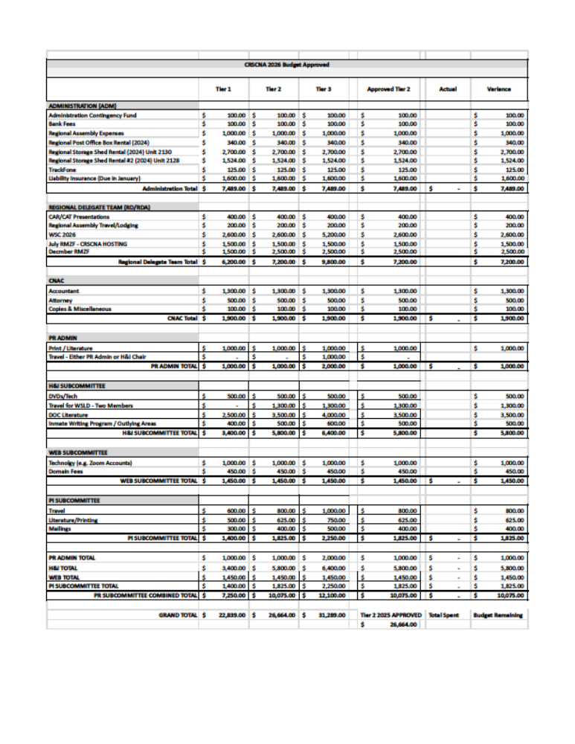

************** **************

COLORADO REGIONAL SERVICE COMMITTEE OF NARCOTICS ANONYMOUS



Archive and Historical Display Subcommittee Guidelines

[Proposed] March 26, 2026

ARTICLE I: Name
Section 1.
The name of this committee shall be the Archive and Historical Display Subcommittee (“Archive Subcommittee”) of the Colorado Regional Service Committee of Narcotics Anonymous (CRSCNA).

Section 2.
The Archive Subcommittee is a standing subcommittee of CRSCNA.

ARTICLE II: Purpose
Section 1.
The purpose of the Archive Subcommittee is to collect, collate, categorize, and make ready for display historical materials relevant to the Colorado Region of NA, the Colorado Regional Convention of NA (CRCNA), the various Areas of the Colorado Region, and the World Service Organization (WSO).

ARTICLE III: Spiritual Guidance
Section 1.
The Archives Subcommittee shall be guided by, and shall not make any proposal or take any action that conflicts with, the Twelve Traditions or the Twelve Concepts of NA Service.

Section 2.
The Archives Subcommittee shall comply in all its actions with the following documents:
- CRSCNA Guidelines
- These Archive Subcommittee Guidelines

ARTICLE IV: Function of the Subcommittee
Section 1. Core Responsibilities
- Maintains in an orderly fashion the Colorado Regional Archive Collection (“Archives”) at a separate and dedicated storage unit per the CRSNA Guidelines (the “Archive Subcommittee Storage Unit”) ;
- Maintains a written inventory of archived historical items;
- The Archive Subcommittee will review requests for display of the Archives (or portions of) at events and will commit to specific events (“designated events”) at the Subcommittee’s discretion.
- Maintains written instructions for hardware construction and display setup at designated events;
- Sufficiently instructs members of the Archive Subcommittee to create, build, maintain, and set up displays and related hardware for the safe and effective display of the Archives at designated events.
- The Archives Subcommittee meets at least quarterly;
- Arranges and coordinates the transport of the Archive materials to and from the Archive Subcommittee Storage Unit for display at designated events;
- Coordinates with CRCNA Subcommittee and CRCNA trusted servants for display of the Archives at CRCNA events, including meeting CRCNA timelines;
  - Must make contact with CRCNA Subcommittee within their first three regular CRCNA meetings for each annual cycle;
  - Coordinates with CRCNA Subcommittee to contact hotel/venue staff and ask for space, tables, and other needs for display of the Archives.
- Coordinates with trusted servants for display at any other designated events;
- Monitors the Archives display during CRCNA or other designated events;
- Regularly requests donations of relevant historical materials from the NA fellowship at large;
- Submits a proposal or budget to CRSCNA for estimated expenses associated with transport or display of Archive materials at designated events, and provides receipts for funds spent to the CRSCNA Treasurer at the next regular CRSNA meeting after the designated event has occurred.
ARTICLE V: Subcommittee Membership
Section 1.
Membership on the Administrative Committee of the Archive Subcommittee of CRSCNA shall consist of:

- Chairperson
- Vice Chairperson
- Secretary
- Dinosaur-Advisor
- Instructor-Fabricator

ARTICLE VI: Qualifications and Responsibilities of Subcommittee Members
Chairperson
- Is nominated and elected at the Regional Assembly in April of every odd-numbered year;
- Is elected for a two-year term for a maximum of two (2) consecutive terms;
- Suggested five (5) years uninterrupted clean time;
- Should have prior Archives Subcommittee service experience;
- Must express a willingness to serve;
- Facilitates all meetings of the Archive Subcommittee with a general understanding of parliamentary procedure and consensus-based decision-making as is defined on the NA.org website;
- Holds a key to the Archive Subcommittee Storage Locker or the code to the lockbox;
- Prepares a report for each CRSCNA meeting and makes all proposals on behalf of the Archive Subcommittee;
- Prepares a budget with the Subcommittee to be submitted in July for approval by the CRSCNA for the upcoming year, according to CRSCA Guidelines;
- If necessary, may be removed by the CRSCNA as outlined in the regional guidelines.

Vice Chairperson
- Is nominated and elected by members of the Archive Subcommittee;
- Is elected for a two-year term for a maximum of two (2) consecutive terms;
- Suggested three (3) years of uninterrupted clean time;
- Should have prior Archive Subcommittee service experience
- In the absence of the Archive Subcommittee Chairperson: (i) fulfils all responsibilities of the Chairperson; and (ii) attends all meetings of the CRSCNA. If directed, will all submit proposals on behalf of the Archive Subcommittee.
- Collaborates with the Chairperson to ensure the smooth operation of the Archive Subcommittee;
- Assume the duties of the Chairperson in the absence of the Chairperson;
- Fill in for and assume the responsibilities of any vacant Administrative Committee positions.

Secretary
- Is nominated and elected by members of the Archive Subcommittee;
- Suggested three (3) years of uninterrupted clean time;
- Works with the Chairperson to prepare a budget to be submitted in July for approval by the CRSCNA, and manages and accounts for any funds allocated by CRSCNA to the Archive Subcommittee.
- Maintains an inventory of items in the Archive, including any excess items as defined in Article VII;
- Prepares and makes available minutes of each Archive Subcommittee meeting.

Dinosaur-Advisor
- Is nominated and elected by the members of the Archive Subcommittee;
- Suggested twenty (20) years of uninterrupted clean time;
- Should have prior Archives Subcommittee Service experience;
- Advises the Archive Subcommittee regarding historical significance, importance and relevance of Archive material and suggested additions to the Archives pursuant to Article VII of these guidelines;

Instructor-Fabricator
- Is nominated and elected by the members of the Archive Subcommittee;
- Suggested two (2) years of uninterrupted clean time;
- Should have prior experience with building and setting up archives displays or similar construction experience;
- Maintains written instructions for hardware construction and display setup at designated events;
- Sufficiently instructs members of the Archive Subcommittee to create, build, maintain, and set up displays and related hardware for the safe and effective display of the Archives at designated events;

ARTICLE VII: Addition and Removal of Items from the Archives
Section 1.
Process for addition of items to the Archive:
- Items will be included in the Archives at the discretion of the Archive Subcommittee, and the Subcommittee will determine the historical significance of such items. Any disagreement regarding inclusion of an item or items shall be resolved by consensus in accordance with CRSCNA Guidelines;
- Items may be donated to the Archives; provided, however, that any items donated shall become property of the Archives and the Archive Subcommittee shall clearly communicate to potential donors regarding same; all donations to the Archives shall be unconditional;
- Where there are more than two (2) duplicates of a single item, any “excess item” (the third or more of the same item) may, at the discretion of the Archive Subcommittee, be donated to CRSCNA or any subcommittee thereof, to be auctioned and the resulting funds dedicated to support the specific CRSCNA subcommittee or the CRSCNA service structure.
Section 2.
Process for removal of items from the Archive:
- Items may be removed from the Archive at the discretion of the Archive Subcommittee, and the Subcommittee will make a determination the historical significance, or lack thereof, of such items. Any disagreement regarding removal of an item or items shall be resolved by consensus in accordance with CRSCNA Guidelines;
- Items removed from the Archive may be delivered back to the care and control of CRSCNA, with approval from CRSCNA, and stored in the regular CRSCNA storage locker, or may be offered to the fellowship, donated, auctioned, or destroyed. Provided, however, no items shall be destroyed except upon approval by the CRSCNA of a proposal to destroy such items;
- Notwithstanding anything to the contrary herein, the Archive Subcommittee shall obtain approval from CRSCNA before disposing of any business records (including but not limited to minutes, budgets, contracts, and bank records) of the CRSCNA.

ARTICLE VIII: Attendance and Reporting
Section 1.
Attendance at Archive Subcommittee meetings will be on site and/or virtual and as outlined in Article IV, Section 9.

ARTICLE IX: Voting
Section 1.
Voting members of the Archive Subcommittee shall be the the members of the Administrative Committee and any NA member after attendance for at least two (2) consecutive Archive Subcommittee meetings.

Section 2.
Voting members lose their vote upon absence without notice from two (2) or more consecutive Archive Subcommittee meetings. Voting privileges will be reinstated after attendance at two (2) consecutive Archive Subcommittee meetings.

Section 3.
The Archive Subcommittee Chairperson only has a vote in the case of a tie.

ARTICLE X: Elections
Section 1.
Any voting member of the Archive Subcommittee may nominate a qualified individual for an Archive Subcommittee position;

Section 2.
A simple majority is required for positions elected by the Archive Subcomittee;

Section 3.
Nominees will state qualifications, answer questions from the Subcommittee, and leave the room or virtual meeting for the Subcommittee to vote by a show of hands. Note- no further discussion will be made once the nominated person has left the room.

Section 4.
Any member may be removed from their position for non-compliance. Two thirds (2/3) majority of voting members present are required for removal. Non-compliance includes, but is not limited to: (i) Interruption of clean time; or (ii) Continual non-performance of their position.

Section 5.
No member shall hold more than one Archive Subcommittee position at a time, and no member shall be eligible to serve more than two consecutive terms in the same member position.

Section 6.
In case of mid-year removal or resignation of an Archive Subcommittee member, other than the Subcommittee Chairperson, a member who meets the qualifications shall be appointed by the Archive Subcommittee Chairperson at the time of removal or resignation. Elections to fill the open position will be held at the next Archive Subcommittee meeting. In the event of the removal or resignation of the Archive Subcommittee Chairperson, refer to the CRSCNA Guidelines.

ARTICLE XI: Ad Hoc Committees
Section 1.
Special Ad-Hoc committees may be appointed by the Archive Subcommittee Chairperson.

Section 2.
The Ad-Hoc committee will be tasked with a specific purpose, is disbanded once the purpose is achieved and a final verbal and written report is submitted to the Archive Subcommittee.

ARTICLE XII: Budget and Financial Procedures
Section 1.
The committee shall adhere to CRSCNA Guideline articles and all other approved CRSCNA financial procedures.

Section 2.
All proposals requiring new budget expenditure require a two-third (2/3) majority of voting members present.

ARTICLE XIII: Amendment to the Archive Subcommittee Guidelines
Section 1.
Any voting member of the Archive Subcommittee may propose an amendment to these guidelines at a regular meeting of the Subcommittee. The proposal must be seconded and submitted in writing, then referred to the CRSCNA for approval at any regular CRSCNA meeting. A two-third (2/3) majority of the voting members is necessary to amend.

Section 2.
The amendment shall go into effect upon its approval by CRSCNA, unless the motion to adopt specifies a time otherwise.

ARTICLE XIV: Suggested Agenda for Archive Subcommittee Meetings
1. Opening Serenity Prayer or Service Prayer
2. The Twelve Traditions of Narcotics Anonymous
3. The Twelve Concepts for NA Service.
4. Welcome new members and/or visitors
5. Recognize Clean Time Birthdays since last Archive Subcommittee meeting.
6. Roll call
7. Approval of the last Meeting Minutes
8. Chairperson report
9. Old business
10. New business
11. Announcements
12. Closing Prayer of choice

CONCLUSION OF ARCHIVE SUBCOMMITTEE GUIDELINES

37060565_v8

.

