
Colorado Regional Service Committee of NA
P.O. Box 1437
Denver, CO 80201
nacolorado@nacolorado.org
CRSCNA Assembly Agenda
July 20th 2025
- Opening Serenity Prayer
- 12 Traditions of NA read by Grant
- Twelve Concepts for NA Service read by Steve
- Clean Time Anniversaries Since Sept. 21st 2024: Nohnie 7yrs; Mike H 20 yrs, Renee 4 yrs, Dave A 39 yrs, Dave L 17 yrs, Teresa 25 yrs
- Welcome New Members: Lisa WRCNA program Chair
- Approval of Last Meeting Minutes approved
- Agree to Meeting Etiquette: read by Matt
- We affirm that mutual respect and trust is paramount to the effectiveness of all Colorado Regional Service Committee activities.
- We strive to achieve consensus whenever possible.
- We will not separate ourselves as individuals from the consensus of the Region and will take responsibility for the decisions of the Colorado Regional Service Committee.
- We will focus ourselves upon establishing unity, mutual respect, and trust during the meeting.
- We will meet our stated objectives for each meeting.
- We agree that only one person will speak at a time, and there will be no sidebar conversations.
- We affirm that action groups (ad hoc committees) will be used at Regional meetings to identify solutions for goals and issues before the Region.
- Zoom Etiquette
- Upcoming events: FLYERS are attached to email containing the minutes

- Announce Assembly, Sept 20 in Boulder
- MHA picnic Sept 13; speaker jam Aug 16; Labor day picnic on Labor day; Hiking meeting Aug 9th
- OTW swinging dance on Aug 9
- WRCNA poker fundraiser July 26
- Rocky Mnt Zonal Forum July 25 and World Unity Day Sept 6
- Links provided:
  - Current NAWS Issue Discussion Topics https://na.org/idt/current-issue-discussion-topics/
  - Dealing with Disruptive and Predatory Behavior
materials https://na.org/wp-content/uploads/2025/04/Disruptive-and-Predatory-Behavior-Revised.pdf
https://na.org/wp-content/uploads/2025/04/Disruptive-and-Predatory-Behavior-Revised.pptx
  - Locally-developed resources on the topic
- Updates to Record of decision document:
- Decided to leave event posting on the CRSC calendar as is, fairly open
- To Do List
- Announce Assembly, Sept 20 in Boulder. Be ready to:
  - Approve budgets
  - Nominate and elect Admin positions for CRCNA, CRRMCO and WRCNA
  - Nominate and elect CRSC Vice Chair
- Angie was appointed to head an Ad Hoc to review CRSC guidelines.
- Please put together a flyer for Miraculous Mondays

- Roll Call: 29 online participants. Includes all CRSC members except Chris F, Coy P, and Karen B

Reports
- Regional Committee Members (RCMs)
    - Boulder Area
RCM 1 – Carl K
The Boulder Area has a now filled all committee positions. Area actives is Julie G, CRCNA Liaison is Jef D.
P.I. H&I are very active as is the new Outreach Committee.
GSR’S were encouraged to attend regional committee meetings.
Discussed Regional Assembly we are hosting in September we have a site in Boulder
( Shepard of the hills church 7707 Harvest Rd Boulder Colorado 80301)
The rental rate is $25.00 an hour.
Regional donation is currently not available.
Note: $2,500.00 donation was received after the report

RCM 2 – Open
    - Bringing Freedom East Area
RCM 1 – Open
RCM 2 – Open
    - Mile High Area
RCM 1 – Beth
Mile High Area Report

Elections for all of the Mile High Area positions were done in June and continue into July. I, Beth L., am the new RCM 1. RCM 2, Assistant Treasurer, Training, and PI/PR chair positions are still open. Area Ad Hoc committee continues to update Area guidelines in areas of Budget, Literature and Literature Bank Account. Approval for the amendments have to pass two months in a row in order to be added. A donation was made to region $2333.10 since April. Activities in the Mile High Area are working on Labor Day Event and a New Years Event. Unity Day is now sending a representative to Area to report about the Event that happens in March every year. The planning meeting happens on one of the last Mondays of the month, this month it’s on zoom and in person at 809 S Washington at 8pm on July 21 if anyone would like to attend. They are currently looking for a new storage area that is more convenient. DTC (Down To Change) 5th Annual Smokin’ Speaker Jam is August 16th at Progress Park from 10-6pm. Uptown Steppers Annual Picnic is September 13th. There is a new queer meeting on Thursday nights and also a new men’s meeting on Thursday nights. There will be a Hiking Meeting starting by the Activities Committee as well. Hiking meeting at Mt. Falcon in August - the 9th at 9am. Meet at trail head. Hiking to picnic area to hold a meeting. Willing to expand other months if it goes well. Thank you for allowing me to be of service, I am new to this position and look forward to learning and improving at this position.

Beth L.

RCM 2 –

    - Mountains West Area
RCM 1 – Open
RCM 2 – Open

    - Off the Wall Area
RCM 1 – Dave A
OTW report to Regional 07/20/25
Welcome from Off The Wall. Not a lot to report as we take a break during July, meeting the other 11 months on the first Sunday of the month in Loveland at 9 a.m. We held some elections last month and failed to elect a Secretary, Alternate Treasurer and H&I chair. We have a member interested in the H&I position and hopefully others for the spots.
Our Activities SC has been busy. A swinging dance is scheduled for August 8th with music from the 40’s and 50’s. A flyer will be posted in the chat. All info is also at otwna.org. A campout is planned for October. Capture the flag has restarted and is a fun way to do some cross pollination in meetings.
For PI we are manning tables in FtC, Greeley and Estes Park. Our PI chair has been unable to attend the monthly PR meeting due to his work schedule. All in all we are functioning very well.
    - RCM 2 – Dave L
  - Grateful for this group and all that you bring. We had a great event recently, looking to improve unity within our Area and nearby
    - Pikes Peak Area
RCM 1 – Open, Jerri Ann sitting in to pass on information to the Area
RCM 2 – Open

    - Serenity Unlimited Area
RCM 1 – Valentina A.
The pig roast/speaker activity the men's group did was very successful. Up coming event the clean and queer group is doing tags and drags speaker meeting topic is unity and overcoming resentments July 26th at 1pm at Church of Christ . Area also just ordered activities games and storage to keep games in.

Home groups total 7 with a new women's group needing support in spreading awareness Tuesdays at 7pm at First Baptist Church.

PI and H&I we are working on building committees

RCM will send refund from Regional Assembly back in April $50.83. She will add receipts in the email to CRSCNA treasurer and chair.

RCM 2 – Open

  - Regional Committee Administration – NO REPORTS
    - Chair – Matt D
      - Since the Assembly in April I have been spending a considerable time reading all of our guidelines over and over. I attended the CNAC board meeting and the regional H&I meeting. I started reaching out to the BASC to prepare them for the September Assembly.
    - Vice Chair – open
    - Secretary – Teresa
Thanks to everyone for the early report, there were 12! And thanks to Matt for all the encouragement. It makes the job so much easier.
Occasionally I receive minutes from other service meeting. I just wanted to mention I am not putting those in these minutes. I will attach them to the email that includes the minutes
Thank you, Teresa
    - Treasurer – Angie R.
CRSCNA Treasurer Report
7/20/25
Good morning All,
Opening balance as of this morning is $17,343.83 which leaves us with $3,356.66 of unencumbered funds before any out of budget disbursement requests. We can now start looking at donating to WSO as our budgets have been met. We did receive a donation from Sally P with no notes from which group or region the donation was made. I line itemed this as unknown donation until we figure this out.
This month I was able to get the CRCNA treasurer her debit card and pin that was finally sent. I’ve also been working with CRRMCO treasurer, Grant P, about banking fees. Long story short, we pay $10 a month for bill pay that is deducted from the CRRMCO account. We use this only to pay the CNAC accountant who does not take any form of payment except checks, which we don’t have. Grant also believes we are all being charged $2 a month for paper statements, which I believe none of us use. We as a region should reimburse CRRMCO for these charges.
So I need direction -
- Does anyone want to continue to receive paper statements or can I remove them from all accounts? No takers, we can remove it
- Does anyone else use bill pay? ??
- Can CNAC reach out to our accountant for alternate form of payment? CNAC will check
- If they can’t, am I able to purchase paper checks (1 book) so we can remove this feature from our account and therefore the charges? get a counter check for those few bill that require it
Other than that, we really appreciate the donations from areas and groups. Meeting our budgets by this point of the year is a huge testament to the strength of our regional donations.
Thank you for letting me be of service,
Angie R.
    - RD – Kathleen
CRSCNA Delegate Report for July 2025

Web Meeting Itinerary - na.org/conference
- 21 June 2025 – CP Web Meeting: Updates on the Strategic Plan, finances, and travel to WSC.
- 12 July 2025 – Fellowship webinar: Dealing with Disruptive and Predatory Behavior IDT
- 16 August 2025 – CP Web Meeting: 2 sessions – 11am–1pm and 1:30pm3:30pm, PDT (see below)
- 18 October 2025 – CP Web Meeting: TBD
- 13 December 2025 – CP Web Meeting: TBD

At this time we’ve collected the input from the CAR Survey, placed them into 5 categories, and we’re on round 2 of the prioritizing process. The categories are:
- New Recovery Literature
- Revisions to Existing Recovery Literature
- New Service Material
- Revisions to Existing Service Material
- Issue Discussion Topics

Upcoming Events (see na.org/dates for a complete list)
- World Unity Day – Beginning with a 24‐hour celebration from 10pm MT, September 5th to 10pm MT September 6th.
- Moment of Silence followed by the Serenity Prayer with members around the world 10am MT, Saturday September 6th. Information is posted at na.org/annualevents
- The Rocky Mountain Zonal Forum is participating in the event on Saturday

Planning
- At the 16 August web meeting, CPs will discuss a draft of the full plan, including solutions. Planning documents are listed below and posted on na.org/planning.

WSC‐Related
- 1 July 2025 – Deadline to receive regional and zonal motions; must be CARready by 3 August 2025
- 30 September 2025 – Deadline for RBZs (regional, board, zonal candidate recommendations) for the Human Resource Pannel - hrp@na.org
  - Human Resource Panel (HRP)—na.org/hrp o RBZ Overview, Process, and Questions - English o RBZ Candidate Submission Form
- 3 November 2025 – 2026 CAR posted
- 3 January 2026 – Deadline for regional material to be submitted for inclusion in the CAT posting
- 3 February 2026 – Conference Approval Track material posted
- 3–9 May 2026 – World Service Conference 2026 o Friday May 1st – Check into hotel & WSC for badges, handouts, etc
  - Saturday May 2nd – Tour of the NAWS Office & Fellowship lunch o Sunday May 3rd thru 9th is the WSC
  - Sunday May 10th – Departure/Return Home

NEWLY POSTED AND/OR REVISED RESOURCES
- 2024 NAWS Annual Report posted as a web‐formatted version and PDF at na.org/ar (contains full WCNA details)
- Serving NA in Rural and Isolated Communities has been updated and posted for 90‐day CP review
- NAWS News – March 2025 English | Farsi | French | German | Portuguese (Brazilian) | Russian | Spanish (na.org/nawsnews)

Colorado Regional Delegate Team
- We will be attending 2 RMZF through 2025
- July 25-26 in Upper Midwest Region o Committee mtg on the 25th
  - 2026-2029 Strategic Plan World Board presentation on the 26th (flyer attached)
- December 12-13 in Upper Rocky Mountain Region o Committee mtg on the 12th o 2026 World Board CAR presentation on the 13th
- Both will be hybrid – everyone is welcome!

At the September 2025 Assembly we will have a timeline of CAR/CAT presentations for our Region along with amendment deadlines and electronic voting tool date.
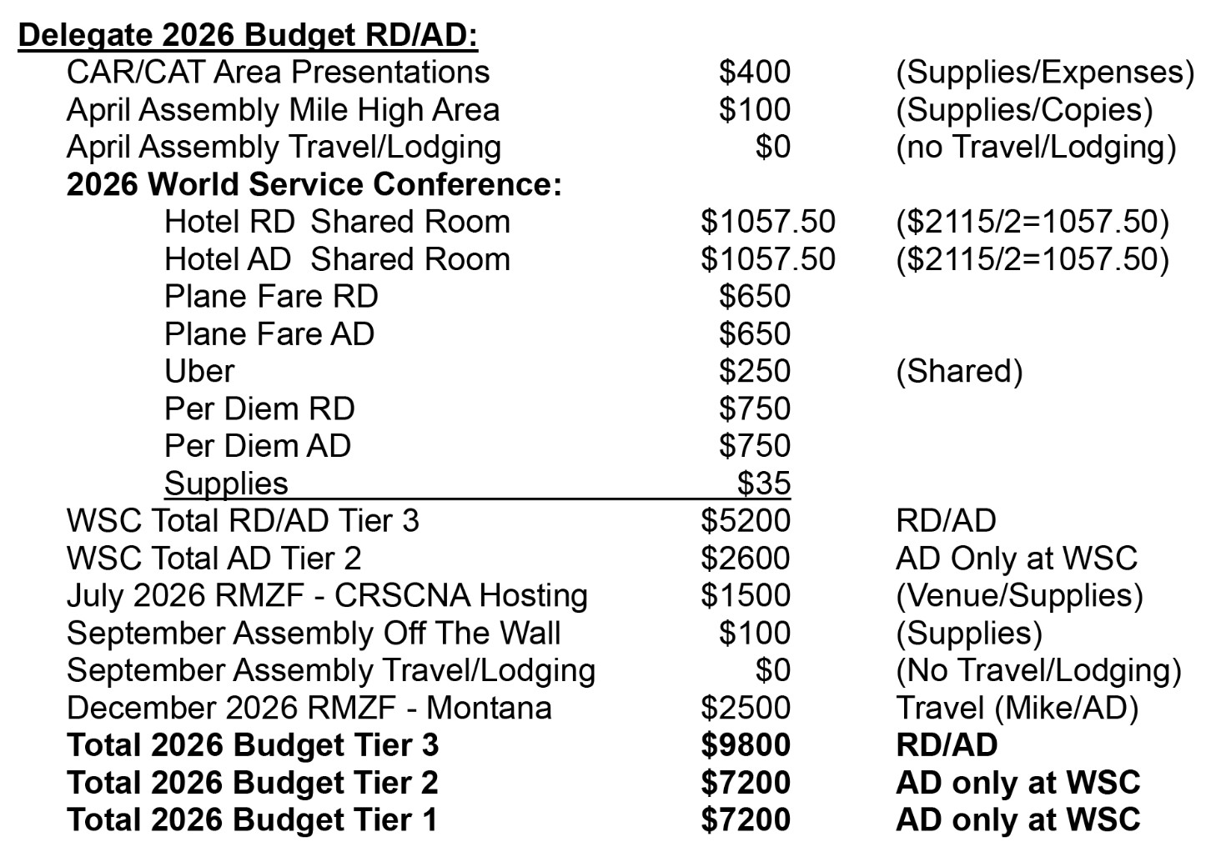

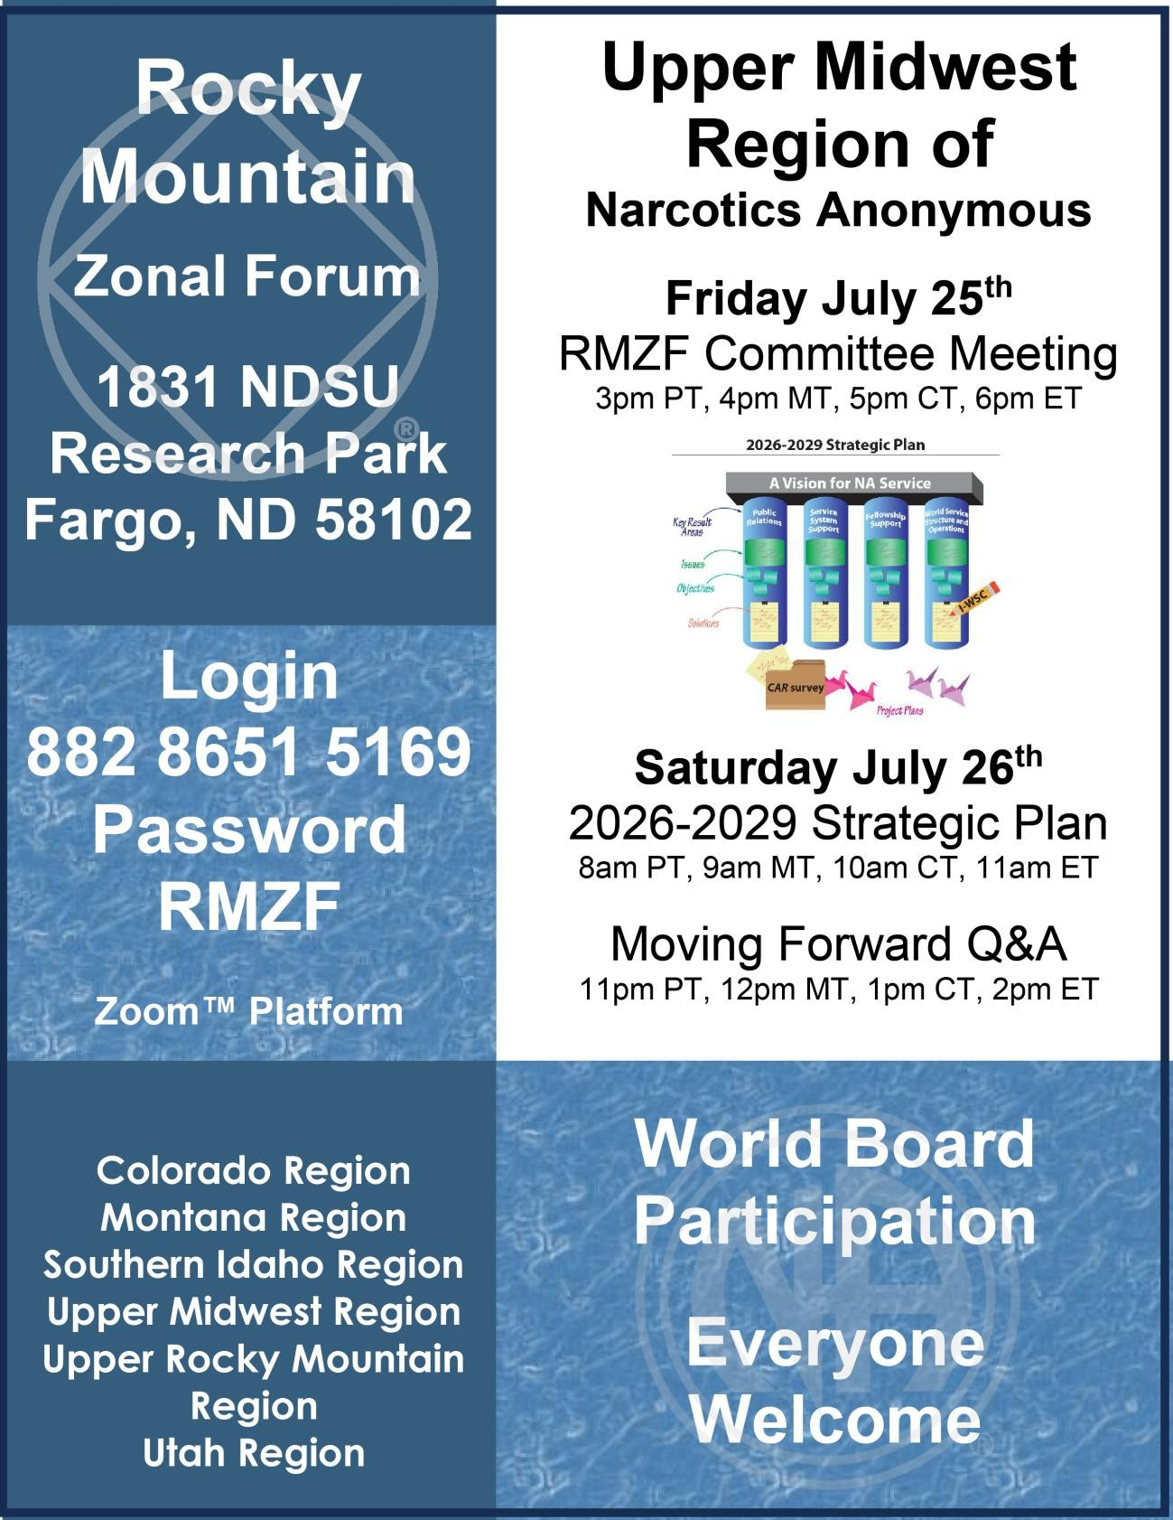

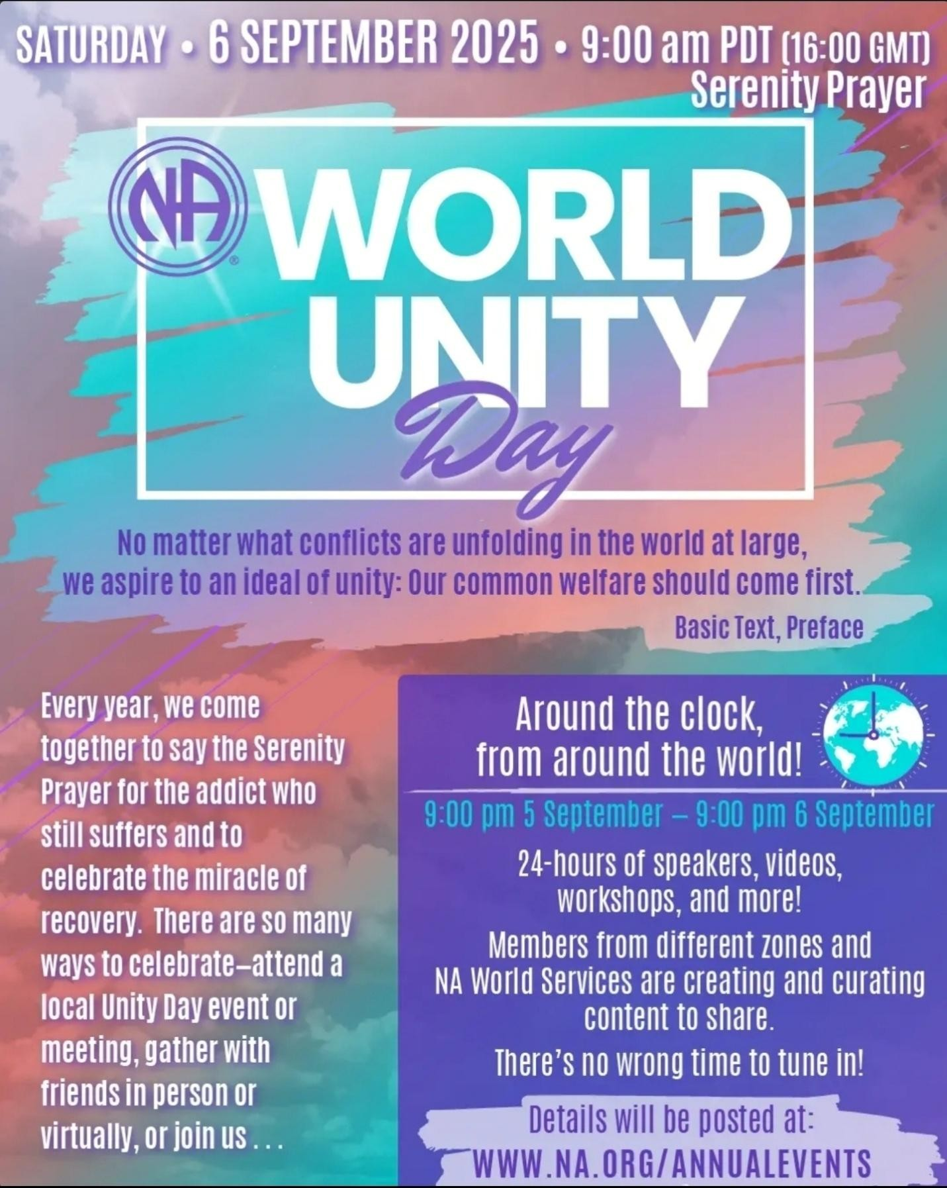

The CRSCNA Delegate Team – rd@nacolorado.or and rda@nacolorado.org Thank you for allowing us to be of service

    - RDA – Mike H
RDA Report to CRSCNA July 19, 2025
I have been assisting the RD with the prioritization of the CAR Survey submissions.
I will be working on an update to the Rocky Mountain Zonal Forum website. www.rmfna.org
I continue to try and stay up to date on the large amount of information available on the na.org website, especially the materials in the sections for Service Resources, World Service Conference, and Strategic Planning.
I am working on my travel plans for the December RMZF meeting in Wyoming.
I will be participating in the following upcoming service meetings:
Rocky Mountain Zonal Forum - Virtual - July 25, 26
World Service Conference Participants Webinar - Virtual - August 16
World Unity Day - Virtual - September 5,6
Colorado Regional Assembly - Boulder - September 20
World Service Conference Participants Webinar - Virtual - October 18
Colorado Regional Convention of Narcotics Anonymous - Denver - November 14,15,16
Rocky Mountain Zonal Forum - Cody WY - December 12, 13
If the Regional or an Area service committee would like to host an IDT or service workshop I will work with the RD to facilitate that.
I will work with the RD and the CRCNA committee to see if we can present some information or facilitate a workshop at CRCNA.
Thank you for asking me to serve
Mike H

    - CNAC – Steve K
CNAC Report to CRSCNA July 20, 2025
CNAC held its Quarterly Board Meeting on July 5, 2025.
We have begun the process of soliciting contracts from hotels for a two or three year period beginning in 2027 (CRCNA LVI). The number of hotels in the Colorado Region that can host our hotel is very small. It must have a banquet room that can hold our Saturday night event as well as reasonable room rates. If any Areas or Group has a suggestion of a property you would like us to pursue, please contact CNAC. Please just pass on the suggestion and we will contact them.
If your Group or Area is holding an event (BBQ, dance, etc.), please send any contracts to CNAC for review and signature. This is to protect an individual addict from holding themselves liable if anything goes wrong. Also, and very important, if the event involves anything that can result in an injury (rafting, paintball, horseback riding, roller or ice skating, etc.), please have all participants sign a Waiver Release Form to not hold CRSCNA responsible if they get hurt. We will be happy to provide the appropriate Waiver Form for your event.
We are currently looking for an Assistant Financial Officer for CNAC. Some financial background is required. We are also looking for a Board Member at Large. Please contact me for any information on how to apply and what these positions entail.
Our Budget has been submitted. The second quarter sales tax return has been filed.
If any of the Event (CRCNA, WRCNA, CRRMCO) Treasures have not received their bank cards, please let us know.
Our next Board Meeting is Saturday October 4th at 9:30am.
Thank you for letting CNAC serve the Colorado Region,
Steve K, CNAC Chair
Colorado Regional Convention (CRCNA) XXXIX NO REPORTS
    - Chair – Kevin W –
CRSCNA July Committee Meeting
CRCNA 39 Chair Report
July 20th, 2025
It has been a busy couple months for the committee. Hotels, merchandise, and programs are all on track for orders, contracts, and speakers. There are no new events to mention at this time, but we do have an ongoing softball league. Matt D. had to cover for me last meeting because I was on vacation without service. CNAC Board requested a couple items. I passed on some info for tapers and entertainment and Hotel & Hospitality did report that we have the atrium Friday night nailed down this year and next. We will get that amended in the contract and pass onto CNAC. We are also tracking down our PO Box key and the treasured did get the bank card for transactions. Hotel is also working on AV with the hotel and a couple outside vendors and we hope to have that nailed down this month after a meeting on the subject. We are already less than halfway there, slow times are over. Everybody right now is doing a great job with all the work needed till now. The subcommittees are working hard to put on another great convention this year.
Thank you for letting me serve,
Kevin W.
CRSC reviewed the list of topics for marathon meetings and for workshops. The program committee will review the guidelines regarding suggested topics to make sure they are included. There will be several interactive workshops this year. Both preliminary lists were approved.
    - Vice Chair – Matt D
He will stay in this position throughout the year but cannot serve as Chair next year. Rather than have someone start as VC at this stage, they decided to keep it open to the whole fellowship and elect next year’s Chair as usual
    - Treasurer – Karen B
Sitting good right now, around 16K in the bank
  - Colorado Regional Rocky Mountain Campout (CRRMCO) NO REPORTS
    - Chair – Rene
CRRMCO 12 Closing Regional Report
This year’s CRRMCO 12 camping event was a huge success, the turnout was great with 131 registered attendees! If there were any more attendees, I don’t know if we would have had enough parking.
Our objective this year was to focus on the inclusion of surrounding areas in different parts of the state and improve our announcement of the event to these areas and meetings. I feel like we achieved this goal as we had attendees turn out from Southern Colorado, Western Slope, Steamboat, and our faithful Mile High and Pikes Peak region. Thank you to our incredible speakers Brandi (Mile High area) Migi (Western Slope) and Dan B. ( Sourthern Colorado) who all nailed it and shared a tremendous message of experience, strength and hope!
Although our committee was small we pulled through and the campout was a hit. Thank you to Coy P. (Vice-Chair) Grant P. (Treasure) Desi (Activities) Samantha (Secretary) Teresa (Member at Large) and to all who helped make this years event happen. The expected work load was challenging at times with the normal registration, food, supplies, equipment, grills, cooking, set-up, and breakdown responsibilities but true to the NA spirit there were plenty of onsite volunteers who showed up and helped.
One of this years highlights was the number of children who showed up this year, which was such a blessing to see. Recovering addicts and their families enjoying the great outdoors was awesome. The pinata and scavenger hunt was a great success that the kids will definitely remember.
In closing the CRRMCO committee will conduct one final meeting to discuss this years pros and cons an settle on our final hand off group conscience for next years event. Our preliminary rough numbers look great as we will have enough funds to cover the much needed new grills for next year, our standard seed money and a donation back to region in excess of $1300. Our treasurer report will have more details on that.
Thank you for letting me be of service.
I hope to to serve and supportr this event for years to come
Rene P. CRRMCO 12 Chair
Merch sales were done by drop ship. It was a bit light, around 30 items. Taxes were paid with the order so CNAC will not need to file.
    - Vice Chair – Coy P

    - Treasurer – Grant P
Not final yet, but prelim numbers looks like $1350 to $1450 surplus will be returned to CRSC
  - Women’s Retreat of Colorado (WRCNA) NO REPORTS
    - Chair – Brandi
WRCNA Report to Region 7/20/25

Hello all! All is well in WRCNA land. We just had our committee meeting yesterday and everything is on schedule and on budget. We expect a successful year. We have scouts looking at the possibilities of new facilities for next year and we will keep you posted. Registration closes soon so please make sure you are announcing the women’s retreat at your meetings. Also, we have our poker fundraiser at 8085 E Hampden at 5pm this coming Saturday so we look forward to seeing you all there!

ILS
Brandi J
    - Vice Chair – Nohnie
    - Treasurer – Kacey
    - Not currently reconciled, lots coming in now. Everything is at budget and looks good.
Programs Chair presented the speaker topics;
Friday: The Courage To Heal
Saturday: A Life Infused With Hope
Sunday: Living in the steps
  - Regional Subcommittees NO REPORTS
    - PR Chair – Chris F
Hello CRSCNA
Hope you're doing awesome! Since the Assembly the PR Committees - H&I, PI, DOC Team, and Website - have been working diligently framing this upcoming term and collaborating together to best serve the Colorado Region.
Here are a couple of current points:
- Miraculous Mondays is up and going strong with attendance from all over the country including prison administrators, inmates, H&I committee members, World Board members, and interested NA members.
- Our web master Dave A. has gotten us all onboard with the emails and Zoom accounts for PR!
- Our H&I Chair Erica has coordinated with the DOC Adhoc to formulate suggestions for guideline updates. These suggestions will be ready to present mid June. This has been quite the challenge for them due to the rapid changes in correctional facilities since the pandemic. They have done great and we're looking forward to the current suggestions.
Our next committee meeting is June 30th and we will be covering the following:
- Elections - H&I Vice Chair and DOC Coordinator
- Inventory Outline
- DOC suggestions for guidelines will be available for review
Everyone is welcome! Please spread the word to your Areas and Homegroups!

Moving Forward:
- We will have a draft from the suggested guideline updates available to CRSCNA in July for review and edits
- We will be asking to send the H&I Chair and DOC Coordinator to WSLD
- And we would like to have consensus on the DOC guideline suggestions and ready for vote at the Assembly
Yes! We're all pretty psyched about how great it's coming together. I would like to extend my appreciation to Erica for jumping in with her expertise and love. And, above all, we want Terry C. to know how much we love her and appreciate all her dedication to our Fellowship and the prisons. Thank you Terry for helping with guideline suggestions, your knowledge is impeccable!

Please let your Areas and Homegroups know about our upcoming committee meeting and elections!
Monday June 30th
Colorado Public Relations NA is inviting you to a scheduled Zoom meeting.
Topic: H&I, PI, DOC Elections & Inventory
Time: Jun 30, 2025 05:30 PM Mountain Time (US and Canada)
Please download and import the following iCalendar (.ics) files to your calendar system.
Join Zoom Meeting
https://us02web.zoom.us/j/84379880695?pwd=W37f44yoOwCzky7njZM5nCSJHM90Z5.1
Meeting ID: 843 7988 0695
Passcode: COREGHI

Thank you CRSCNA for all your love and support!
In Loving Service,
Chris F.
Colorado Regional PR Chair
Erica H.
Colorado Regional H&I Chair
    - H&I Chair – Erica
Regional H&I Subcommittee Report for July 20 CRSCNA Meeting

Budget submitted for 2026, totaling $6,400
Out-of-budget disbursement request to go to 2025 WSLD submitted to treasurer
We’ve completed the rewriting of the Regional H&I Guidelines. They just need to be sent out to and voted on by the voting members of the Regional H&I Subcommittee and then sent to Regional PR Subcommittee for approval, then ratified at the Regional Assembly.
We are in a transition with the DOC Subcommittee, new members expected to be voted in after new Regional H&I Guidelines are approved and set in stone. Lots of changes and lots of moving parts still this year.
Current stockpile of books is being counted and handed over to Regional H&I Chair
Regional H&I email has been accessed, as it was never even opened before. Found a request from Red Rock Recovery that they would like an H&I meeting there at their Morrison Location on Fridays at 7:30pm. I’ve been working with the Area H&I Chair (Sinko) to put together a panel and get that going. I will bring this to the next Area meeting.
Presented H&I to Marisol Homes in Lakewood. H&I was going in there a while ago, but they weren’t happy with the message the members from NA were bringing so they want new members to come in. I went in and listened to their feedback and concerns which included the fact that they were hearing a message that people on MAT are not welcomed in NA. They are also requesting the meeting format to be a speaker meeting. It is a women’s facility, so I’d love to get a panel of women together who are passionate about the program and also open-minded to MAT. I will bring this to the next Area meeting.
Banyan is another treatment facility who has reached out to me requesting an NA H&I meeting. I need to reach back out to them to get more details on when they want a meeting. The facility is in Castle Rock. I will bring this to the next Area meeting and hope that people around the area are willing to be of service!
Crowley Detention Center has requested books/supplies to start a meeting/”NA study group” so I will be getting literature and supplies from Terry.

    - PI Chair – Russ
      - Went to the East UT recovery rally. Cortez meeting asked about being added to our meeting list.
      - The Feds and members of the Navajo Nation would like more information on NA. He will be teaming up with the Rio Grande Region
      - Looking forward to WSLD
    - Web Chair – Dave A.
Web Servant report to Regional 07/20/25
First off, I had an issue on Thursday night when adding a menu. Something went wrong and the home page became unorganized. I was able to get things organized and in the process moved around a few items. Everything is still there but Service Bodies and for NA Members shuffled some tabs. Other highlights – created crscnadoc@nacolorado.org for use with communication between H&I and DOC. A credit card option was added to buy Campout merch. Updated info about WSLD. Added emails to contact us page for transparency.
An issue came up with the Calendar. There is nothing in the guidelines about it but the general rule has been that it is to be used for regional events only. Something called Bishop’s Castle is listed for this weekend. I did not feel comfortable removing that event. I could write the organizer and ask them to not post on the regional calendar. Frankly, I don’t have a strong opinion as to what to do, so would like feedback and possible a consensus. Perhaps we send it back to the ASC’s to get their input. If every event from every area is listed it will get cluttered. But, more communication and opportunity is a big plus. What say you – under new business.
Speaking of communication, I have asked three times for an updated mtg list from Mountains West without a response. I am at a loss as to how to proceed.
Lastly, Google now requires 2 step verification for all admin accounts. I added it for admin@nacolorado.org with my phone number. Hopefully, this will not cause any issues for other members.
The issue of who can post events was discussed and we agreed to leave it as is.
- July CRSCNA Meeting items
  - Article 6, Section F, Steps and Schedule: CRSCNA Administration, RD/RDA, CNAC and PR Subcommittee (combining PI, H&I, etc.) will prepare and present the Tier 1, 2, & 3 proposals for the budget.
    - Budgets were reviewed, notable changes are:
      - In general, everything has gone up. Total contracts increased +$1831, storage increase was significant.
      - RD team is up $4500 because everything is expensive, this is a WSC year, and we are hosting WSLD. We are saving travel expenses by switching off, only sending one RD/RDA when possible
      - CNAC is down $140 due to less need for accountants now that taxes are fixed
      - PR budget not submitted, repeating last year
      - Web needs to pay $400 for our three year domain name
      - PI no change
  - CRCNA Program Chair present the CRCNA Program and Marathon meeting topics to CRSCNA for approval. All were approved

- Old Business
None

- New Business
  - An addict from Boulder joined the meeting to get input regarding disruptive and predatory behavior. Fortunately (so), this region, and several Areas in it, have been working on this issue and have a great deal of experience to share. Suggestions of what others have done were given. A list of useful web links was shared, contact to an Area Ad Hoc, and the RD’s expressed their willingness to give the WSO presentation to the meeting/Area if requested.
  - Budgets – how to use them, change them, report them, etc.
    - The CRSC budget is set in three spending tiers. Those are approved at the September Assembly. The tier we are in for the year is decided at the January CRSC meeting determined largely by the strength of the CRCNA donation for the year. Budgeted funds are released as needed. Any other funding request through the year needs to be submitted as a motion and approved at the CRSC meeting/Assembly
  - Open Positions
    - CRSCNA – Vice Chair, no volunteers
    - CRCNA – Vice Chair, decided to wait for next cycle
  - H&I Guideline change review? Not yet
  - Guideline changes _ Guidelines? We have discovered that the 60 day notice for guideline changes is not actually in the guidelines. It was approved but never made it in. Also, there are a few other oddities. Angie was appointed to head an Ad Hoc to review guidelines for update and cleanup.
  - Secure Facility for next Assembly – Boulder Area is working on it from 8:00 to 6:00 with a budget of $500.00. They have a group that is close to securing a facility.
    - Would love to have people submit videos/pictures/presentations, etc. from NA events and groups to liven up the Assembly. Kathleen is available to help.
  - New Proposals – An out of budget expenditure to send two members from the H&I committee to Western Service Learning Days (WSLD) was submitted and approved. The CRSC funds exceed the encumbered funds.
- Closing Treasurer Report

  - Closing balance unencumbered funds $2,240.73; $2,000 sent to WSO leaving $40.73

Record of decision:
2025-Jan-19
- Verified: taxes for Regional events will be paid out of the Regions budget and handled by CNAC
- CRCNA seed money increased to $15,000.00
- Tier 2 budget level for 2025
2025 -Mar-16
- CRCNA 39 and CRRMCO 12 budgets approved
- Clarified: The Regional treasure will make the guideline mandated 25% donation of CRCNA profit to WSO
2025 -April-19 Assembly
- CRCNA Guideline changes ratified
- CRCNA Guideline changes ratified
2025 July 20
- Decided to leave event posting on the CRSC calendar as is, fairly open

