Colorado Regional Service Committee of NA  
P.O. Box 1437  
Denver, CO 80201  
nacolorado@nacolorado.org

**CRSCNA Meeting Agenda**  
March 16th 2025

1. **Opening Serenity Prayer**
2. **12 Traditions of NA Read by Casey**
3. **Twelve Concepts for NA Service Read by Nohnie**
4. **Clean Time Anniversaries Since Jan. 21, 2025 Hiedi 8 yrs**
5. **Welcome New Members Beth, RCM2 MHA**
6. **Approval of Last Meeting Minutes approved**
7. **Agree to Meeting Etiquette: Read by Matt D**

* We affirm that mutual respect and trust is paramount to the effectiveness of all Colorado Regional Service Committee activities.
* We strive to achieve consensus whenever possible.
* We will not separate ourselves as individuals from the consensus of the Region and will take responsibility for the decisions of the Colorado Regional Service Committee.
* We will focus ourselves upon establishing unity, mutual respect, and trust during the meeting.
* We will meet our stated objectives for each meeting.
* We agree that only one person will speak at a time, and there will be no sidebar conversations.
* We affirm that action groups (ad hoc committees) will be used at Regional meetings to identify solutions for goals and issues before the Region.
* Zoom Etiquette

1. **Roll Call** Nellie H (crsc vice-chair) and Nichole R (rcm1 PPA) absent
2. **Upcoming local area events: FLYERS are attached to email containing the minutes**

* **Regional Assembly:** April 19th: First congregational church, 1425 N 5th St, Grand Junction OR via zoom. The Zoom link is on the [NAColorado.org](https://nacolorado.org) calendar
* CRCNA Pancake Breakfast, May 3rd , 9:00am, 8085 E Hampton
* Call for speakers at the Pancake Breakfast

1. **Updates to Record of decision document:**

* CRCNA 39 and CRRMCO 12 budgets approved
* Clarified: The Regional treasure will make the required 25% donation of CRCNA profit to WSO

1. **To Do List**

* **Regional Assembly:** Groups will ratify guideline changes to WRCNA and CRCNA at the Assembly. Review proposed changes on the [Regional webpage](https://nacolorado.org/rsc/region-guidelines-pdf/).
* RCMs please let RD Kathleen know the number of groups (not meetings) in your Area so they can gauge the response to surveys. NOTE: OTW lists 15 groups in their report

1. **Reports**

* **Regional Committee Members (RCMs)**
  + - **Boulder Area**RCM 1 – Grace F.
    - Boulder Area Region Report March 2025
    - • Donated $488.62 to Region for March
    - • We held elections in March, we still need a Treasurer, vice treasurer and activities
    - • We are still investigating our Venmo donation- so currently no donations to Venmo
    - • We have a new accessible PO Box- 408 in Boulder
    - • Centennial Peaks Hospital and Broomfield County Jail, Boulder County Jail H&amp;I needs
    - panel members
    - • Bingo Night tentatively in March went well!
    - • Several group level service positions always open
    - • Total Income from Literature Sales: $546 for the month of January
    - • We had a total Literature Order of: $1000 from the groups and H&amp;I
    - • Treasurer Report: Previous balance: $ 1765.29
    - Income Total from groups: $458.50
    - Literature Sales: $ 546
    - Other Sources: $ 0
    - Total income: $ 1004.50
    - • Grand Total (new and old money on hand): $ 2769.79
    - o Expenses $ 1281.17
    - o Total adjusted (less expenses) on hand: $1488.62
    - o Prudent Reserve: $ 1000
    - o Total Available to Donate: $488.62
    - o Donate to Region: $ 488.62
    - o New Balance $ 1000 (including prudent reserve)
    - RCM 2 – Carl K - absent
    - **Bringing Freedom East Area**RCM 1 – Open  
      RCM 2 – Open
    - **Mile High Area**RCM 1 – Heidi G.
    - Still struggling a little from being without a Treasure a few months then getting the bank switched over causing a few bills to be missed. The coffee lady had not been paid and threatened to cut us off—she was paid with haste
    - Quarterly donations of $1264.41 to Region and $842.94 to WSO done
    - Open positions include Web chair, GSF liaison
    - Continue to update guidelines including addressing Ad Hoc concerns
    - Predatory behavior Ad Hoc was disbanded because it met the objective of providing a safety statement
    - Finally found a mailbox key and discovered letters from prisoners dating back to June 2024. – Regional PR Chair notes all letters that could be answered have been.
    - RCM 2 – Open
    - **Mountains West Area**RCM 1 – Open
    - Report given by Russ
    - Started a new meeting in Delta
    - They have a temporary RCM, Mike F, he was unable to attend today
    - Have 12 to 14 groups in the area
    - The Rifle Meeting is still looking for meeting space.
    - **CARBONDALE**
    - **SUNDAY**  
      6:00 PM • Growing The NA way• (HY, O, SR D, WC, CS)  
      Carbondale, CO • 981 Cowen Dr. (Downstairs)  
      Zoom ID: 831 9393 4631 / Password: NASUNDAY
    - **CRAIG**
    - **SUNDAY**  
      5:00 PM • Easy Does It • (C, BK) Craig, CO • Calvary Baptist Church, 1050 Yampa Ave Zoom ID: 867 4927 1603/ Password: CLEAN23
    - **DELTA**
    - **TUESDAY**
    - 11:00 AM Recovery Hangout (O) 151 W 2nd ST Delta CO
    - **GLENWOODSPRINGS**
    - **Wednesday**                                                                                                                                                                                           8:00PM Candlelight group, first Presbyterian church 1016 Cooper Ave. (JFT, D)
    - **GUNNISON**
    - **FRIDAY**
    - 7:00 PM - Gunnison Group Bethany church
    - 909th Wisconsin St Gunnison Co.81230 (entrance in alley)
    - **GRAND JUNCTION**                                                                                                                                                                            **MONDAY - SATURDAY**
    - 1:30 PM • Never Give Up (O, IW, WC, CS) Grand Junction, CO • New Life Church, 1350 N 7th St.

RCM 2 – Open

* + - **Off the Wall Area**RCM 1 – Dave A

1. 03/16/24 OTW RCM1 Report to CRSCNA
2. Our H&I SC started mtgs at the Harmony Treatment Center in Estes Park every other Friday at 7. We serve five other facilities across the area. The Activities SC has a St Patrick’s day event tomorrow in Loveland and a bowling event in April. Events are planned for May and June as well. We have no open positions at present but lots of positions to be voted on in May and the executive committee is elected in June. Dave A. had hoped to rotate out in May but a possible replacement has Sunday conflicts. We plan to drive to GJ in April for the Assembly. OTW has 15 groups with 35 mtgs weekly.
3. Dave A.
4. 970-682-0437
5. crscnaweb@nacolorado.org

RCM 2 – Dave L

What Dave said

* + - **Pikes Peak Area**RCM 1 – Nichole B, unable to report due to illness  
      RCM 2 – Open
    - **Serenity Unlimited Area**RCM 1 – Valentina A.
    - Have filled a lot of positions, Vice Chair is still open
    - Changed Area meeting to every other month
    - Asking Dave A to work with them to get the GJ meeting list updated on the Regional website. They do not have a local website to scrape from.
    - $410.00 donated to Region
    - They have set up the Regional Assembly location and food
    - RCM 2 – Open
  + **Regional Committee Administration** 
    - Chair – Matt D
    - Vice Chair – Nellie absent
    - Secretary – Teresa no report
    - Treasurer – Angie R.
* **CRSCNA Treasurer Report**
* 3/16/25
* Good morning All,
* Opening balance as of this morning is $16,154.48 including the donations and CRCNA donation. That also includes a payment for reimbursement and the 25% World donation as dictated by the guidelines.
* It’s been a busy couple of months. We have paid the PO Box - good through March 1, 2026. The amount was higher than budgeted due to a rate increase of $17 (total is now $332 a year).
* The biggest item was storage this month. I worked with CNAC and got our insurance certificate updated, saving us $13/month on each unit. We will be getting a credit for $25 on each unit applied to the next billing cycle.
* I went in February and got a statement of accounts for both units. The main storage (2130) is on a month to month payment as 303 Storage no longer offers an upfront payment discount. I had to change the card on file to CRSCNA as it was charging Mike P. (former treasurer). We owe him for 5 months of charges - $1190. I have accounted for this payment as $714 (3 months) out of budget and $476 (2 months) as budgeted storage expenses.
* Archives storage (Unit 2128) is paid through December of 2025. We can assess if they bring back discounts again whether to prepay or pay month to month for this one also.
* I’ve included the summary income/expense statement as well as budgets remaining. We are $2188.52 from meeting our budget and can start donating to World after as CRSCNA sees fit.
* Thank you for letting me be of service,
* Angie R.
* Net donated from CRCNA was $5144.38
  + - RD – Kathleen

**Delegate Team Report March 16, 2025**

We continued keeping all the Areas informed in regard to the Interim and amendments. Also visited Pikes Peak Area for a presentation onsite. It was an excellent turnout with lots of interaction and great hospitality.

We had the Colorado Region motions outcome meeting on 02/23/2025 to discuss any abstentions and to clarify remaining questions. We also discussed the voting process for the upcoming WSC 2026. We would like to have our tally options more inline with our Regions CBDM process.

We attended the Interim Orientation with other Delegate teams and World Board members. It was very informative and we were able to get set up with the voting tool and other communication opportunities in order to streamline the process.

A couple of hours following the Orientation, the first initial straw poll was sent out. The Delegates weren’t expecting this so soon. We were very fortunate to have several tally sheets submitted for our Region with unified responses. Following the straw poll, we emailed the outcomes to the RCM’s for their reports to their Areas. Below are our Regions responses and the iWSC adopted motions.

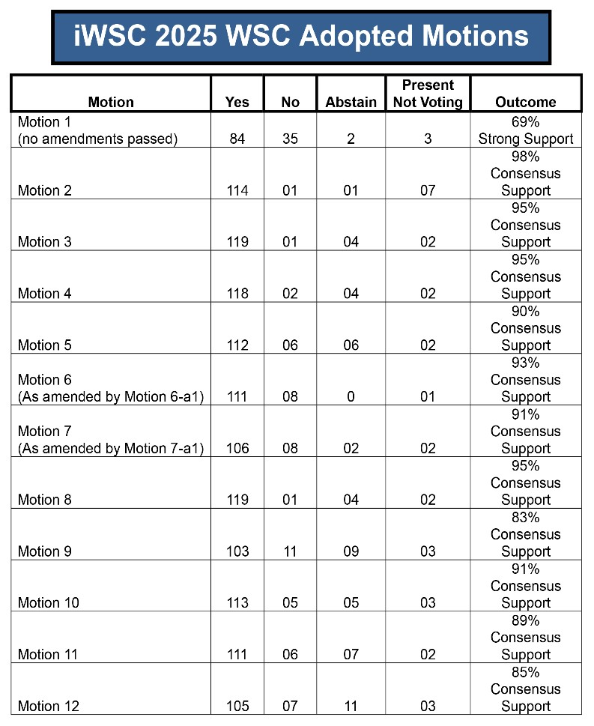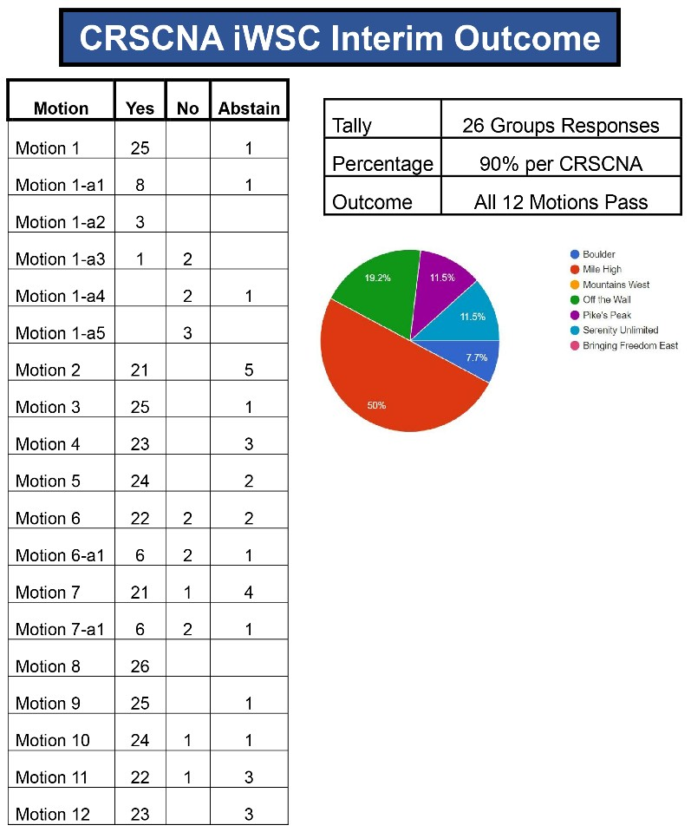

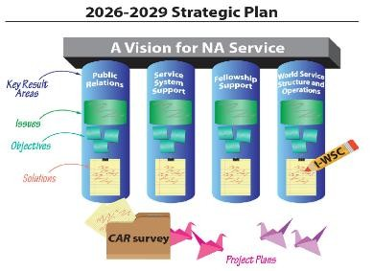Full details at <https://na.org/summaryofdecisions> The initial straw poll<https://na.org/conference> **Day 2 of the conference**

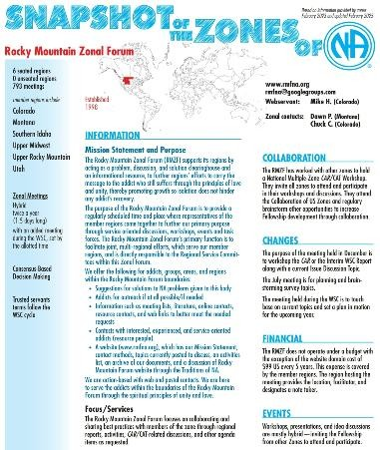

We focused on the Strategic Plan we’ve been working on for the past few years. See Mike’s report for details. We would like to go over the timeline at the Assembly.

**The Snapshot of Zones for Narcotics Anonymous 2025** [https://na.org/wp-content/uploads/2025/02/Snapshot-of-theZones-2025-02-04.pdf](https://na.org/wp-content/uploads/2025/02/Snapshot-of-the-Zones-2025-02-04.pdf)

**Idea Discussion Topics IDT’s**

For this conference cycle, we have 4 IDT’s preparing to be set into motions and project plans. We have had workgroups in our Region reviewing these topics and formulating input. We will be connecting them with workgroups in other Regions.

**Timeline as passed from Motion 5:**

**March 2025:**

Email conference participants link to 2023 *CAR*  survey and ideas received since 2023 **March–May 2025:**

Collect ideas for 2026 *CAR* survey, including ideas generated at Interim WSC **June or July 2025:**

Ballot of all ideas sent to Conference Participants (prioritize or simple yes/no?) **July 1, 2025:**

Regional and Zonal motions must be received by July 1st and be in CAR-ready form by August 3, 2025. R/Z are encouraged to send their motions as early as possible!

**August 2025 CP web meeting:**

Discuss list and prepare list of ideas for the 2026 *CAR* survey. The list could be finalized at the web meeting or require another ballot.

**September 30, 2025:**

Deadline for RBZs to submit candidate recommendations for the HRP

**Delegate Timeline moving forward:**

April 19, 2025 Regional GSR Assembly in SUANA

I’ve been talking with our Regional Chair about presentations from CRSCNA committee members. Along the lines of interactive Q&A with lots of info and fun!

|  |  |
| --- | --- |
| July 25-26, 2025 | RMZF in Upper Midwest Region (hybrid) |
| Late October 2025 | The 2026 WSC CAR will be available |
| December 13, 2025 | RMZF will workshop the CAR (hybrid) |
| January/February | The CAT will be available |
| January thru April | Our team will workshop the CAR/CAT several times |
| March | Electronic Tally Sheets will be available |
| April 18, 2026 | Regional Assembly WSC votes tallied for the conference |
| May 1 -10, 2026 | World Service Conference 2026 |

Narcotics Anonymous World Unity Day is September 6, 2025 and our Zone will have a timeslot and will collaborate with the Regions in our Zone along with our CO PR Chair!

* + - RDA – Mike H

RDA Report to CRSCNA Mar 16, 2025

The Interim World Service Conference 2025 adopted all 12 motions from the CAR with 6 and 7 amended. I learned a lot about the processes that the conference uses for conducting business. We broke into small groups most of the second day and reviewed all the steps of the strategic planning process up to the current state of the project. The conference participants confirmed the work done so far and added additional input. The next steps will include collecting ideas from the fellowship regarding literature, issue, service material, discussion topic ideas, between now and May. These will be prioritized by the conference participants to become the CAR Survey. The plan will continue to be developed until it is presented in the 2026 CAR.

The plan is organized into 4 Key Results Areas, each with specific Issues, Objectives for each Issue, and Solutions to achieve the Objectives.

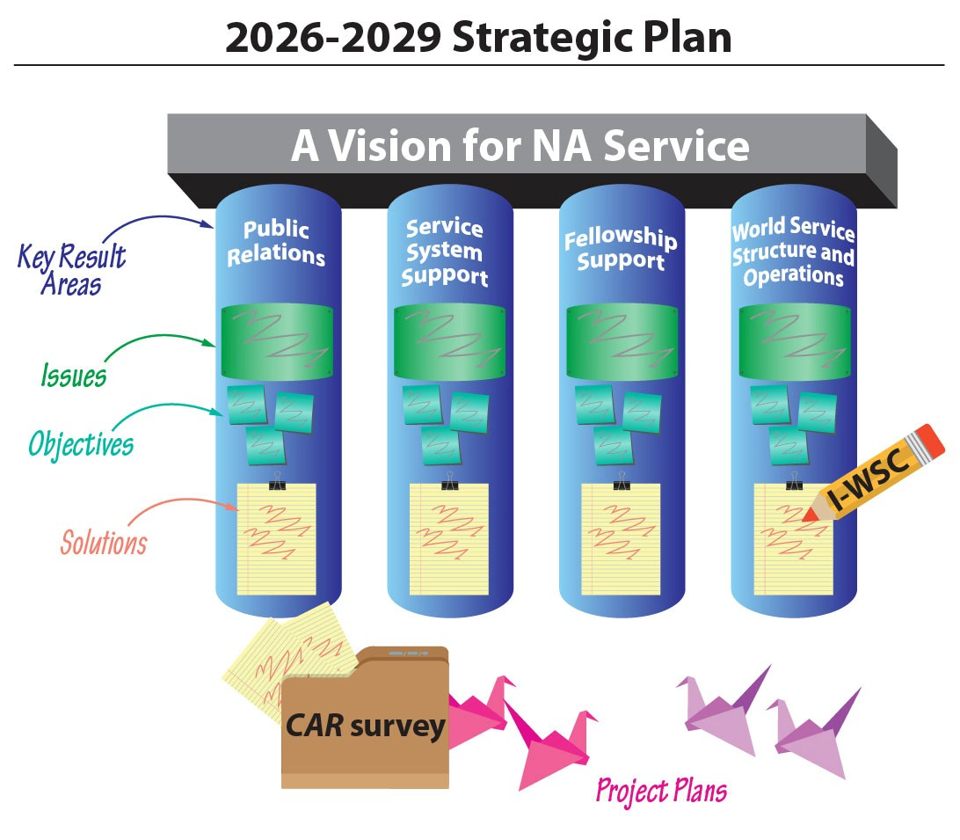

**Key Result Issues Objectives**

**Areas**

# Public Relations

## Credibility of NA

1. Create PR training tools for these audiences
   1. General public (including families)
   2. Government (criminal justice, policy)
   3. Addiction treatment
   4. Medical profession
2. Raise addiction treatment professionals’ awareness of and confidence in NA

# Service System Support

## Safety and Belonging

3. Raise consciousness regarding diversity and inclusion, and develop tools to ensure members and potential members feel safe, welcomed, and included.

## Impact of the Rise of Virtual NA

4. Enhance the ability of virtual groups to fully participate in the service system and for their voices to be heard as part of the NA Fellowship’s conscience.

## Lack of Cohesion in the Service System

5. Further the concept of collaboration within the service system and the understanding and appreciation of complementary roles and contributions to A Vision for NA Service.

## Development and Organization of Trusted Servants

1. Increase the interest of younger members in service.
2. Through mentorship, training, and tools, increase continuity of service delivery.

## Disruption in the Flow of Funds

8. Create tools for groups to offer convenient ways for members to contribute, and to ease and encourage the flow of funds through all components of the service system.

# Fellowship Support

## Harm Reduction

9. In the spirit of our Third Tradition, achieve a common understanding across the Fellowship of what it means to be an NA member and how to create the space for addicts to choose membership, regardless of how they found NA.

## Generational and Cultural Differences

10. Continue to update communication methods to meet younger members’ preferences for engagement.

# World Service Structure and Operations

## Three-year Conference Cycle

1. Further refine and describe the three-year conference cycle, including major meetings, policies, process deadlines and guidelines.
2. Evaluate and define the collaborative planning process for ongoing implementation.

## Future of the World Convention

13. Create a financially sustainable model for the World Convention, in harmony with our Eleventh Concept, that meets the needs and expectations of the Fellowship in a changing world.

## NAWS Sustainability

1. Enhance NAWS’ stability by diversifying revenue sources.
2. Evaluate and adjust activities at NA World Services to best support its roles and functions in a changing world.
3. Raise understanding of the need for and importance of adequate financial resources in carrying the message of recovery.

I will not be in attendance at the April assembly. I will send a report with the RD and follow up after with her to see what I miss.

Thank you for asking me to serve

Mike H

* + - CNAC Board Chair – Mike H

CNAC Chair Report - 03/16/2025

We will do the first quarter 2025 Colorado sales tax filing next month. We have gathered all of the financial information from last year's CRCNA, WRRCNA, and CRRMCO for our 2024 federal filing and will be working with the accountant to complete that process.

We have worked with the insurance company to update our liability insurance policy for 2025 and issue new certificates to facilities that have requested them.

There are openings for members at large on the CNAC board. We are always looking for members of the fellowship with experience in contract review and negotiation, liability insurance, state sales tax, and federal non-profits.

The next quarterly CNAC Board Meeting will be

Saturday April 5th, 2025 @ 09:30 AM MDT Zoom Virtual Meeting:

Meeting ID: 826 1753 3475

Passcode: CNACBOD

Thank you for allowing me to serve,

Mike H

* **Colorado Regional Convention (CRCNA) XXXIX**
  + **Article 7 Section B: The CRCNA Annual Budget is reviewed and approved.**
    - Chair – Kevin W – Gives Report

CRCNA 39 Chair Report

March 8th, 2025

CNAC continues to work on getting the new people on the bank account. As of now there are no expenses that need to be paid, and our hotel deposit required for this year is paid.

Budgets were submitted this month at the committee meeting and good discussion was had. CRCNA budget is basically increasing by roughly $20,000 (budget attached). The vast majority of that is with Hotel A/V costs. Last year it was almost double what we expected, and we even cut stuff that we should not have. Sub-Committee budgets increased or decreased a little. The group did a good job of trying to cut, when possible, but as has been the case for the last couple of years prices continued to increase. We are doing our best to keep reasonable and prudent costs down while providing a good convention for the fellowship.

All subcommittee positions are filled. Nonie stepped up to be Merchandise chair, and JR stepped up to be Vice Treasurer to ensure continuity of service for next year. Flyers are out for Pancake Breakfast event and Speaker solicitation. Also, Theme & Logo contest submissions deadline is the end of March (31st). We have been announcing it to get submissions in. Attached with my report is all the flyers and budget.

Thank you for letting me serve,

Kevin W.

Discussed and approved CRCNA 39 Budget, major points:

* The budget is significantly higher, largely due to an increase of $20,000 in AV and anticipated increases in food at the convention and during F&E events
* While the budget is bigger than last year, it is based on last year’s actuals and we came out ahead at these prices.
* The $5.00/banquet meal increase will be passed onto the ticket price
* There is no discussion about increasing registration costs at this time.

|  |  |  |  |
| --- | --- | --- | --- |
| **CRCNA XXXIV Budget 2025** | | | |
| **Account** | **Item** | **2024** | **2025** |
| **100** | **Administrative 2025** |  |  |
| 101 | Bank Charges (Include Checks) CC Internet Fees Analysis Fee | $1,500.00 |  |
| 102 | Office Supplies | $220.00 |  |
| 103 | Rent | $120.00 |  |
| 104 | Taxes | $1,000.00 |  |
| 105 | Basic Texts | $300.00 |  |
| 106 | Hardware/Software | $120.00 |  |
|  |  |  |  |
|  | **Total Administrative** | **$3,260.00** | **$3,260.00** |
| **200** | **Print & Display 2025** |  |  |
| 201 | Banner Printing 1@ canvas | $125.00 |  |
| 202 | Signs | $420.00 | $450.00 |
| 203 | Prize for Logo Winner | $35.00 |  |
| 204 | Registration form Printing | $265.00 | $50.00 |
| 205 | Program Schedule Printing | $470.00 |  |
| 206 | Flyer Printing | $260.00 | $150.00 |
| 207 | Name Tags & Banquet/Event Tickets during Convention | $260.00 |  |
| 208 | Office Supplies | $50.00 |  |
|  |  |  |  |
|  | **Total Print & Display** | **$1885.00** | **$1590.00** |
| **300** | **Fundraising & Entertainment Budget 2025** |  |  |
| 301 | **Kickoff S&S Pancake Breakfast** |  |  |
| 302 | Food / Supplies | $700.00 | $875.00 |
| 303 | Venue Rental | $400.00 | $475.00 |
| 304 | Chair rental | $150.00 |  |
| 305 | Cooking supplies | $100.00 |  |
| 306 | **F&E Individual Area Events** |  |  |
| 307 | Seed money for venue rental/supplies/food up to 4 area events | $1000.00 | $1200.00 |
| 308 | Customized prizes/raffle items/silent auction items | $320.00 | $600.00 |
| 309 | **Convention F&E** |  |  |
| 310 | Hospitality Room Games/Entertainment/Karaoke | $500.00 | $1000.00 |
| 311 | DJ for Friday Night | $1,000.00 | $1500.00 |
| 312 | Poker | $1,000.00 |  |
| 313 | Talent Show/Contests/Game Show Prizes | $300.00 | $350.00 |
| 314 | Friday and Saturday Entertainment | $5,000.00 |  |
| 315 | Chance to win tickets | $50.00 |  |
| 316 | Blanket for Raffle | $125.00 | $200.00 |
| 317 | Prizes | $300.00 |  |
|  |  |  |  |
|  | **Total Fundraising & Entertainment** | **$11,220.00** | **$13,125.00** |
| **400** | **Merchandise 2025** |  |  |
| 401 | Convention / Pre-Convention Merchandise | $9,600.00 | $10,500.00 |
| 402 | Pre-Convention Merch | $1,400.00 |  |
|  | Pancake Breakfast ($700.00) |  |  |
|  | Area Events x 2 ($420.00) |  |  |
|  | On-line Pre-Convention sales ($280.00) |  |  |
| 403 | Postage/Copies/Supplies | $50.00 | $100.00 |
| 404 | NA Literature (to sell) | $500.00 | $500.00 |
|  |  |  |  |
|  | **Total Merchandise** | **$12,250.00** | **$12,500.00** |
| **500** | **Programs 2025** |  |  |
| 501 | Speaker Flights (2 x $500.00) | $1,000.00 | $1,200.00 |
| 502 | Speaker Gifts (3 x $75.00) | $225.00 | $300.00 |
| 503 | Workshop Expenses Included in Supplies (Interactives) | $700.00 | $850.00 |
| 504 | Postage/Copies/Supplies | $250.00 |  |
|  |  |  |  |
|  | **Total Programs** | **$2,280.00** | **$2,780.00** |
| **600** | **Registration 2025** |  |  |
| 601 | Registration Badges and Lanyards (1000 X $2.32) | $2,325.00 |  |
| 602 | Registration Packet Items | $5,175.00 |  |
| 603 | Office Supplies | $165.00 |  |
| 604 | Main Speaker Registrations x 3 ($55) | $165.00 |  |
| 605 | F&E Registration prizes x 5 ($55) | $275.00 |  |
|  |  |  |  |
|  | **Total Registration** | **$7,665.00** | **$7,665.00** |
| **700** | **Hotel 2025** |  |  |
| 701 | Audio Visual | $15,500.00 | $35,000.00 |
| 702 | Main Speaker Meals ($112.50 x 3 (55+35+25%) | $321.00 | $340.00 |
| 703 | Main Speaker Hotel Rooms (8) x $149.00 | $894.00 | $1,300.00 |
| 704 | Taper Hotel Rooms (2) x $149.00 | $298.00 |  |
| 705 | Taper Meal (1) x $80.00 | $80.00 | $100.00 |
| 706 | Centerpieces | $650.00 | $500.00 |
| 707 | Fellowship Room Supplies | $1,000.00 | $500.00 |
| 708 | Table Gifts | $650.00 | $700.00 |
| 709 | Banner Hanging Fees | $1,550.00 |  |
| 710 | Food & Beverage Contractual | $13,000.00 | $14,500.00 |
| 711 | Pipe & Drape | $500.00 |  |
| 712 | Parking ($2,000 + 25%) | $2,500.00 |  |
| 713 | Stage/Dancefloor | $1,500.00 |  |
| 714 | Room Turns ($1000.00 x 2) | 0 | $2,000.00 |
|  |  |  |  |
|  | **Total Hotel & Hospitality** | **$38,443.00** | **$61,288.00** |
| **800** | **Hospitals & Institutions 2025** |  |  |
| 801 | Basic Texts | $620.00 |  |
| 802 | Office Supplies | $100.00 |  |
| 803 | Admin supplies | $240.00 |  |
| 804 | Banquet Dinners for Speakers: ($80.00 x 3 = $240.00) | $240.00 |  |
|  |  |  |  |
|  | **Total Hospitals & Institutions** | **$1,200.00** | **$1,200.00** |
|  | **Total 2025** |  |  |
|  | **Total Budgeted Expenses** | **$78,203.00** | **$103,408.00** |

* + - Vice Chair – Matt D
    - Secretary – Jasmine
    - Treasurer – Karen B
  + **Colorado Regional Rocky Mountain Campout (CRRMCO)** 
    - **Article 7, Section C: CRRMCO Budget is reviewed and approved.**
    - Chair – Rene – Gives Report
    - We selected a theme and logo for the campout
    - Registration is open and we will have a table at Unity Day
    - We are looking for speakers and hoping to find a balance from around the state and among women and men.
    - We are asking for help from anyone who knows how to search/set up online merchandise with drop shipping.
    - We are discussing getting a grill and where it could/should be stored.
    - Vice Chair – Coy P
    - Treasurer – Grant P

**CRRMCO XII Treasurer Report, March 15th, 2025 – Grant P.**

February-end financial status & 2025 budget proposal:

Outstanding Actions:

* Bank account handover
  + Signatory form submission: Complete (hooray!)
  + To do: Get access to online account – need to go to branch; possible online?
  + - Registration link addition to CRRMCO webpage: Complete
  + New Items:
  + - Paypal issue with transactions expiring: Resolved; manual capture required.
  + - Paypal transactions successfully posting w/bank acct passthrough: Complete.
  + - 2024 tax information for CNAC tax filing: Submitted, approval pending.
  + - 2025 budget proposal: Complete – as shown above.
* Budget was discussed and approved. Major changes are the expected increase in attendance and registration income, added cost for a grill, and increase in food cost
  + **Women’s Retreat of Colorado (WRCNA)** 
    - Chair – Brandi – Gives Report
  + WRCNA Chair Report to Region
  + 3/16/25
  + Hello everyone!
  + WRCNA registration will be open very soon!  We are solidifying pricing to reflect the small increase in the facility
  + Call to speakers is still open and flyer is on the website.  It will close in April.
  + Our first event (Spaghetti Dinner) was a huge success.  Bingo will be our next event in Denver.  We are solidifying the exact time with the church.  4-12 @ 8085 E Hampden Ave Denver CO confirming 5 pm with church
  + We reviewed the guidelines with you at last region and I resubmitted with the changes we went over.  I look forward to your approval today.
  + We are excited to bring our region another successful year of WRCNA!
  + ILS
  + Brandi J
  + Registration will open in the next few weeks
  + They will have a Registration table at Unity day and the Assembly
    - Vice Chair – Nohnie
    - Secretary - Angie
    - Treasurer – Casey

Hi Fam!

…….In our adventures….

Great success on our first event! All expenses have been accounted for. However, even though we did not meet the amount we set out to, it was still a success. We need all the support we can get!  We want this to be a success, especially for the newcomers. It takes a village! We plan on having a table at Unity Day too! See you there!

Bank rec including event will be solidified on next month's meeting since most transactions took place on 3/1. To include:

-I wrote a check for $161.87 to reimburse F&E Chair for supplies, receipts were captured.

-Also wrote a check for venue rental for $50.

-Reimbursed Food Chair $56 for Event cakes, receipt captured.

Other items:

* Spoke with Steve K and sent over requested tax information.
* My name is spelled wrong its Kacey B can you please make the correction.               -
* H&I subject:
  + I have been on the Freedom of Choice zoom meetings that Paul M heads up, the meetings have been amazing. The opportunities this brings is amazing. I can't tell you with words how awesome this is.
  + Meetings at LaVista on Mondays have been outstanding. Attendance is down because they have a new system, only odds and evens on opposite weeks can come to keep the bad behaviors down to a minimum. They also have 2 other new programs running at same time slot. Mondays are anywhere 15-25 in attendance compared to 40+. I have someone making a flyer and the volunteer coordinator has agreed to post them all over to help increase attendance. We need more volunteers on our side to bring the message in on Mondays.
    - Last Sunday of the month attendance is completely dissipated because of lack of acknowledgement from the facility with announcing it from facility, hopefully flyers will help.  Also was told by some offenders that they just forget because it's not constant on a weekly basis and they are very routine bound, something out of the ordinary is difficult for them to remember. They said even though we tell them on Monday prior its a different group that may get to come on that same week's Sunday. I am open for ideas to help, but based on personal experience, I believe if it happened more than once a month it would have a higher success rate.

Please send me any questions or comments, I can use all the support!

 ***I’m truly grateful to work on this WRCNA XII committee, its an honor to be a part of something so much bigger than me. I love that we are some newcomers first introduction to NA and what an honor and a privilege that is. Thank you all for the love!

Kacey B. 10/19/09

* + - Vice Treasurer – Karen S.
  + **Regional Subcommittees – all chairs give report**
    - PR Chair – Chris F
      * Miraculous Mondays, some type of zoom meetings into prisons, is going strong and involving many states in the area
      * Continuing to work on getting literature on laptops into facilities. It seems like a more cost-effective way to get NA literature behind the walls
      * Mesa County and Rifle are using the laptop technology for NA literature
      * There is a drug “tomb” that is snuck in on printed pages so some facilities are reducing the number of printed books let inside
      * Working on introducing NA into seminaries, giving students the tools to help their addicted constituents. Similar to Iran educating religious leaders.
      * Working on an IP for long term incarcerated people.
      * We need techno savvy people to help us get electronic information into prisons.
      * The speaker tapes are available at nacolorado.org -> drop down service bodies -> H&I speakers
    - H&I Chair – JR
  + Good Morning Colorado Region,
  + We had 4 volunteers trained for the Department of Corrections about 4 weeks ago. They are now cleared as green badges to help take meetings behind the wall in the Department of Corrections. A panel was created and a meeting was taken into Trinidad Correctional Facility last Sunday, 3/9/2025. I was there and those members are hungry and begging for NA. It was a beautiful meeting. We are looking for members that have been cleared through the Department of Corrections and willing to be part of a panel to attend a weekly meeting at Trinidad Correctional Facility. The meeting will be Sunday's early afternoon. Contact myself, JR G. or Terry C. if you are willing to be of service or for more information. Terry C. and Erin B. are getting ready to place an H&I literature order. If regional H&I needs any literature, please reach out to Terry or Erin. Thank you
  + In Loving Service,
  + JR G.
  + Colorado Regional H&I Chair
    - PI Chair – Russ –

Greetings Colorado,

Chris has been working with multiple Regions Nationwide on technology platforms to carry and capture our Life saving message. Colorado PR is hosting “Miraculous Monday”.  
We have over a hundred Addicts behind the Walls attending. Our speakers are being recorded and will be downloaded with Edovo and Cyberworx.

In Colorado,

The Rifle Corrections Center & Mesa County Jail are currently accessing NA literate on tablets in their jails.  
We are behind the technology curve with our DOC Jail had NA literate on tablets. This will be addressed with our new H&I & DOC Chairs that will be elected in the Spirit of Rotation.  
Dave A has also downloaded our new Speakers on our regional website for our Brothers and Sisters in isolated communities.  
Our Steps behind the walls writing program is finally starting to get traction as well.

FD has helped with new meeting startups in Delta and Rifle.  An addict in Gunnison reached out to get meeting list info. The addict expressed his gratitude through tears. “We have been working on this for a long time”.  More startups coming soon.  
Chris has been also working with NAWS on PR/H&I Basics to be used with technology.  
We hope to serve Region as the PR/PI Chair another 2 years and look forward to seeing these projects grow to fruition in Colorado soon.  
Respectfully,  
Christopher F & Russ E

* **PR/H&I WSLD Members Experience**
  + Improve trust between institution and NA Panel Members
  + Being of service and selfless with members’ time
  + Sharing ESH with attendees inspiring hope
  + Attendees share gratitude and display respect for NA members
  + Provide resources directly to inmates for improved outcomes
  + A safe environment for all
* **Attendees Experience**
  + Online Meetings
  + Meetings of NA
    - Web Chair – Dave A.
* Web report to CRSCNA 03/16/25
* Added Generic Privacy Policy under Contact Us – needs review by CNAC? Worked with Teresa about possible CRCNA guidelines mismatch. Added Proposed CRCNA & WRCNA guidelines to Service Bodies > Region Guidelines. Updated zoom accounts for PP, MH and SUANA. CRRMCO registration added and have received three emails for registrant. Added CRRMCO committee mtgs for Feb and March using OTW zoom. April mtg coincides with the Regional Assembly so could not use regl/CNAC account. However, it is on the regional calendar for that Saturday as is the Women’s retreat mtg. How these conflicting meetings will be handled is not up to me. Also, it is unclear to me who should be setting up the reg’l meetings on the calendar. Kathleen asked me to schedule the Assembly on the calendar, so I did. I thought perhaps it is the secretary’s duty so I read the guidelines, quite a novel approach, and found that it is under my purview so I will get the rest of them scheduled for the year. Updated Chris about a change I made to PR password. Tried to clear up confusion about what the PR email is. Added links to new Monday morning Zoom PR special webinars/speakers. We have one extra zoom license so the subject of giving that to the PR SC was brought up but for now PR is using the CNAC zoom and we will have an open zoom license. However, if the body desires to move it to PR that is fine by me. Helped Elizabth from Boulder get logged in and add zoom mtgs. Sorry if this is a little jumbled as I made notes chronologically so not real focused.
* Dave A.
* 970-682-0437
* [crscnaweb@nacolorado.org](mailto:crscnaweb@nacolorado.org)

NOTE: when designing flyers, please consider the amount of ink it takes to print them on our home computers. Flyers with solid color backgrounds are not that feasible for printing.

* **CNAC**
  + Chair – Steve K – pending
  + Vice Chair – Dan B - pending
  + Financial Officer – Jay M
* **Old Business**
  + At the last meeting we thought Region had paid $9000 in hotel deposits for CRCNA 38. After further review, that was actually a payment made to WSO.
  + Assembly 4/19 is set and ready
* Location – First congregational church, 1425 N 5th St, Grand Junction OR via zoom. The Zoom link is on the [NAColorado.org](https://nacolorado.org) calendar
  + - Snacks/Drinks – Matt D
    - Equipment/materials – Kathleen
    - Lunch – will order food in based on attendance
* **Open Forum/Open Discussion**
  + We discussed the need for a second grill for the campout. If one is bought, where will it be stored?
    - Some thought CRSC’s storage is better than someone’s house
    - Currently it will not fit in the storage locker. If we get high shelves, we could store it under those. The shelves would have to be free standing and able to hold significant weight.
    - The grill would need to be thoroughly cleaned after each use to keep bugs and rodents away.
  + JR G was nominated and qualified for CRCNA Vice Treasure. However, that position is not elected at CRSC, but it was sure nice hearing from him
* **New Business**  
   **Article 7 Section B: The CRCNA Annual Budget was reviewed and approved, see discussion under the CRCNA Chair report**

**Article 7, Section C: The CRRMCO Annual Budget was reviewed and approved, see discussion under the CRMMCO Treasure report**

* **Closing Treasurer Report**
  + $16,154.48, same as opening. We have not met the encumbered funding level yet, so there is nothing to send to WSO at this time.

|  |  |  |  |  |  |  |  |  |
| --- | --- | --- | --- | --- | --- | --- | --- | --- |
|  |  |  |  |  |  |  |  |  |
| **CRSCNA 2025 Budget Approved** | | | | | | | | |
| **Tier 2 Year** | | | | | | | | |
|  | **Tier 1** | **Tier 2** | **Tier 3** |  | **2025 Approved Tier Budget Amount** |  | **Actual** | **Variance** |
| **ADMINISTRATION (ADM)** |  |  |  |  |  |  |  |  |
| Administration Contingency Fund | $ 100.00 | $ 100.00 | $ 100.00 |  | $ 100.00 |  |  | $ 100.00 |
| Bank Fees | $ 100.00 | $ 100.00 | $ 100.00 |  | $ 100.00 |  | $ 4.00 | $ 96.00 |
| Office Supplies & Expenses | $ 25.00 | $ 25.00 | $ 50.00 |  | $ 25.00 |  |  | $ 25.00 |
| Regional Assembly Expenses | $ 1,000.00 $ 315.00 $ 2,196.00  $ 1,524.00 $ 99.00 | $ 1,000.00 | $ 1,000.00 |  | $ 1,000.00 |  |  | $ 1,000.00 |
| Regional Post Office Box Rental (2024) | $ 315.00 | $ 315.00 |  | $ 315.00 |  | $ 332.00 | $ (17.00) |
| Regional Storage Shed Rental (2024) Unit 2130 | $ 2,196.00 | $ 2,196.00 |  | $ 2,196.00 |  |  | $ 2,196.00 |
| Regional Storage Shed Rental #2 (2024) Unit 2128 | $ 1,524.00 | $ 1,524.00 |  | $ 1,524.00 |  | $ 714.00 | $ 810.00 |
| TrackFone | $ 99.00 | $ 99.00 |  | $ 99.00 |  |  |  |
| Liability Insurance (Due in January) | $ 1,500.00 | $ 1,500.00 | $ 1,500.00 |  | $ 1,500.00 |  | $ 1,492.01 | $ 7.99 |
| **Administration Total** | **$ 6,859.00** | **$ 6,859.00** | **$ 6,884.00** |  | **$ 6,859.00** |  | **$ 2,542.01** | **$ 4,217.99** |
|  |  |  |  |  |  |  |  |  |
| **REGIONAL DELEGATE TEAM (RD/RDA)** |  |  |  |  |  |  |  |  |
| Miscellaneous Supplies & Expenses | $ 200.00 | $ 300.00 | $ 400.00 |  | $ 300.00 |  |  | $ 300.00 |
| Regional Assembly Travel/Lodging | $ 1,000.00 | $ 1,000.00 | $ 1,000.00 |  | $ 1,000.00 |  |  |  |
| Rocky Mountain Zonal Forum July - RD Travel/Lodging | $ 1,000.00 | $ 1,500.00 | $ 2,000.00 |  | $ 1,500.00 |  |  | $ 1,500.00 |
| Rocky Mountain Zonal Forum Dec - RD Travel/Lodging | $ 1,000.00 | $ 1,500.00 | $ 2,000.00 |  | $ 1,500.00 |  |  | $ 1,500.00 |
| **Regional Delegate Team Total** | **$ 3,200.00** | **$ 4,300.00** | **$ 5,400.00** |  | **$ 4,300.00** |  | **$ -** | **$ 3,300.00** |
|  |  |  |  |  |  |  |  |  |
| **CNAC** |  |  |  |  |  |  |  |  |
| Accountant | $ 1,500.00 | $ 1,500.00 | $ 1,500.00 |  | $ 1,500.00 |  | $ - | $ 1,500.00 |
| Attorney | $ 500.00 | $ 500.00 | $ 500.00 |  | $ 500.00 |  |  | $ 500.00 |
| Copies & Miscellaneous | $ 50.00 | $ 50.00 | $ 50.00 |  | $ 50.00 |  |  | $ 50.00 |
| **CNAC Total** | **$ 2,050.00** | **$ 2,050.00** | **$ 2,050.00** |  | **$ 2,050.00** |  | **$ -** | **$ 2,050.00** |
|  |  |  |  |  |  |  |  |  |
| **PR ADMIN** |  |  |  |  |  |  |  |  |
| Print / Literature | $ 1,000.00 | $ 1,000.00 | $ 1,000.00 |  | $ 1,000.00 |  |  | $ 1,000.00 |
| Travel - Either PR Admin or H&I Chair | $ - | $ - | $ 1,000.00 |  | $ - |  |  | $ - |
| **PR ADMIN TOTAL** | **$ 1,000.00** | **$ 1,000.00** | **$ 2,000.00** |  | **$ 1,000.00** |  | **$ -** | **$ 1,000.00** |
|  |  |  |  |  |  |  |  |  |
| **H&I SUBCOMMITTEE** |  |  |  |  |  |  |  |  |
| DVDs/Tech | $ 500.00 | $ 500.00 | $ 500.00 |  | $ 500.00 |  |  | $ 500.00 |
| DOC Literature | $ 2,500.00 | $ 3,500.00 | $ 5,000.00 |  | $ 3,500.00 |  |  | $ 3,500.00 |
| Inmate Writing Program / Outlying Areas | $ 400.00 | $ 500.00 | $ 600.00 |  | $ 500.00 |  |  | $ 500.00 |
| **H&I SUBCOMMITTEE TOTAL** | **$ 3,400.00** | **$ 4,500.00** | **$ 6,100.00** |  | **$ 4,500.00** |  |  | **$ 4,500.00** |
|  |  |  |  |  |  |  |  |  |
| **WEB SUBCOMMITTEE** |  |  |  |  |  |  |  |  |
| Technolgy (e.g. Zoom Accounts) | $ 1,000.00 | $ 1,000.00 | $ 1,000.00 |  | $ 1,000.00 |  |  | $ 1,000.00 |
| Domain Fees | $ 450.00 | $ 450.00 | $ 450.00 |  | $ 450.00 |  |  | $ 450.00 |
| **WEB SUBCOMMITTEE TOTAL** | **$ 1,450.00** | **$ 1,450.00** | **$ 1,450.00** |  | **$ 1,450.00** |  | **$ -** | **$ 1,450.00** |
|  |  |  |  |  |  |  |  |  |
| **PI SUBCOMMITTEE** |  |  |  |  |  |  |  |  |
| Travel | $ 600.00 | $ 800.00 | $ 1,000.00 |  | $ 800.00 |  |  | $ 800.00 |
| Literature/Printing | $ 500.00 | $ 625.00 | $ 750.00 |  | $ 625.00 |  | $ - | $ 625.00 |
| Mailings | $ 300.00 | $ 400.00 | $ 500.00 |  | $ 400.00 |  |  | $ 400.00 |
| **PI SUBCOMMITTEE TOTAL** | **$ 1,400.00** | **$ 1,825.00** | **$ 2,250.00** |  | **$ 1,825.00** |  | **$ -** | **$ 1,825.00** |
|  |  |  |  |  |  |  |  |  |
| **PR ADMIN TOTAL** | $ 1,000.00 | $ 1,000.00 | $ 2,000.00 |  | $ 1,000.00 |  | $ - | $ 1,000.00 |
| **H&I TOTAL** | $ 3,400.00 | $ 4,500.00 | $ 6,100.00 |  | $ 4,500.00 |  | $ - | $ 4,500.00 |
| **WEB TOTAL** | $ 1,450.00 | $ 1,450.00 | $ 1,450.00 |  | $ 1,450.00 |  | $ - | $ 1,450.00 |
| **PI SUBCOMMITTEE TOTAL** | $ 1,400.00 | $ 1,825.00 | $ 2,250.00 |  | $ 1,825.00 |  | $ - | $ 1,825.00 |
| **PR SUBCOMMITTEE COMBINED TOTAL** | **$ 7,250.00** | **$ 8,775.00** | **$ 11,800.00** |  | **$ 8,775.00** |  | **$ -** | **$ 8,775.00** |
|  |  |  |  |  |  |  |  |  |
| **GRAND TOTAL** | **$ 20,759.00** | **$ 23,809.00** | **$ 28,384.00** | **#** | **$ 21,984.00** |  | **$ 2,542.01** | **$ 18,342.99** |
|  |  |  |  |  |  |  |  |  |
| **Non-Budgeted Items** |  |  | **Approval Date** |  | **Approved Amount** |  | **Actual** | **Variance** |
| **Sales Tax - 2024** |  |  |  |  | $ 897.36 |  | $ 897.36 | $ - |
| **Reimburse Mike P for Storage Unit 2130 - 2024** |  |  |  |  | $ 714.00 |  | $ 714.00 | $ - |
| **WSC Donation - 25% of CRCNA** |  |  |  |  | $ 1,286.10 |  | $ 1,286.10 | $ - |
|  |  |  |  |  |  |  | $ - | $ - |
| **Total Non-Budgeted** |  |  |  |  | **$ 2,897.46** |  | **$ 2,897.46** | **$ -** |
|  |  |  |  |  |  |  |  |  |
|  |  |  |  |  |  |  | **Money Spent** | **BUDGET REMAINING** |
|  |  |  | **Grand Total** |  | **$ 22,698.00** |  | **$ 5,439.47** | **$ 18,342.99** |

|  |  |  |  |  |  |  |  |  |
| --- | --- | --- | --- | --- | --- | --- | --- | --- |
|  |  |  |  |  |  |  |  |  |
| **CRSCNA 2025 Budget Approved** | | | | | | | | |
| **Tier 2 Year** | | | | | | | | |
|  | **Tier 1** | **Tier 2** | **Tier 3** |  | **2025 Approved Tier Budget Amount** |  | **Actual** | **Variance** |
| **ADMINISTRATION (ADM)** |  |  |  |  |  |  |  |  |
| Administration Contingency Fund | $ 100.00 | $ 100.00 | $ 100.00 |  | $ 100.00 |  |  | $ 100.00 |
| Bank Fees | $ 100.00 | $ 100.00 | $ 100.00 |  | $ 100.00 |  | $ 4.00 | $ 96.00 |
| Office Supplies & Expenses | $ 25.00 | $ 25.00 | $ 50.00 |  | $ 25.00 |  |  | $ 25.00 |
| Regional Assembly Expenses | $ 1,000.00 $ 315.00 $ 2,196.00  $ 1,524.00 $ 99.00 | $ 1,000.00 | $ 1,000.00 |  | $ 1,000.00 |  |  | $ 1,000.00 |
| Regional Post Office Box Rental (2024) | $ 315.00 | $ 315.00 |  | $ 315.00 |  | $ 332.00 | $ (17.00) |
| Regional Storage Shed Rental (2024) Unit 2130 | $ 2,196.00 | $ 2,196.00 |  | $ 2,196.00 |  |  | $ 2,196.00 |
| Regional Storage Shed Rental #2 (2024) Unit 2128 | $ 1,524.00 | $ 1,524.00 |  | $ 1,524.00 |  | $ 714.00 | $ 810.00 |
| TrackFone | $ 99.00 | $ 99.00 |  | $ 99.00 |  |  |  |
| Liability Insurance (Due in January) | $ 1,500.00 | $ 1,500.00 | $ 1,500.00 |  | $ 1,500.00 |  | $ 1,492.01 | $ 7.99 |
| **Administration Total** | **$ 6,859.00** | **$ 6,859.00** | **$ 6,884.00** |  | **$ 6,859.00** |  | **$ 2,542.01** | **$ 4,217.99** |
|  |  |  |  |  |  |  |  |  |
| **REGIONAL DELEGATE TEAM (RD/RDA)** |  |  |  |  |  |  |  |  |
| Miscellaneous Supplies & Expenses | $ 200.00 | $ 300.00 | $ 400.00 |  | $ 300.00 |  |  | $ 300.00 |
| Regional Assembly Travel/Lodging | $ 1,000.00 | $ 1,000.00 | $ 1,000.00 |  | $ 1,000.00 |  |  |  |
| Rocky Mountain Zonal Forum July - RD Travel/Lodging | $ 1,000.00 | $ 1,500.00 | $ 2,000.00 |  | $ 1,500.00 |  |  | $ 1,500.00 |
| Rocky Mountain Zonal Forum Dec - RD Travel/Lodging | $ 1,000.00 | $ 1,500.00 | $ 2,000.00 |  | $ 1,500.00 |  |  | $ 1,500.00 |
| **Regional Delegate Team Total** | **$ 3,200.00** | **$ 4,300.00** | **$ 5,400.00** |  | **$ 4,300.00** |  | **$ -** | **$ 3,300.00** |
|  |  |  |  |  |  |  |  |  |
| **CNAC** |  |  |  |  |  |  |  |  |
| Accountant | $ 1,500.00 | $ 1,500.00 | $ 1,500.00 |  | $ 1,500.00 |  | $ - | $ 1,500.00 |
| Attorney | $ 500.00 | $ 500.00 | $ 500.00 |  | $ 500.00 |  |  | $ 500.00 |
| Copies & Miscellaneous | $ 50.00 | $ 50.00 | $ 50.00 |  | $ 50.00 |  |  | $ 50.00 |
| **CNAC Total** | **$ 2,050.00** | **$ 2,050.00** | **$ 2,050.00** |  | **$ 2,050.00** |  | **$ -** | **$ 2,050.00** |
|  |  |  |  |  |  |  |  |  |
| **PR ADMIN** |  |  |  |  |  |  |  |  |
| Print / Literature | $ 1,000.00 | $ 1,000.00 | $ 1,000.00 |  | $ 1,000.00 |  |  | $ 1,000.00 |
| Travel - Either PR Admin or H&I Chair | $ - | $ - | $ 1,000.00 |  | $ - |  |  | $ - |
| **PR ADMIN TOTAL** | **$ 1,000.00** | **$ 1,000.00** | **$ 2,000.00** |  | **$ 1,000.00** |  | **$ -** | **$ 1,000.00** |
|  |  |  |  |  |  |  |  |  |
| **H&I SUBCOMMITTEE** |  |  |  |  |  |  |  |  |
| DVDs/Tech | $ 500.00 | $ 500.00 | $ 500.00 |  | $ 500.00 |  |  | $ 500.00 |
| DOC Literature | $ 2,500.00 | $ 3,500.00 | $ 5,000.00 |  | $ 3,500.00 |  |  | $ 3,500.00 |
| Inmate Writing Program / Outlying Areas | $ 400.00 | $ 500.00 | $ 600.00 |  | $ 500.00 |  |  | $ 500.00 |
| **H&I SUBCOMMITTEE TOTAL** | **$ 3,400.00** | **$ 4,500.00** | **$ 6,100.00** |  | **$ 4,500.00** |  |  | **$ 4,500.00** |
|  |  |  |  |  |  |  |  |  |
| **WEB SUBCOMMITTEE** |  |  |  |  |  |  |  |  |
| Technolgy (e.g. Zoom Accounts) | $ 1,000.00 | $ 1,000.00 | $ 1,000.00 |  | $ 1,000.00 |  |  | $ 1,000.00 |
| Domain Fees | $ 450.00 | $ 450.00 | $ 450.00 |  | $ 450.00 |  |  | $ 450.00 |
| **WEB SUBCOMMITTEE TOTAL** | **$ 1,450.00** | **$ 1,450.00** | **$ 1,450.00** |  | **$ 1,450.00** |  | **$ -** | **$ 1,450.00** |
|  |  |  |  |  |  |  |  |  |
| **PI SUBCOMMITTEE** |  |  |  |  |  |  |  |  |
| Travel | $ 600.00 | $ 800.00 | $ 1,000.00 |  | $ 800.00 |  |  | $ 800.00 |
| Literature/Printing | $ 500.00 | $ 625.00 | $ 750.00 |  | $ 625.00 |  | $ - | $ 625.00 |
| Mailings | $ 300.00 | $ 400.00 | $ 500.00 |  | $ 400.00 |  |  | $ 400.00 |
| **PI SUBCOMMITTEE TOTAL** | **$ 1,400.00** | **$ 1,825.00** | **$ 2,250.00** |  | **$ 1,825.00** |  | **$ -** | **$ 1,825.00** |
|  |  |  |  |  |  |  |  |  |
| **PR ADMIN TOTAL** | $ 1,000.00 | $ 1,000.00 | $ 2,000.00 |  | $ 1,000.00 |  | $ - | $ 1,000.00 |
| **H&I TOTAL** | $ 3,400.00 | $ 4,500.00 | $ 6,100.00 |  | $ 4,500.00 |  | $ - | $ 4,500.00 |
| **WEB TOTAL** | $ 1,450.00 | $ 1,450.00 | $ 1,450.00 |  | $ 1,450.00 |  | $ - | $ 1,450.00 |
| **PI SUBCOMMITTEE TOTAL** | $ 1,400.00 | $ 1,825.00 | $ 2,250.00 |  | $ 1,825.00 |  | $ - | $ 1,825.00 |
| **PR SUBCOMMITTEE COMBINED TOTAL** | **$ 7,250.00** | **$ 8,775.00** | **$ 11,800.00** |  | **$ 8,775.00** |  | **$ -** | **$ 8,775.00** |
|  |  |  |  |  |  |  |  |  |
| **GRAND TOTAL** | **$ 20,759.00** | **$ 23,809.00** | **$ 28,384.00** | **#** | **$ 21,984.00** |  | **$ 2,542.01** | **$ 18,342.99** |
|  |  |  |  |  |  |  |  |  |
| **Non-Budgeted Items** |  |  | **Approval Date** |  | **Approved Amount** |  | **Actual** | **Variance** |
| **Sales Tax - 2024** |  |  |  |  | $ 897.36 |  | $ 897.36 | $ - |
| **Reimburse Mike P for Storage Unit 2130 - 2024** |  |  |  |  | $ 714.00 |  | $ 714.00 | $ - |
| **WSC Donation - 25% of CRCNA** |  |  |  |  | $ 1,286.10 |  | $ 1,286.10 | $ - |
|  |  |  |  |  |  |  | $ - | $ - |
| **Total Non-Budgeted** |  |  |  |  | **$ 2,897.46** |  | **$ 2,897.46** | **$ -** |
|  |  |  |  |  |  |  |  |  |
|  |  |  |  |  |  |  | **Money Spent** | **BUDGET REMAINING** |
|  |  |  | **Grand Total** |  | **$ 22,698.00** |  | **$ 5,439.47** | **$ 18,342.99** |

**REGIONAL ASSEMBLY ARPRIL 19TH 2025 HYBRID**