CRCNA XXXVIII Committee Meeting Minutes
October 12, 2024

9:12am Open Meeting – Serenity Prayer
Observance of Clean Time- Tim O. 4yrs, Brandi J. 3yrs
12 Traditions read
12 Concepts of Service read
CRCNA 38 Committee Roll Call
New Members- Kevin W. (will be volunteering for Chair of CRCNA 39)

Liaisons Reports:
Pikes Peak: Rob V.
Announcing book drive, registration, etc.

Mile High: Herb B.
Announcing book drive, collected some books and will give them to Matt at the convention.

Boulder: Kelly J
Printed activities flyers and handed out at area, Boulder area donated $150 to CRCNA for coffee! Collecting books for book drive.

Off the Wall: Paul W.
Not present.

Others: BFE, Mountains West, Serenity Unlimited, Ute Pass
None present.

Elections:

Open Admin Positions (elected at Region):
- Vice Treasurer (suggested clean time – 5 years) – Karen B nominated last month
  - Will nominate as Treasurer at next month’s Region

Open Subcommittee Positions (elected at CRCNA Meeting):
- Print and Display Chair (suggested clean time – 4 years)

Administrative Reports:

Chair: Dan B.
Hello again CRCNA 38 committee!
I attended the Regional Assembly on Sept. 21st, I reported on our upcoming events, happenings, etc. Kathleen gave me $790 from preconvention merchandise sales at World! My primary area of concern at the assembly was with the hotel wanting full payment 5 days before the event. There was discussion about this, Mike H explained how the contract read differently in a couple of places and how this slipped by us in the process. We decided to behave in a manner where we would have what we needed to pay before CRCNA. Region had almost $8,000 in unencumbered funds to help pay this, so they decided to suspend donations to World until after CRCNA, that way Region could help cover the cost of the hotel. There will be one more Regional meeting the week before CRCNA; this meeting was originally scheduled for the weekend of CRCNA, but the region decided to move it to the week before. So there should be more unencumbered funds available after that meeting just in time to write the check!
Elections took place at Region, and I had to inform them that when I reached out to the Vice Chair, Dave R., to see if he would be at Region, he informed me that he quit. Needless to say, we didn’t get much accomplished for elections during the assembly, however if everything goes as planned today, we should have a CRCNA 39 chair in attendance today. He will just need to be elected at the next Regional meeting. We also have someone in our committee who is interested in Vice Chair; we’ll need a Treasurer and Secretary as well.
Matt also got the AV budget estimate from the hotel, and it was almost $35,000. He thought he could trim some off of this, but it wouldn’t be anywhere near $17,000. As a result of this discussion I have volunteered to supply the region’s projector and screen to the H&I training at the hotel, last I heard was that Russ had these, but he only had the screen and believed that Kathleen had the projector, but Kathleen informed me that she did not have it. Since Russ is all the way over in Grand Junction, I was able to coordinate with Tim O. to pick this up from Russ and bring it today, so thank you Tim if you were able to bring these today! The projector Russ provided is his personal one, and it’s a bit antiquated. I’ll have to test it to see if it will work, and if not then I will make arrangements to have a working projector.
Russ also asked if we could find a table for him at CRCNA for PR. If this will be a problem to ask from the hotel, I will bring a table and a tablecloth for him.
I asked Kathleen if there was something I was missing when it comes to ordering literature form World before CRCNA, and I informed her that the Area that sold it last year wouldn’t be doing it again this year, and since there is no one else wanting to do this, there won’t be a need to order literature.
In the days following the assembly I was in contact with Steve K on the CNAC committee, and he told me he was making contact with the hotel sales manager, he believed that the accounting department person that spoke with Matt might’ve needed to ask for full payment up front but it might not actually be necessary.
I attended a CNAC meeting Oct 5th as CRCNA Chair. We had a discussion about the hotel contract, and I was informed that Steve K did get in contact with the sales manager, he advised that the contract is arbitrary and that the hotel agreed that we could write a check to the hotel about 5 days before CRCNA for $10,000 as another good faith payment. We also had discussions on the following years’ CRCNAs about trying to nail down pricing on AV items in the contract so that committees don’t experience drastic changes in AV costs. This info is very valuable to have much earlier in the year as it should affect registration prices. We have an AV budget that is about 45% more than last year. The final payment for AV last year was about $13,000. With much work and great effort, Matt has been able to trim this year’s AV budget to somewhere around $20,000, which is still a huge increase over last year. My biggest concern is whether we charged enough for CRCNA this year to cover these expenses.
Another area of business was the NA’s Greatest Talent Show on Sept. 28th in Colorado Springs. I wanted to be there early to get set up with square readers, but I had to deal with a personal matter in which I needed to involve law enforcement, so I wasn’t able to get there early. I spoke with Gari about bringing my cotton candy machine to selcotton candy as an additional fundraiser, and Gari checked with the Area hosting the event on this and advised that this would be fine. This raised $40 at the event (20 bags at $2 per bag). If agreed upon, I’ll bring the cotton candy machine to the other fundraisers that happen this month.
On Sept. 30th, I went to the bank and deposited the money from the cotton candy sales and the money from Kathleen, and reported this to Ricky.
I got mail rounded up from Angie. This included a registration from Steve K. with a check, and I contacted him about this and he advised that he went ahead and registered online because of the delay in the check being posted, so at his request I tore up his check.
On a final note, Terry reached out to me last month to let me know she would be delegating responsibilities for CRCNA this year, and she wanted to know if I could get the zoom log in info for the Sunday morning meeting so she could forward it off to whoever needed it at the State. So I was able to get with Kathleen and she set up this info.
Dan B.

Tim O. shared today that Serenity Unlimited Area in Grand Junction is disbanding and has some literature, and a volunteer has stepped up to sell literature at CRCNA for a few hours.

Vice Chair: OPEN

Treasurer: Ricky M.
Good Day Too You All!

Here is a quick rundown of where we are at with Treasury for the Convention as of 10/12/2024…..

Since we last met we are getting money out in support of fundraisers,paying for merchandise, as well as tying up the loose ends for the convention next month..WOW, that went quick!

This is what was paid OUT since we last met….

F&E $870.57

Merchandise $4,224.78

Bank Fees $4.00

Total: $5099.35

This is what was deposite IN too the BANK ACCOUNT….

PayPal Transfer $10,000.00

Merchandise sold at World $790.00

Cotton Candy at Fundraiser(Dan) $40.00

Total: $10,830.00

Bank account Balance as of this meeting: $18,000.55

PayPal Balance as of this meeting: $9992.34

Total Convention Funds Today: $27992.89

ILS,

Ricky M
CRCNA38 Treasurer

Vice Treasurer: OPEN

Secretary: Sage B.
I sent the minutes out after our meeting last month! ILS, Sage

Subcommittees Reports:

Registration Chair: Brandi J.
Hello all!

• I have been announcing CRCNA registration info at all meetings and events I attend. I now have the flyer printed to hang at home groups etc. I brought 50 copies today and I will distribute more to the best of my ability.
• I received all of our swag. We have a swag stuffing party on 10-26. I will email details if anyone wants to join us. It will be starting at 11 so that we can finish before the fundraiser.
• I need access to the storage facility on 10-26 to store the swag
• Updated registration numbers are in the working spreadsheet. Thank you to Grant and Sage for the continued help with keeping up with the numbers.
• I have been having a lot of people ask me about newcomer registrations. Let’s discuss.

ILS,
Brandi J., CRCNA 38 Registration Chair

Zac asked for 200 registrations set aside for newcomers, Zac will have a form so they can let people tell us what facility they are coming from, clean dates, etc. Brandi will have another Newcomer sign-up sheet at Registration table.

Hotels & Hospitality Chair: Matt D.
Hello all,
This month has been relatively quiet. I have been working with programs that require small bits
and pieces. I’ve been in touch here and there with everyone. Many small bits do not need to be
written out in a report. Other chair reports will cover most.
I renegotiated the AV from $45,000 after the service charge to about $24,000 after the service
charge. We will be bare bones. However, we should have all the AV capabilities needed to run
the H&amp;I stuff Saturday night and Sunday morning.
If you have any must-haves, please send them to me within the next week. I have to get the
final requests to the hotel asap.
I do need help with supplies for the hospitality room. I don’t live in a place where I’m comfortable
having stuff shipped, and I don’t have free cash to go to Costco. So if someone can use the
CRCNA card or put the money up at Costco and get reimbursed, I would appreciate that help. I
am happy to help in any way.
I will be using the CRCNA card for table gifts for the banquet. We will be doing gift editions of
the SPAD for the newest member at the table.
I don’t know exactly where we are at for banquet sales, but, I recommended that we “pre-buy” a
handful of banquet tickets for sale at the door. For example, if we have pre-sold 200 banquets,
we hold 50 tickets to sell. For that, we will have to pay the hotel for those banquets before the
event. This is definitely a decision that need to be made at the committeee level.
I’ll be putting up for vice-chair at region.
Next meeting will be at the hotel on Thursday before CRCNA
(6 pm, 11/14/2024 – Denver Marriott DTC 4900 S Syracuse St, Denver, CO 80237)
ILS,
Matt

Need supplies for hospitality suite, can someone use the CRCNA card and have supplies delivered or go with Matt to Costco to get supplies

Committee needs to decide how many extra banquet tickets above what’s already been purchased with registration to commit to purchase to have extras available. Committee Decision: 20 chicken, 20 veg, 5 beef preemptively with possibly some breakfast but as they sell the numbers will shrink

Matt will be volunteering for Vice Chair position for CRCNA 39.

Fundraising & Entertainment Chair: Gari G.
Howdy Fellow CRCNA Committee Commitment-Keepers!
The F&E Subcommittee is rolling along smoothly into Convention month! We have one Area Fundraiser “under our belt”, and another one to come at the end of the month.
The Pikes Peak Area Activities Committee put on an awesome Talent Show, and raised $661.00 in total! They had estimated raising $250-$500, so this event was hugely successful! Much gratitude for all who were of service!

The income breakdown from Pikes Peak Area’s Addendum G is as follows:

Participation/Entry Fees: $ 50.00
Food &amp; Beverages: $403.00
Raffle Tickets: $128.00
Cotton Candy Sales (courtesy of Dan B.) $ 40.00
$661.00

Winners of the CRCNA38 Gift Vouchers are as follows:
$15 CRCNA Merchandise Gift Voucher – Ashley Quarles 727-551-1492 (PP Area Talent Show)
$45 Basic Registration – JC (Joseph Creamer) 970-391-5925 (PP Area Talent Show) I emailed Brandi 9/30

The Boulder Area and the Off the Wall Area will be holding their Halloween Party/Carnival fundraising event on Saturday, October 26 th , from 4-9pm in the gym at the First United Methodist Church in Loveland. The flyer is available online at https://nacolorado.org/crcna/ , please promote and attend!
NOTE: Members of the F&E Subcommittee will be helping the Registration Subcommittee stuff Swag Bags on that same day, October 26th , from 11am-2pm.

Deposits have been sent out to Entertainment providers: The Denver DJ (Chris), Mechanical Bull (Stan), and “Prince” (Phillip Lamar). I will be requesting their final payment checks, and hand-delivering the balance of their entertainment fees to each of them at the time of the event. All prizes, trophies, and supplies have been ordered, and are ready to go. Tiffany is handling the trophies for the Poker Tournament; those have also been ordered, and they should be ready to pick-up soon.

We have a schedule of F&E subcommittee members who have volunteered to oversee specific
events/activities, and that schedule will be available to all CRCNA38 Committee Members, (along with their phone numbers). Please let me know of any issues, or contact them directly during the event.

I have a long list of “to do” items, most of which must be done on-site at the convention. One
outstanding item is to figure out how to provide for the band’s food tab at Pint Brothers Ale House. (It was suggested that I purchase a pre-paid Visa card, so I just need to check with the restaurant that they will be able to use it, and I want to make sure that we can retain any balance on it for CRCNA next year.)

All else seems to be in place…I have been working a month ahead of schedule, so that I could
accommodate my professional commitments; I am currently in Nashville until October 25th .
Our next F&E subcommittee Zoom meeting will be on Sunday, October 27th, from 4-6 pm.
Hugs to y’all!
Gari G. – F&E Subcommittee Chair, CRCNA38

Merchandise Chair: Tim O.
Afternoon family. I hope you all had a great September! Merchandise is on the move with everything. I also celebrated 4 years clean on October 6th and am very grateful for NA and the 12-Steps. Below is completed and upcoming business. I’ll be there for the in-person walk-though this weekend and look forward to seeing all of you.
Completed Business:
- Unfortunately, after a couple of calls with Pine Printshop, we were able to agree on a 50% down payment for printing and shipping the merchandise. After our last group concious, I called our salesman there, and he agreed on net 30 over the phone but walked back that agreement when the time came to move forward and sign off on everything. He explained that he was a newer employee and was very apologetic about the miscommunication. After a small group conscious with a few of the committee members, we decided to move forward with the down payment to get our merchandise. The DP was $4224.78 and we’ll pay the remainder on Nov. 18th.
- Merch will be delivered on October 23rd-24th. I’ll be heading to Denver October 30-Nov. 2nd to organize and sort everything in preparation for CRCNA.
- H&I Banner was delivered
- SUANA is going to be selling literature at CRCNA on Saturday afternoon.
Upcoming Business:
- Need to get silent auction items for CRCNA - Is Events covering Silent Auction or am I?
- Merchandise will need some volunteers for all weekend. I’ll be planning shifts so one or two people don’t get stuck at the table.
  - Please inform your areas and groups that I’ll need volunteers or that you can contact me. (970)261-6671
- We need to decide whether Alt. Merch will sell on Sunday morning.
ILS, Tim O.
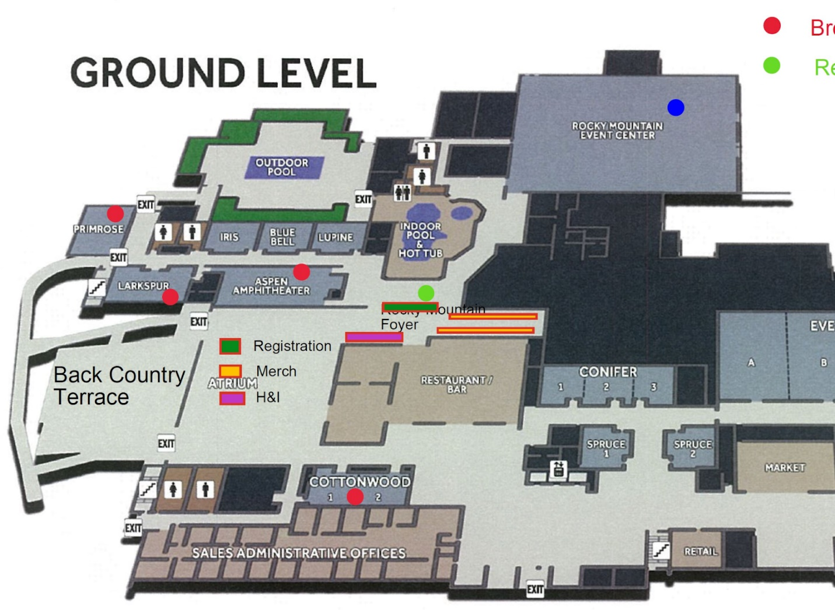

Program Chair: Sandra J.
Verbal report.

Convention Information & Website Chair: Grant K.
This month I continued to export registration order reports to send to the registration committee. I also help coordinate receiving a payment from a member who did not get to complete their order due to confusion with the checkout. I have exported the current state of our Hospitality and Marathon Meeting sign up sheets. I will be closing the online registration October 31st.

QR Codes were created for online program schedule and map of hotel, to be printed on the paper program schedules.

Print & Display Chair: OPEN (Sage B. stepping in)
Hello CRCNA committee!
For Print & Display, I got a flyer created for Registration pre-orders, indicating that online registration will close Oct 31, and sent out to the committee for distribution.
I’ve been working on the program schedule, and have some print-outs for us to look at today. They’re 8.5 x 14, and I’m happy with the larger print this has allowed us to have. I look forward to feedback from the committee today. I’m working with Grant getting a QR code to put on these, to lead folks to an online program and a map of the hotel. I’m waiting until Oct. 21st to place the order for these, so there’s plenty of time for the printing company to get the order fulfilled and then for me to fold them!
I ordered and received a foamboard poster of the CRCNA logo, and have a stand to display this so that people can take photos in front of it during the convention. Just need to figure out where it should be displayed.
Kathleen has asked if we’d like to have the eternity wall up again this year. I sent an email out about it and it sounds like everyone is in favor of this, if there’s a spot for it? Next to ballroom.
I’m keeping a list of signs to print, but I’m not sure if we need all of them. I’m hoping to get that solidified today after talking with y’all and walking through the hotel as needed. Here’s the list I have: 22
- Auction Sign – 8.5x11
- Silent Auction forms (for people to bid on items)
- Best of CRCNA 1987 – 2024
- Marathon Meeting Room sign w/list of topics
- H&I Welcome /Sign In Here – 24x36
- Hospitality Room Sign – 11x17
- Hospitality Location Info Sign (for lobby) – 8.5x11, qty 5
- Hotel Map (1 or 2?)
- Main Lobby sign – 24x36
- Marathon Meeting “How to Chair” sign – 11x17
- Meeting in Progress signs on pink paper (quantity?)
- 5 Minutes Remaining signs for speakers on pink paper (quantity?)
- Merchandise Room main sign – 24x36
- Merchandise Credit Card Sales – 8.5x11
- Merchandise Cash Sales – 8.5x11
- Merchandise On Site Sales sign – 8.5x11
- Pre-ordered Merchandise pick-up sign – 8.5x11
- Program Speakers sign-in – 11x17
- Quilt sign – 8.5x11
- Registration Line sign – 24x36
- Friday Entertainment sign- dance & poker (Gari created and will print)
- Saturday Entertainment sign- band & karaoke (Gari created and will print)
- Extra posterboards and markers for anything we might need during the convention!
Other items to print
- Program Schedules (1000)
- Program’s preambles and formats (brought these today)
- Name tags (need size to fit in lanyards)
- Banquet table signs- beef, chicken, veg (need quantities of each)
- Sunday morning breakfast cards (need quantities of each)
- Entertainment tickets (F&E printing these)

Thank you for the opportunity to serve! - Sage B.

Hospitals & Institutions Chair: Zac H.
October H&I Report
Spoke to Terry- Natalie should be conversing with H&H to make Friday morning run smoothly.
Making my last round of calls to treatment centers before the end of October.

Other Business / Final Discussions:

Clean time count down discussed

Total years clean announcement during Saturday night meeting discussed

Tickets for Paizley Park in all swag bags

Elections for CRCNA 39 Subcommittee Chairs:
Registration: None
Hotels & Hospitality: Jen S. nominated
Fundraising & Entertainment: Jules nominated
Merchandise: Jess H. nominated
Programs: Melissa B. nominated, Tina W. nominated
Convention Info & Web: Dan B. volunteered
Print & Display: Sage B. nominated
H&I: Brandi J. volunteered

Next CRCNA 38 Committee Meeting:
November 14, 2024 at 4:00 PM – Hybrid:

In Person: Hospitality Room _, on the 11th floor at the Hotel, Marriot Denver,
4900 S. Syracuse St. Denver, CO 80207

Zoom: Meeting ID: 290 350 0360
Passcode: CRCNARocks
https://us02web.zoom.us/j/2903500360?pwd=TVBrSlF3TEF4QUZORHhaT0NVYk5FUT09

Meeting adjourned at 1:01 PM.

