CRCNA XXXVII Meeting Minutes
Meeting: September 9, 2023 Held in person and on Zoom

9:00 a.m. Open Meeting

Serenity Prayer

Clean Time Celebrations:
Beth R. 5 years!!
Congrats, Beth!
12 Concepts read

Roll Call

Approval of minutes from August; approved

Administrative Reports:

- XXXVII Chair: Lindsey B.

Nothing formal to report, has hopped into committees as needed.

- XXXVII Vice Chair: Dan B.

Pikes Peak taco party was moderately attended, has the contract for next year’s CRCNA will start looking at that in detail.

- XXXVII Treasurer: Nick P.

Hi all,
Every thing looks good. We have 24,310.42 in the bank but I will need to give the hotel a check for
approx 10K tomorrow morning. In addition to this we are going to have to lend CNAC around 3k to
pay the deposit on next year’s hotel. This is not ideal but we have been assured that region will
reimburse us this month.
One other thing to note is there are 2 transactions not accounted for on the P&l that I sent out. One is
for 8.76 and the other is for 4.38 and the bank feed is as follows SP THE BASIC STORE
HTTPSTHEBASIC. Does anyone recognize this? This is super odd because I do not recall anyone
asking for a an amount this low and do not seem to see any requests. My suspicion is that this may be
some kind of subscription or fee.

- XXXVII Vice Treasurer: Vacant

- XXXVII Secretary: Matt D.
Nothing to report. Thanks for letting me be of service

Subcommittee Reports:

- XXXVII Program Chair: Ian D.

September CRCNA 37 Programs Report
- Committee met to discuss current status of workshop speakers and set goals and deadlines to
ensure we meet commitments to have a completed program with speakers to P&D in time to get
the layout completed.
- Created sign up forms for Room Coordinators and Workshop Chairs
- Discussed work to be done at next committee meeting.
- Flights booked and room nights for speakers coordinated.
- Still owe meal preferences to Registration.
- Fixed a couple of scheduling issues with P&D and on our forms.
- Signed Taper contract submitted to CNAC for approval and returned to vendor.
- Confirmed A/V Needs with H&H.
Thank you all for allowing me to serve this convention.
In Loving Service,
Ian D

- XXXVII Hotels & Hospitality Chair: Kathleen L.
Current Business:
- Working with the Programs Subcommittee to meet printing and AV deadlines.
- They will have the workshop speaker and chair names between September 24 th
and I will have the final schedule to print and AV by Sept 30 th for their deadline.
- Coordinating with the WB for participation at the Friday workshop
- Met with hotel to finalize all BEO’s
- Subcommittee needs have been submitted to the hotel and AV, with the
exception of the reader boards for Programs
- Waiting on invoice from AV and will send it out for review as soon as it’s received
- Will have centerpieces complete by end of this month
- All hotel rooms in our block are reserved, there are very few at regular rate
- We suggest checking with hotels in the surrounding area
- Grant has all the sign up links up and ready to go!
- New Business:
- Next meeting with the hotel will be during the walk through
- Will ask committee and Treasurer if we can order table gifts

$713.75 Subtotal
-$46.39 Invoice Discount
$60.00 Shipping
$727.36 Total with Tax

- Please fill out the sheet going around for the BT Book Drive, we would like to get
an estimate at this time
- Hotel has asked for a PreCon mtg Nov 9 th at 1pm. Several committee members
will be there and we will also have it virtual for those not at the hotel yet or feel
free to send questions
- Awaiting the upcoming Regional Assembly to see if there will be new Trusted
- Servants elected and then we will finish the letter for H&I - Erica, JR, Chris,
Natalie - to send to facilities. Looking at having 5 hybrid opportunities if this body
agrees with this.
XXXVII Print & Display Chair: Empty (Kathleen L. Stepping in)

Current Business:
- Draft copy of the program schedule is complete and sent to the Program
- Subcommittee and CRCNA Chair for review, approval, and finalization
tickets and name tags printed and given to Registration Chair as of this mtg
- Upcoming Business:
September 30 th is the deadline to receive final speaker and chair names for
program schedule and send to AV and print
- Please submit additional sign requests this month
- XXXVII Merchandise Chair: Jessica H.

Completed Business:
- Made master list for the convention
- Sent out emails to people who ordered single color shirts
- Had subcommittee mtg to determine final coffee mug design and talk about
- notebooks/hats
- Responded to emails about the art gallery

Paypal total for aug-$627

Current Business:

- Still in the process of working on coffee mug order, but just waiting to hear on final go.
- Looking for forms for alternative merchandise so they can sell on Sunday
- Announcing art gallery at meetings and collecting art for this.
- Bid on journals from hopefully Gina
- Ending pre order around Sept 20th

Upcoming Business:
FINAL MERCHANDISE ORDER
Finish coffee mug order
Decide on journals, stickers and other items to sell at convention.

- XXXVII Registration Chair: Sarah J.
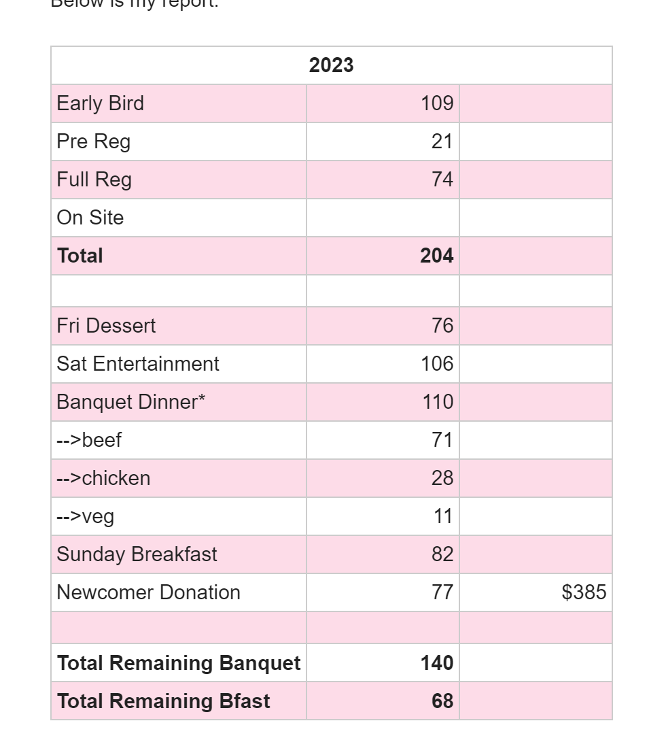
Overpayment issue from last month
- The member who overpaid $10 for her registrations agreed to accept an additional Sat entertainment ticket for the overage
- We had a handful of members who paid $40 while it was listed at that amount. My suggestion is to just leave as is. Not like we'd follow up and ask them to pay extra.
- We had one member ask for a refund (2 early bird registrations) -- this was completed.
- My banquet numbers/totals are off by 4. I’ve gone through all my PayPal and Square reports several times, no idea why. I’m hoping I can get everything to align when I do my final run through of everything before giving totals to Kathleen in Nov.
- All registration packet items have arrived.
- Subcommittee did not meet this month. I’m organizing several meetings over the next two months to pack the registration packets and go over how things will run for registration at the convention, to ensure everyone knows how to fulfill their service commitment.
- We still have a lot of open slots for registration at the convention. Please reach out to me if you have someone who wants to be of service and I’ll contact them.

See you all Saturday in Loveland!
Be well,
Sarah

- XXXVII Entertainment: Beth R.

- Friday Night DJ and Masquerade DJ: Kathleen created a contract, waiting for signatures. Will need to provide hotel room reimbursement and food vouchers (within budget).
- Saturday Night Illusionist: Deposit has not been received (how was payment made?).
- Will be providing 2 banquet meals
- Equipment needs given to Kathleen for Hotel
- Collecting swag items for silent auction and prize give aways, spread the word
- Friday Bingo-no updates
- Poker night-no updates
- Quilt maker-will touch base to see if there are any needs this month
- Fellowship Room-no updates

Thank you for letting me be of service,
Beth

- XXXVII Convention Information & Website Chair: Grant K
This month I met with Sarah to discuss what we will need for a master list of registrations. I’m
planning on having these printed for us at the convention so we can have lists of pre orders for
registration and merch to reference.
There was one request for a registration refund which I initiated in paypal for us. I believe this is
also described in the registration report.
I created and launched the sign up sheets for hospitality room, game room, greeters, and
marathon meetings. Kathleen initially gave me a list of the marathon meeting topics, and I’ve
just read Ian’s email about the marathon meetings times, I’ll update these to be 50 minute
increments.
We also discussed that we will post on the website soon when online registration and
merchandise orders will end. For registration we are ending Oct. 31st, and merchandise it
sounds like potentially Sept. 15? Will confirm this hopefully in our subcommittee meeting today.

Transferred money from paypal to the crcna bank account with Nick P.
Thank you for letting me be of service.
Grant K.

- XXXVII Hospitals & Institutions Chair: Erica H.
CRCNA XXXVII H&amp;I Report September 2023
Current Business
3 speakers finalized: Brandi J, Chris F, and now Natalie A
Sent email flier to all facilities we were able to get ahold of

Upcoming Business
Awaiting info for Zoom call to give to facilities so they may join
Get sharpies and plastic lining to sign new comer sheet on

LIASION REPORTS:
BFE: None
Boulder: Eric C.
Book Drive - Will get best count as possible after Boulder’s area tomorrow
Mile High: Hidy F.
Book Drive – Will have rough numbers after Mile High Area tommorrow
Mountains West: None
Off the Wall: Tamara J.
Pikes Peak: Dan B.
Nothing to report
Serenity Unlimited: None
Ute Pass: None

Elections:

Print and Display: no nominations

Committee Roll Call:
Administrative Committee:
- Chair: Lindsey B.
- Vice Chair: Dan B.
- Treasurer: Nick P.
- Vice Treasurer: Empty
- Secretary: Matt D.
Subcommittees:
- Program Chair: Ian D. -
- Hotels & Hospitality Chair: Kathleen L.
- Print & Display Chair: Kathleen L. (stepping in)
- Fundraising & Entertainment Chair: Beth R
- Merchandise Chair: Jessica H.
- Registration Chair: Sarah J.
- Convention Information & Website Chair: Grant K.
- Hospitals & Institutions Chair: Erica H.

Old Business:
Badges to be made for alternative merchandise vendor(s) so the committee knows who is approved to sell and who is not.
Sept 1 will be the start of sign-ups for hospitality room (Fellowship room). When announcing signups there will be an option for groups to sponsor a coffee station for ($XXXXX)
We ran through Basic Texts last year so the basic text donation is very important this year. There is not a surplus this year like there has been in recent years. Covid carry overs allowed for the surplus the last few years, we now have caught back up. PLEASE DONATE BASIC TEXTS for the giveaway.
Also, if your homegroup would like to put in homegroup information (Date, time, address , etc.) please do not put in phone numbers or identifiable information.
Storage visit and inventory will be in September.
Open and closed times need to be submitted to Kathleen for P&D by September
October 31st will be end of online registration
Sept 30th will be end of online merchandise
If people cannot afford registration, no addict will be turned away. We will provide a free registration and ask them to see Kathleen to help volunteer for small projects to help keep CRCNA running smooth.
Sept 16th will be regional assembly
8085 E. Hampden Denver CO
Elections for CRCNA 38 will be in October.

New Business:
Steve K. joined on behalf of CNAC-

Explained that there are a very limited amount of hotels in Colorado that can hold CRCNA. Ballroom has to be around 11 square feet.

CNAC tried the following hotels that didn’t work o:
Double Tree – Pikes Peak
Hyatt In the DTC – Mile High
Plus 2 other that didn’t work

CRCNA 38, 39, and 40 will be held at:
DTC Marriott – Mile High
Room Rates for CRCNA 38 will be $139
On behalf of the Pikes Peak region, Dan B. asked in the future how can CRCNA be held closer to that region. Steve K.’s answer was that while we can theoretically rent places like the Pueblo convention center, we would have to find adjecent hotels. Again, that is doable, however, when we go through hotels that have convention space, we get the room blcks and food and very ofetn we get the entire convention space for free.

CRCNA committee will need two storage meetings; one for inventory and one for moving the supplies and banners to the convention.
Tabled: Where should the last committee meeting be held?

Next CRCNA XXXVII Meeting:
October 14th,2023 9:00am - Noon - On Zoom Only
Zoom Meeting will start at 10 am
ID: 290 350 0360 Passcode: CRCNARocks

