CRCNA XXXVII Meeting Minutes
Meeting: September 9, 2023 Held in person and on Zoom

9:00 a.m. Open Meeting

Serenity Prayer

Clean Time Celebrations:
12 Concepts read

Roll Call

Approval of minutes from August; approved

Administrative Reports:

XXXVII Chair: Lindsey B.

XXXVII Vice Chair: Dan B.

XXXVII Treasurer: Nick P.

XXXVII Vice Treasurer: Vacant

XXXVII Secretary: Matt D.
Nothing to report. Thanks for letting me be of service – I have 10 basic texts from my homegroup, DTC – Down to Change in my car for BT drive. Will bring it to the hotel.
ILS,
Matt D.

Subcommittee Reports:

XXXVII Program Chair: Ian D.

- Completed the schedule for speakers and have the physical prints back from the printer.
- Had to cancel recording vendor to due their ilness, and their backup folks couldn’t attend. And the reached out to other vendors and found one and they are now under contract, unfortunately the deal was not as good as the original, CNAC was involved in negotiations and the hit should not be felt. CDs and thumb drives will be available.
- Working to finalize the room coordinators, finalizing gifts for speakers, reimbursement request will be coing for airfare for speakers as well as gifts and other misc. items. Budget overall will be under.
- If GC decides to have inmates read at the Sunday morning, let him know so he can adjust the format for the meeting.
- Completed and submitted schedule of workshop speakers
- Recieved and reviewed draft of printed trifold
- Procured replacement Recording vendor
- Working to finalize room coordinators and meeting formats
- Working to finalize main speaker gifts
- Sent Tshirt and mug requests for main speakers
Left To DO:
- Send confirmations for main speakers but my committee have been in regular contact with them
- Printing surveys, speaker release forms, and formats
- Consolidating digital resources onto Google Drive for future Program Chair
- Next meeting: Sunday, October 22nd 4:30-6P online using CRCNA Committee Zoom Room

XXXVII Hotels & Hospitality Chair: Kathleen L.
Current Business:
Centerpieces are complete to coincide with the masquerade theme.
- Table gifts are in.
- Hotel has scheduled a precon meeting Thurs Nov 09 at 1pm in the JQ Hammond
Boardroom to go over any remaining logistics, please let me know who is
attending. We can set up a virtual component if you’d like.
- Waiting on AV for invoice and other questions.
Hybrid speaker meetings are in place and H&I has received the schedule with all
the details and cover letter for the facilities. All are welcome to login.
Hybrid meetings will be as follows:
o Friday 5pm – NA World Board Presentation
o Friday 7pm – CRCNA XXXVII Kick-Off Speaker Meeting
o Saturday 2pm – CRCNA XXXVII & Workshop
o Saturday 7pm – CRCNA XXXVII Main Speaker Meeting
o Sunday 10am – CRCNA XXXVII Closing Speaker Meeting
- BT Book Drive is going well with the exception of a few lingering resentments
from members about having left over BT in 2021. Not sure how to resolve this
just trying to remain neutral. Such a bummer.
- Discussion about the salad bar
- Need greeters at hotel
New Business:
- Tracking hospitality and greeter signups, will ask Grant for info.
- Receive banquet numbers the first week of November.
- Will continue to coordinate with Entertainment committee about needs –
greenroom, illusionists meals, and any last minute details.
- We really would like some Greeters to help in the lobby with arriving guests.
- Will be going to the storage unit Oct 21 st around noonish to pick up supplies.
Please let me know what you would like picked up and stored at my house then
brought to CRCNA.
Getting very excited and freaked out all at the same time! Please let me know if
I’m missing something or if anyone needs anything. It’s been a huge pleasure
serving with each of you and I’m humbled by your expertise and graciousness.

XXXVII Print & Display Chair: Empty (Kathleen L. Stepping in)

Current Business:
- The program schedule had some last minute changes from the Program
committee, everything is finalized and sent to print. Will dropship these to the
Registration chair.
- Last minute changes to the MM list, this is finalized, MM sign is updated, and
new list is sent to the Website.
- Signs have been submitted for print along with new preregistration nametags and
large map for the rotunda. Sept prereg nametags will be dropshipped to Reg
chair and Oct prereg nametags will be brought to the convention.
- Sent survey template and speaker sign-in template to Programs for their use. I
believe there are some printed forms in the tote from last year, please check this
prior to making more copies.
- There will be small stand up tables in both hallways for surveys throughout the
convention.
Upcoming Business:
- Will be going to the storage unit Oct 21 st around noonish to pick up supplies.
Please let me know what you would like picked up and stored at my house then
brought to CRCNA.

XXXVII Merchandise Chair: Jessica H.

Completed Business:
Final merchandise order completed!!!
Mugs received
Responded to emails about the art gallery and alternative merch

Current Business:
Need to order easels

Upcoming Business:
Make bags for convention

XXXVII Registration Chair: Sarah J.
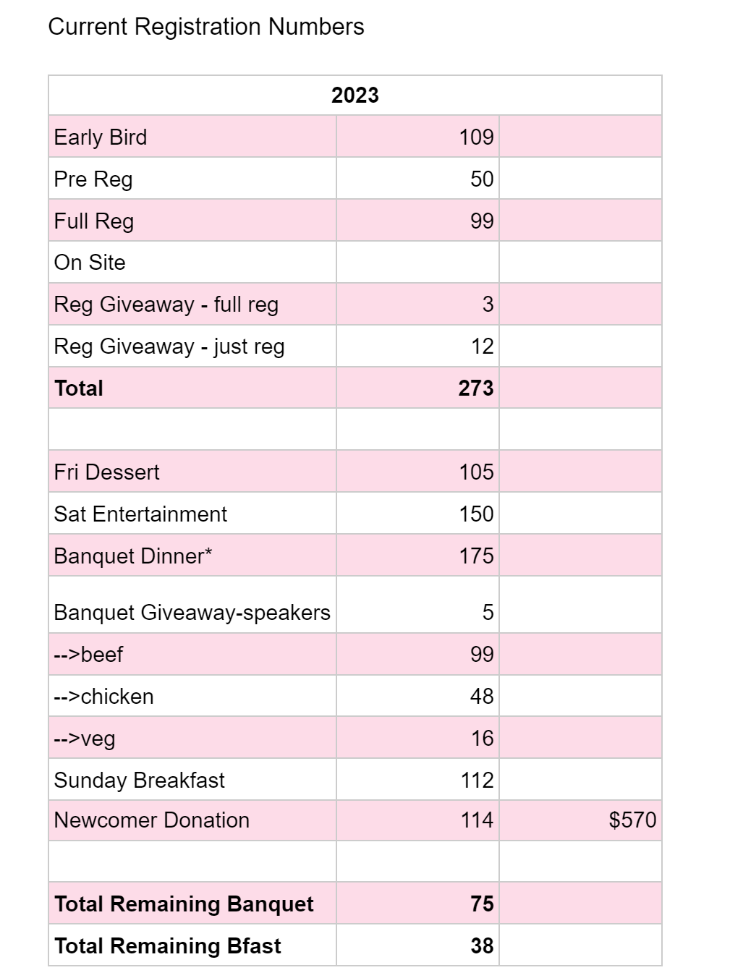

September was a great month– lots of full registrations and additional items purchased.
Subcommittee has met once to put packets together. Our next get together will be Sunday, October 15th to (hopefully) put together the rest of the packets. Let me know if anyone would like to join.
We’re still looking for members to be of service in registration. Announcing at meetings and slowly filling the open spots.
My budget sheet (which is likely slightly off) says registration has currently brought in $25,940. Last year registration made a total of $47,746, so I feel we’re in a good spot this year. We still have the month of October and on site, which brought in almost $15k last year.

Be well,

Sarah

XXXVII Entertainment: Beth R.

Illusionist:
- Both performers are vegan, considering offering doordash card for them to
purchase a meal.
- Otherwise, all set to go. Nathan M will be entertainer liaison and will help
to see to needs for entertainers

Masquerade Ball:
- Pricing of doorway décor, balloon stands and other minimal décor (Ally is
completing funds request so that these can be ordered.
- Subcommittee will decorate before event, any volunteer help will be
greatly appreciated
Dylan and Maya :
- Need Contract signed from them…

- Bingo: Will Inventory on the 21 st and evaluate needs
- Poker: Tiffany will provide tables and all equipment
- Game Room: Should be all set
- Quilt: Will touch base one more time, unless more is needed before convention.
- Will complete check request form for her payment.

Will have one more subcommittee meeting before Thursday night at the
convention hotel. Next meeting 10/26/23 at 6:30pm on Zoom

XXXVII Convention Information & Website Chair: Grant K

Not too much, keeping the numbers sent to reg and merchandise accurate and timely. Sending Paypal report to Nick and has updated the website/shop as needed. Happy to help subcommittees as needed at the convention.
This past month I worked with registration and merchandise to get the reports of sales from the
online website, as well as gave our treasurer a full report of paypal sales from April-September.
I have sent the current state of the sign ups for Hospitality, Greeters, and Game room to
Kathleen. I will also send the MM list to Ian.
I will also be pulling a total list from Square for registration and merch to have.

XXXVII Hospitals & Institutions Chair: Erica H.
Current Business
- Fliers handed out and emailed out to over 100 people in the fellowship at last area
(thanks to Denise and Chris) to get the word out about the zoom options for CRCNA
- Books received (thanks to Kathleen)
- Total book count for the areas…Heidi? Kathleen?
Upcoming Business
- Last few calls to be made to facilities far away to invite them on zoom
- Get sharpies and plastic lining for new comer sheet

LIASION REPORTS:
BFE: None
Boulder: Eric C.
Started to collect books, has a stash in his trunk, and will continue to collect up to the convention. Will deposit to H & I table at the convention.
Mile High: Hidy F. - Absent
Mountains West: None
Off the Wall: Tamara J.
Things are going along and have been going to meetings to collect Basic texts. Fighting an opinion that books are being hoarded, unfounded, but fighting the misconception.
Pikes Peak: Dan B.
Hard on the area to get invloved with service, will start attending meetings and will find willing members to serve.
Serenity Unlimited: None
Ute Pass: None

Elections:

Program Chair: No Nominations
H & H Chair: Eric C. Nominated – Declined
Note: H & H will have support from Mike H. and Steve K. from CNAC
Matt D (Mile High Area) volunteered for position, has 3.5 years clean, guidelines suggest 5. Conversation around waving or not. Qualified outside of clean time - Elected
Print and Display: No Nominations
Merchandise: Sarah J. nominated – Declined
Registration: No Nominations
Entertainment: Gari G. nominated – qualified - Elected
Information and Website: Grant k. expressed interest in doing the position again, knowing the position will allow him to be more effective next year. Elected
H & I : Erica H. expressed interest in retaining position Elected

Admin Committee Nominations (to be ratified and voted on at NA region)
Vice-Chair CRCNA 38:
Treasurer:
Vice-Treasurer:
Secretary CRCNA 38: Sage B. nominated – discussion was to bring her nomination to region

Committee Roll Call:
Administrative Committee:
- Chair: Lindsey B.
- Vice Chair: Dan B.
- Treasurer: Nick P.
- Vice Treasurer: Empty
- Secretary: Matt D.
Subcommittees:
- Program Chair: Ian D. -
- Hotels & Hospitality Chair: Kathleen L.
- Print & Display Chair: Kathleen L. (stepping in)
- Fundraising & Entertainment Chair: Beth R
- Merchandise Chair: Jessica H.
- Registration Chair: Sarah J.
- Convention Information & Website Chair: Grant K.
- Hospitals & Institutions Chair: Erica H.

Old Business:
Steve K. joined on behalf of CNAC-

Explained that there are a very limited amount of hotels in Colorado that can hold CRCNA. Ballroom has to be around 11 square feet.

CNAC tried the following hotels that didn’t work o:
Double Tree – Pikes Peak
Hyatt In the DTC – Mile High
Plus 2 other that didn’t work

CRCNA 38, 39, and 40 will be held at:
DTC Marriott – Mile High
Room Rates for CRCNA 38 will be $139
On behalf of the Pikes Peak region, Dan B. asked in the future how can CRCNA be held closer to that region. Steve K.’s answer was that while we can theoretically rent places like the Pueblo convention center, we would have to find adjecent hotels. Again, that is doable, however, when we go through hotels that have convention space, we get the room blcks and food and very ofetn we get the entire convention space for free.

CRCNA committee will need two storage meetings; one for inventory and one for moving the supplies and banners to the convention.
Tabled: Where should the last committee meeting be held?

New Business:
Meeting to go to the stoage unit – Banners need to be taken from unit to convention. Lindsey B. asks for help getting the banners to and from. Has commitments from Dan B. and other to help move them. Kathleen has the storage key and will soon be passed to the vice-chair of region. Keys have been a huge topic around region, the decision has been made to have a check in/ check out system. A second key needs tp be made, working with only one key right now, which isnt realistic.

Ian asked if a screen drop if possible or a laptop connected to a TV for main speakser for those that were not in the room and simulcast the speakers. that hasn’t been included in the budget. And didn’t want to commit until broughtto the CRCNA Committee.

Sunday moning meetings F&E will read
Website and Info will read
+2 others
Cookies in the boardroom for the CRCNA meeting before CRCNA, bring cookies.
Salad bar is on the hotel if it flaunders due to loacation change for their “Manager Hour”

Next CRCNA XXXVII Meeting:
November 9th,2023 at the hotel 6:00pm at the hotel
& Zoom Meeting for those who cannot attend
ID: 290 350 0360 Passcode: CRCNARocks
Hotel: 4705 Clydesdale Pkwy, Loveland, CO 80538

