CRCNA XXXVII Meeting Minutes
Meeting: August 12, 2023 Held in person and on Zoom

9:00 a.m. Open Meeting

Serenity Prayer

Clean Time Celebrations:
None announced
12 Concepts read

Roll Call

Approval of minutes from August; approved

Administrative Reports:

- XXXVII Chair: Lindsey B.

Hi everyone,
Another quiet month for me, not a whole lot to report.
I have been corresponding with the Pikes Peak activities chair and they have decided to host the
Mexican dinner fundraiser on 9/4 from 2-5. I now realize this is a Monday so maybe there was a typo on
the date. Also need to find out the location. I checked their area website and didn’t see anything.
I received an inquiry about an alternative merchandise vendor who was interested in working our
convention and I told him that we already had a vendor for this year.
I am looking forward to the walkthrough next month and for things to start coming into focus!
As always, let me know what I can do to support your subcommittee.
Grateful to serve,
Lindsey B. CRCNA XXXVII Chair
- XXXVII Vice Chair: Dan B.

Nothing to report, was unable to be in person (was on zoom) happy to be voted in last region and looking forward to serving. Is also temporary liaison for the Pikes Peak area. Will try to make all subcommittee meetings.

- XXXVII Treasurer: Nick P.

Sorry I am unable to attend this months meeting but please feel free to reach out if there is anything I
can help with.
My Income statement represents the most resent bank statement and not the current balance(as usual).
The statement ends at the end of each month so this number is accurate up to July 31st 2023. The
current balance is $10905.51. This may seem like a large drop from last months 18k number but this
includes our donation to region from last year which has finally been put behind us.(YAY)
There is also 12274.40 in the papal account. So our effective cash balance is $23,179.91.
This being left in the paypal account is likely my fault and I discussed with grant that we would get it
transferred this month and try to do transfers once a month moving forward now that transaction are
picking up.

- XXXVII Vice Treasurer: Vacant

- XXXVII Secretary: Matt D.

Asked about the key will get with Ian to get a new key handed off. That’s all, thank you for letting me serve.

Matt D.
Subcommittee Reports:

- XXXVII Program Chair: Ian D.

Program was approved at Region with a small change to the title of one workshop, gratefully accepted and incorporated into the schedule sent to Print & Display
The Regional body was given the option to choose between the History of NA presentation or a World Board presentation on the Future of Narcotics Anonymous which will be a presentation about the motions that were passed during this most recent WSC. Region chose The World Board presentation. Program Chair to coordinate.
Committee met July 30th in person for celebratory BBQ for getting the Program approved by Region.
During this meeting we discussed and reinforced the commitment to attempting to gain widespread representation from all areas in the Colorado region. In order to facilitate this, we decided to create a form that will concatenate a number of pieces of information related to clean time, choice, time commitments, et cetera.
We also decided to extend invitations to speak at a workshop for those that were on our top list and late submitters.
Sonic and Ian met to coodinate creation of this Form and it’s associated QR Code.
I have been working with Kathleen to coordinate production of the program and scheduling and feel great about where we’e at with that.
Thank you for allowing me to serve along side all of you. I’m getting really excited for this convention.
In Loving Service,
Ian D Program Chair CRCNA 37
Workshop Speaker Survey Link and QR code below
https://forms.gle/tSAEs9Wc5a681zmG6

- XXXVII Hotels & Hospitality Chair: Kathleen L.

Current Business:
• Working diligently with Programs and the hotel staff on the BEO’s (attached separately)
• Will go over subcommittee hotel needs and the layout during this meeting
• Once we have everything established, we’ll get the invoice from AV
• Working with the Entertainment subcommittee designing centerpieces
• All hotel rooms in our block are reserved, there are a few rooms at regular rate
• We suggest checking with hotels in the surrounding area for a more reasonable price
New Business:
• Next meeting with the hotel is August 18th at 9am via Zoom
• Will launch Hospitality Room signup in August along with Greeters
• Will ask committee and Treasurer when the best time to order table gifts will be

- XXXVII Print & Display Chair: Empty (Kathleen L. Stepping in)
Current Business:
• Draft copy of the program schedule is complete and sent to the Program Chair,
Reg Chair, and CRCNA Chair for review
• Once the program schedule is approved we’ll get it to H&I for their form letters
• Tickets and name tags are complete and below for review
• Working with Registration on schedule format to best fit reg packets
• Please review times and locations and advise on updates/changes (see below)
Upcoming Business:
• Keeping in touch with AV for all needs
• Tickets & name tags will be printed and given to Reg committee at our Sept mtg
• Program schedule will be complete end of Sept and ready for print
• Please submit sign requests this month, will have previews at our Sept mtg
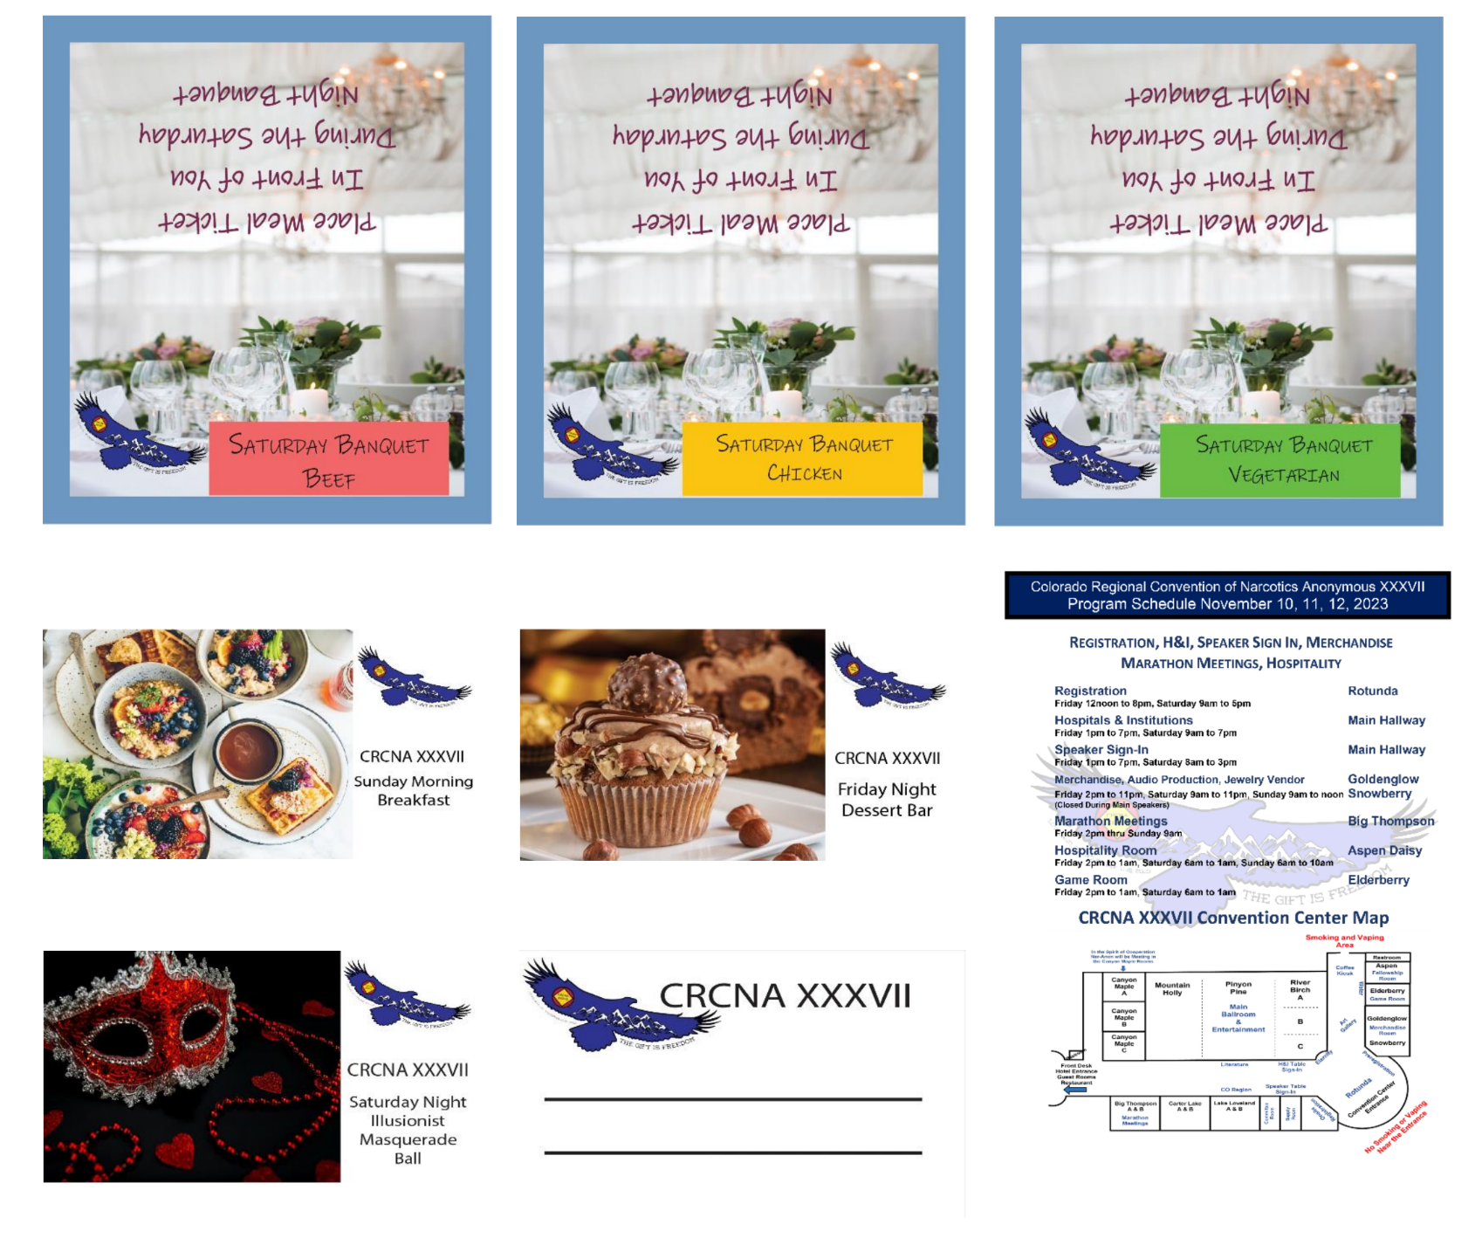
XXXVII Merchandise Chair: Jessica H.
Completed Business:
- Attended DTC BBQ and brought in $78
- Got paypal reports from April through July completed and sent to treasurer
- Paypal total for July ~ $571
Current Business:
- Send out emails to people that ordered single color shirts.
- Still in the process of working on coffee mug order.
- Announcing art gallery at meetings and collecting art for this.
- Working on pre order master list to have at the convention
Upcoming Business:
- Subcommittee meeting next week
- Finish coffee mug order
- Decide on journals, stickers and other items to sell at convention.
- Pre order convention list from square and paypal

XXXVII Registration Chair: Sarah J.
Subcommittee did not meet this month. We were not able to attend the 4th of July picnic. We attended the DTC picnic but unfortunately did not sell any registrations.

- PayPal total for July – $3,810
- Pricing is now $45 for registration and $150 for full registration.
- Still need members to be of service at the convention for registration.
- Packet items status
  - Pins - received. Brought the tiny pin to show everyone.
  - Neck wallets - received. They look great.
  - Pens - just ordered.
  - Magnets - received. Brought to show the committee.
- Upcoming events
  - Bingo Night – Aug 12th
  - Women’s Retreat – Aug 25th to 27th – not sure if this is viable but will ask when I get there. I’ll bring some forms and will have my phone that I can use as the square reader.
  - Labor Day Picnic – Sept 4th
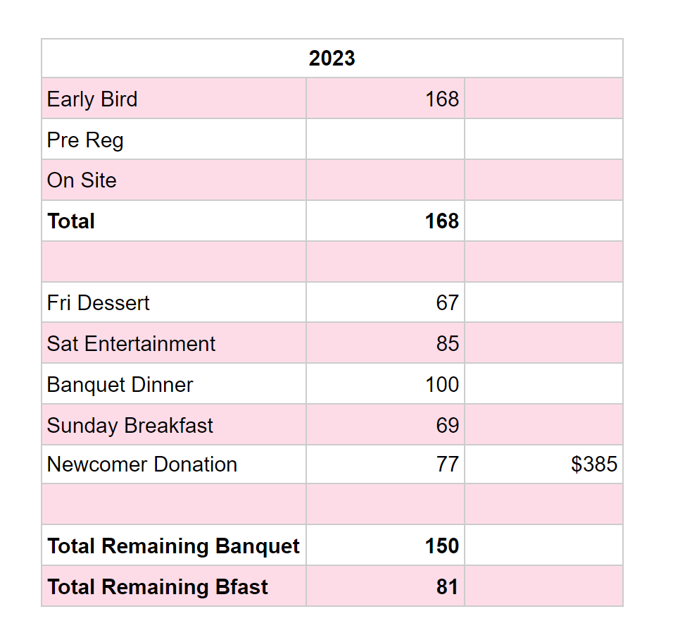
- XXXVII Entertainment: Beth R.

Quilt: 2 drop offs with T-shirts have been made to Mary (Thank you Kathleen!)

Illusionist is available to Perform for our Saturday Night event before
Masquerade Ball: Contract and initial invoice attached for review.
Awaiting Contract from Friday Night/Masquerade Ball DJ
Tiffany S. is available and able to run the Poker Tournament this year!
In the process of collecting swag for prizes (taking donations if all could
announce)
Would like to request that we start announcing for the need for volunteers to help
with events; would love to have enough help that EVERYONE can rotate through
and enjoy the convention events.
No meeting for this sub-committee in July as we were in a holding pattern waiting.
for confirmation from entertainment choices. Next meeting will be August 17th at
6:30 pm on Zoom.
Spoke with Shannon in Pikes Peak area - 4th sept Mexican dinner 2 pm – 5 pm in Colorado Springs
2221 N Wasatch Ave Colorado Springs 80907

- XXXVII Convention Information & Website Chair: Grant K

On the evening of July 31st I updated the registration prices from the early bird registration price
to the pre-registration prices. We did have one order from a member late on the evening of July
31st after I had updated the price, and mentioned to Sarah that perhaps we would want to
reimburse them since they technically did order within the early bird window. Sounds like she
will be reaching out to this member.
There were some orders on the web store that showed as “canceled”, meaning they started an
order but did not complete the checkout process. I am reaching out to these people to verify that
they meant to cancel their order, in case this was also a cause of members thinking they had
placed an order but it wasn’t paid for last year.
I’ve sent our convention information and flyer to world and contacts for some surrounding
regions and areas. Continuing to do this. Full accountability, I apologize that I did not realize this
was much earlier on the timeline for my position until I saw the timelines again. Another thing I
think I am a little behind on is the sign ups for marathon meetings and hospitality. I’ve contacted
Ian and Kath to see how we want to handle this and will get those set up ASAP.
- XXXVII Hospitals & Institutions Chair: Erica H.

LIASION REPORTS:
BFE: None
Boulder: Eric C.
Will be at the Boulder Area Labor day picnic
Mile High: Hidy F. (Absent W/ Notice)
Mountains West: None
Off the Wall: Tamara J.
Pikes Peak: Dan B.
Pikes Peak area - 4th sept Mexican dinner 2 pm – 5 pm in Colorado Springs
2221 N Wasatch Ave Colorado Springs 80907
Serenity Unlimited: None
Ute Pass: None

Elections:

Print and Display: no nominations

Committee Roll Call:
Administrative Committee:
- Chair: Lindsey B.
- Vice Chair: Dan B.
- Treasurer: Nick P. (Absent w/ Notice)
- Vice Treasurer: Empty
- Secretary: Matt D.
Subcommittees:
- Program Chair: Ian D. -
- Hotels & Hospitality Chair: Kathleen L.
- Print & Display Chair: Kathleen L. (stepping in)
- Fundraising & Entertainment Chair: Beth R
- Merchandise Chair: Jessica H.
- Registration Chair: Sarah J.
- Convention Information & Website Chair: Grant K. (Absent W/ Notice)
- Hospitals & Institutions Chair: Erica H.

Old Business:
Hotel chairs/tables/tablecloths and signage to Kathleen by July meeting!
IF WE DO ANY CHANGES AT THE CONVENTION, EACH CHANGE IS $250!

Square terminals are here and are set up

Dan B asked about the hotels for upcoming conventions. The discussion revolved around the cost of hotels post-covid. The cost and size requirements (at least 1500 people) seriously limits the number of hotels available. Maintaining reasonable prices for registration and banquets demands that the cost be as low as possible.

New Business:

Badges to be made for alternative merchandise vendor(s) so the committee knows who is approved to sell and who is not.
Sept 1 will be the start of sign-ups for hospitality room (Fellowship room). When announcing signups there will be an option for groups to sponsor a coffee station for ($XXXXX)
We ran through Basic Texts last year so the basic text donation is very important this year. There is not a surplus this year like there has been in recent years. Covid carry overs allowed for the surplus the last few years, we now have caught back up. PLEASE DONATE BASIC TEXTS for the giveaway.
Also, if your homegroup would like to put in homegroup information (Date, time, address , etc.) please do not put in phone numbers or identifiable information.
Storage visit and inventory will be in September.
Open and closed times need to be submitted to Kathleen for P&D by September
October 31st will be end of online registration
Sept 30th will be end of online merchandise
If people cannot afford registration, no addict will be turned away. We will provide a free registration and ask them to see Kathleen to help volunteer for small projects to help keep CRCNA running smooth.
Sept 16th will be regional assembly
8085 E. Hampden Denver CO
Elections for CRCNA 38 will be in October.

Next CRCNA XXXVII Meeting:
Walk through at the Hotel
Embassy Suites and Convention Center in Loveland
4705 Clydesdale Pkwy, Loveland, CO 80538
JQ Hammond Boardroom
September 9th,2023 9:00am - Noon - On Zoom/In-Person
or
Zoom Meeting will start at 10 am ID: 290 350 0360 Passcode: CRCNARocks

