CRCNA XXXVII Meeting Minutes
Meeting: June 10, 2023 Held in person and on Zoom

9:00 a.m. Open Meeting

Serenity Prayer

Clean Time Celebrations:

12 Concepts read

Roll Call
Dan B.

Approval of Minutes from March; approved

CRCNA XXXVII

Administrative Reports:

- XXXVII Chair: Lindsey B.
Hi everyone,
Fairly quiet this past month. The pancake breakfast was such a success! Thank you to everyone who
helped make this such a great event.
I participated in a regional adhoc last weekend regarding the CRCNA archives and came up with a good
solution that essentially puts all of the responsibility on the regional vice chair, and people who need the
archives for events will “check it out” from them and return when finished. It was mentioned that the
CRCNA vice chair will be responsible to set up and break down the archives for the convention every five
years (or more frequently if the CRCNA committee decides). I believe the last time we had the display
was CRCNA XXXV so this potentially may not be relevant again for CRCNA until the 40th convention. I
received an email from Nar anon, who brought up several topics we can discuss in new business.
As always, let me know what I can do to support your subcommittee.
Grateful to serve,
Lindsey B. CRCNA XXXVII Chair

- XXXVII Vice Chair: EMPTY

XXXVII Treasurer: Nick P.
Hi Everyone,
Sorry for the late email. Unfortunately, I will only be able to be on for about 30-45min tomorrow.
I am a little behind on my report so I should be able to have everything wrapped up this weekend.

Current bank balance is 20,184.24 this includes the donation that is still pending to region and does not include the necessary reimbursement mentioned last month.

I have not attached a Income statement yet because there is a discrepancy that I want to work out with square and fees.
I should be able to get this done this weekend.

Thanks,
Nick

- XXXVII Vice Treasurer: EMPTY

- XXXVII Secretary: Matt D.
Hello all,
Didn’t check mailbox but did go last month. But, if you know that something is coming in, reach out and I am happy to get it for you. Thank you for getting your reports in, I appreciate it very much.

ILS,
Matt D.

Subcommittee Reports:

XXXVII Program Chair: Ian D.
Hello everyone,

I canceled the April Programs meeting due to a death in my family and several members of my committee traveling that day. We are diligently working on speaker evaluations and topics and, will have a list for approval to present to this service body next month, as required. Thank you for letting me serve.

ILS

Ian D

- XXXVII Hotels & Hospitality Chair: Kathleen L.
Current Business:
- Coffee During Convention
o The hotel F&B will provide 4 gallons of coffee in the Fellowship Room from 10pm until empty both Friday and Saturday nights
o The hotel F&B will provide 3 gallons of coffee in the Fellowship Room from 5:30am until empty both Saturday and Sunday mornings
o Coffee with the Dessert Bar available until it runs out
o Coffee with the Saturday banquet & Sunday Breakfast available until it runs out
- Soup & Salad Bar
o The soup & salad bar will be available Friday and Saturday evenings from 5pm to 7pm in order to streamline the dinner rush. This includes a water and coffee station. Would we like to add Thursday to this?
o This is a flat fee of $20 +tax each person will pay the hotel directly at time of service
- Game Room
o On the BEO
- Hotel map draft diagram below along with the guest room chart
- Will begin purchasing table gifts and decorations this month
- Next HH mtg is June 17th onsite in Greeley
- Next meeting with the hotel is the end of July
- Continue building BEO’s
New Business:
- Need to have a draft copy of the program schedule to plug in the BEO’s and calculate the AV expenses using best convention room arrangements

- XXXVII Print & Display Chair: Empty (Kathleen L. Stepping in)
Current Business
- Flyers and table signs printed and distributed to Sub’s
- Registration and Merchandise order forms printed and distributed to Sub’s
- Banner printed and distributed to CRCNA Web Chair
- Upcoming Business
- Need Program schedule draft to begin format development
- Working with Registration on schedule format to fit reg packets
- Received donations from WSO for events or Merchandise auction/chance to win
- Expenses:
No current expenses at this time

- XXXVII Fundraising & Entertainment Chair: Beth R.
Pancake Breakfast was fun, well attended with lots of help from members of this
subcommittee, CRCNA members and other NA members. Thank you all for your help.
A special thank you to Kathleen for helping with supply retrieval and set up.
• Budget items:
1. Budget was $1100.00 for breakfast including supplies budget and donation
to facility
2. Actual spent was $1117.84 with $817.84 in food and supplies and $300.00
in donation to the facility
• Pastor Brittany from the facility visited during event and was very grateful for how
well the space was cleaned and welcomes any future NA events.
• May meeting of this subcommittee with focus on securing the live entertainment for
the convention.
Minutes from Meeting:
• Pancake Breakfast!!!!!! April 22, 2023 0730-1430 (actual event 9am-1pm)
1. Spoke with Pastor Brittany, all ready to host event: request that we
leave everything as we found it and to vacuum after event
2. Site visit tonight for anyone who can attend 8pm at 4210 South
Chambers Road-need to see how many table, space, layout and any
other needs
3. Need to put together a shopping list and will work with CRCNA
treasurer to coordinate a shopping trip
4. Inventory of current supplies this Saturday evening around 5pm
5. ZOOM option for speakers portion of event for anyone who is not local
or who can not attend!
6. Logo has been chosen
7. Will need to assign volunteers for working the door, introduction-
speaking, serving, cooking, clean up
8. Centerpieces
9. Any other thoughts, needs or ideas
10. Comments (PANCAKE BREAKFAST):
a. There’s value in hosting the breakfast at alternative locations
each year. We’ve heard positive feedback from the location
selection this year.
b. Subcommittee members should arrive early.
c. Zoom will be setup for the speaker portion/logo unveiling of
the breakfast.
d. Logo has been selected, but is still confidential for the
moment; 12 submissions for this year; Kathleen is ordering the
banner.
e. The location has two parking lots, so we’re not worried about
parking.
f. Sq. footage of the location should suffice for estimated
number of attendees.

a. We’ll be in both of the rooms. One room will be a “sensory room” (a place
for writing/journaling, board games, drawing, arts/crafts–
quiet activities). Second room will be a game room (cornhole,
ping pong, other games–the hotel will setup the games for
$300/day. Budget is available for this; subcommittee decided
to execute).
b. Coffee will be available at night in these rooms; Hotels &
Hosp. will purchase the coffee for these rooms from the hotel
(hotel will prep and maintain + provide materials).
c. There’s discussion around asking the groups to sign up
for time slots to host an activity/event within the rooms.
i.There will not be hospitality rooms for future
CRCNAs.
d. Hotel will open a soup/salad bar of the evenings in the
location where they serve the free breakfast.

1. Action Items:

a. None discussed for the time being.

• Saturday Night Entertainment
One submission from a band, one from a
comedian
• Comments:
Beth is going to look into a “silent disco.”
• Action Items:
Review the one band; Beth will send out review material for
comedian; there is also a DJ who’s requesting review, but as of
now, we do not have review materials–Beth will get
information from Lindsey.

• Friday Night Entertainment
• No action items for the time being.
• BINGO
• Think about where to host this.
• Poker
• Think about where to host this.
• Open Discussion
• None; contact Beth if there’s any thoughts afterward.
• If folx identify centerpiece things while they’re out and about, send a
picture to the group chat.
▪ Next meeting; May 25th at 6:30pm on Zoom

- XXXVII Merchandise Chair: Jessica H.
Completed business
- Sold tshirts at pancake breakfast
- 15 shirts sold in cash ($300)
- 16 sold on square ($320)
- 49 shirts left that were sold at bingo and other events ( I’ll get the update from my subcommittee next week)
Current business
- In the process of working with West Press to get coffee mug order completed
- Talking to Rich and Liz about jewelry order
- Announcing silent auction, art gallery and encouraging online sales
Upcoming business
- Meeting with subcommittee next week to finalize other items for convention; bookmarks,
- journals, etc.
- Finalize coffee mug and jewelry orders

XXXVII Registration Chair: Sarah J.
Registration Packet Items
- Neck Wallets
  - The committee decided on black neck wallets with white ink – I’ve been working with a vendor and am just about ready to order. Attached is the final mockup we are going with, wanted to bring it to the committee as well to show everyone.
- Pens
  - Committee decided on the colorway for pens – getting ready to order those as well
- Schedules
  - The committee decided they’d rather have more color ink on the schedule and not have the booklet (as booklets are about double the cost and wouldn’t allow for much color)
- Pins
  - Excited to say that we’ve been working with a vendor (Serenity Sam) who has created a design within our budget that looks great. He’s been very patient with the back and forth needed to figure out what will work with the logo. Attached is the final mockup – will be ordering those hopefully next week as well
Ideas for Merchandise
- Rainbow printed CRCNA shirt
- Sunglass cloth w/convention logo
- Sunglasses with the logo on the side
Upcoming/Past Pre-Registration Opportunities
- Women’s Bingo event
  - Two members from the subcommittee were there. I was planning on attending but experienced flight delays and didn’t make the event
  - We had a couple pre-registrations
- Square terminal
  - Suggestion to CRCNA committee is that we invest in another one so that merch and registration can both have one at events and at the convention
- Mile High Area Events
  - I’ll be at the following upcoming events
    - Memorial Day Picnic
    - Service Carnival
- Wyoming Convention
  - Should we get another sign printed for Kathleen to take?
Need for Volunteers
- Our subcommittee is looking for members to be of service for registration at the convention. If you know someone who would like to help out, please give them my email
Be well,
Sarah
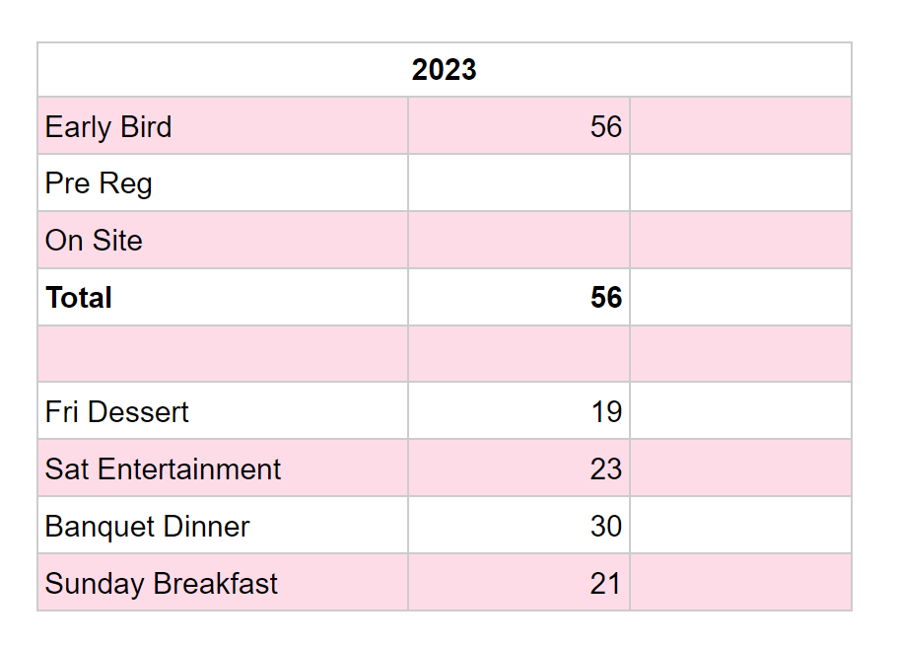

- XXXVII Convention Information & Website Chair: Grant K.
Hello all,
- I have been continuing to maintain our web store and creating reports for registration and
merchandise committees. I’ll be continuing to work with them to get them the data they need.
- The reports are a bit cumbersome, and I’d like to work towards getting clearer reports for those
committees to ensure we have a smooth and transparent process while taking web registrations
and merch orders.
- I’ve also received some follow up emails from a vendor who submitted a proposal to us a few
months ago.
- Q: Do we have any plans for our vendors?

- I have shared paypal and square reports with our treasurer.
- Thank you for letting me be of service to our fellowship, and as always feel free to reach out if
there is anything I can help with.
- XXXVII Hospitals & Institutions Chair: Erica H.
Completed Business
- Almost all facilities have been called
- Current Business
- Need to get jpg of logo to put on sheet, will reach out to Grant
Upcoming Business
- Book drive

LIASION REPORTS:
BFE: None
Boulder: None
Mile High: Hidy F.
Mountains West: None
Off the Wall: Tamara J.
Pikes Peak: None
Serenity Unlimited: None
Ute Pass: None

Elections:

P&D Nomination – None

Committee Roll Call:
Administrative Committee:
- Chair: Lindsey B.
- Vice Chair: Empty
- Treasurer: Nick P. (Absent W/ Notice)
- Vice Treasurer: Empty
- Secretary: Matt D.
Subcommittees:
- Program Chair: Ian D. -
- Hotels & Hospitality Chair: Kathleen L.
- Print & Display Chair: Kathleen L. (stepping in)
- Fundraising & Entertainment Chair: Beth R
- Merchandise Chair: Jessica H. - Absent w/ Notice
- Registration Chair: Sarah J.
- Convention Information & Website Chair: Grant K. -
- Hospitals & Institutions Chair: Erica H. – Absent w/ Notice

Old Business:

Conversation around lowering/raising price of registration.
Invite CRRMCO and Women’s retreat to have a table at the pancake breakfast.

If you have contracts take them to the board, Chair of the board is Mike H, and he needs to sign those. The Board meets quarterly. Amounts over $1000, and you can get them to Lindsey.

Mile high asked: Is there a possibility to have a booth at CRCNA to encourage service?
Committee said yes and we should encourage other areas as well.

New Business:

Theme and Logo were chosen.

Square training:
DO NOT put your phone number in the square app if it asks to “Secure your account”

Motion to Close

Adjourn Meeting

Thank you for letting me be of service,
Matt D.

Next CRCNA XXXVII Meeting:
June 10th 9:00am - Noon - On Zoom
Meeting ID: 290 350 0360 Passcode: CRCNARocks

