  
Colorado Regional Service Committee of NA  
P.O. Box 1437  
Denver, CO 80201  
nacolorado@nacolorado.org

CRSCNA Meeting Minutes  
November 10, 2024

1. Opening Serenity Prayer Matt
2. 12 Traditions of NA Angie
3. Twelve Concepts for NA Service Matt
4. Clean Time Anniversaries Since Sept 21, 2024; Casey 15 yrs; Matt 7 yrs;
5. Welcome New Members; Karl; Matt D; Jasmine; Patty C regional PR;

Nellie H; Kevin CRNCA; Vennesa

1. Approval of Last Meeting Minutes; approved
2. Agree to Meeting Etiquette:

* We affirm that mutual respect and trust is paramount to the effectiveness of all Colorado Regional Service Committee activities.
* We strive to achieve consensus whenever possible.
* We will not separate ourselves as individuals from the consensus of the Region and will take responsibility for the decisions of the Colorado Regional Service Committee.
* We will focus ourselves upon establishing unity, mutual respect, and trust during the meeting.
* We will meet our stated objectives for each meeting.
* We agree that only one person will speak at a time, and there will be no sidebar conversations.
* We affirm that action groups (ad hoc committees) will be used at Regional meetings to identify solutions for goals and issues before the Region.
* Zoom Etiquette

1. Roll Call Teresa
2. Upcoming local area events? SEE FLYERS AT END OF REPORT
   * Aug 22-24 WRCNA (3) theme and logo; call for speakers; basic info for 2025 retreat
   * Dec 31st OTW New Years Eve party
   * CAR/CAT timeline
   * Dec 13-14 Rocky Mnt Zonal Forum
   * Dec 1 Sponsorship Day
   * Jan 11 first Campout subcommittee meeting, call for help
   * Every Mon and Thur Fellowship night at 1425 N 5th St ?
3. Reports

* Regional Committee Members (RCMs)
  + - Boulder Area  
      RCM 1 – Grace F. present
      1. Need H&I volunteers, only 3 main people
      2. Phone line chair needed
      3. Having a service event in Feb
      4. Little response to Halloween event, trying to find out ways to improve participation
      5. $1036 + $800income – having accounting issues due to absence of Treasure, new ball $1283.35 maybe – no donation due to confusion, we will catch up next time

RCM 2 – Carl K absent

Homegroups none

* + - Bringing Freedom East Area  
      RCM 1 – Open  
      RCM 2 – Open

Homegroups none

* + - Mile High Area  
      RCM 1 – Heidi G. absent  
      RCM 2 – Open

Homegroups none

* + - Mountains West Area  
      RCM 1 – Open
      1. Russ speaking for MW
      2. Zoom account almost set up

RCM 2 – Open

Homegroups none

* + - Off the Wall Area  
      RCM 1 – Dave A present
  + Hello NA Region,
  + All is well in OTW area. We have the Vice Treasurer position open and we did not make a donation to the region this month. We are in discussion about adding a PR chair and will have an ad hoc meeting in the near future to work that out.
  + Here is the flyer for the OTW NYE event.
  + Thank You

RCM 2 – Dave L present

Homegroups none

* + - Pikes Peak Area  
      RCM 1 – Nichole B absent, emailed Area minutes as report  
      RCM 2 – Open

Homegroups none

* + - Serenity Unlimited Area  
      RCM 1 – Valentina A. present
      1. Area, Sec and Trea all open. Need more people to help with area service
      2. Phone line has ended in the area due to lack of support
      3. Possible men’s campout next year

RCM 2 – Open

Homegroups none

* + Regional Committee Administration
    - Chair – Matt D present
      * Nothing big going on
    - Vice Chair – Open
    - Secretary – Teresa present, no report
    - Treasurer – Angie R. present
      * Starting balance $15640.71, encumbered funds $7664, leaves $7976 extra.
      * The storage was way higher than expected, by $700+. In addition, an addicts personal card was charged for one month at about $350. Angie will meet with the storage people and get this worked out.
    - RD – Kathleen present

Delegate Report for CRSCNA November 10, 2024

Membership Survey [2024 Membership Survey (MS-EN) (surveymonkey.com)](https://www.surveymonkey.com/r/membership_survey_2024)

Updated NAWS website [Narcotics Anonymous World Services](https://na.org/)

Annual NA Sponsorship Day see flyer below

Next CP Webinar December 07, 2024

CAR/CAT Interim Timeline November 2024 – April 19, 2025 (see attached)

CAR/CAT Brief Descriptions:

“CAR” stands for the Conference Agenda Report. The CAR is a document that NA World Services (NAWS) publishes every two years before the World Service Conference (WSC). The purpose of the CAR is to inform NA members about key issues, motions, and proposals that will be discussed and voted on at the upcoming conference.

The CAR typically includes:

• Policy Changes: Proposals for amending NA policies or guidelines.

• New Literature Proposals: Suggestions for new NA literature or changes to existing publications.

• Service Structure Recommendations: Ideas for improving how NA services are organized or delivered.

• Reports and Discussions: Overviews of important issues and the direction NA World Services is considering.

Groups and members are encouraged to review the CAR, discuss it, and provide feedback to their regional delegates, who represent them at the WSC. This democratic approach helps ensure that members have a voice in the direction and decisions of the fellowship.

“CAT” stands for the Conference Approval Track. The CAT is a set of materials published by NA World Services (NAWS) in preparation for the World Service Conference (WSC), typically a few months after the Conference Agenda Report (CAR) is released.

The CAT focuses on:

• Budget Proposals: Detailed financial plans and budget allocations for NA World Services.

• Project Plans: Proposed plans for projects that NAWS intends to work on over the upcoming conference cycle.

• Policy or Procedure Updates: Suggestions for changes to policies, service manuals, or guidelines that impact NA service structures.

• Operational Issues: Administrative topics or ongoing work that may need input or approval from conference participants.

While the CAR addresses broader issues that are often discussed at group and regional levels, the CAT tends to focus more on organizational and administrative matters within NA’s service structure.

* + - RDA – Mike H present
      * Regional Delegate Alternate Report 11/10/24
      * I will be facilitating the workshop on the IDT Reimagining and Revitalizing Service Committees at CRCNAonFriday the 15th at 3:45pm. I think the workshop will be helpful for our region and areas as well as contributing to the fellowship wide project.
      * The other three issue discussion topics will be addressed at a presentation at CRCNA at 5:15 on Friday.
      * Myself and the RD are available to help the fellowship facilitate these IDTs as requested.
      * I will be attending the December RMZF meeting in Boise Idaho to learn about the interim CAR/CAT and meet some of the RDs and RDAs that I will be working with over the next 5 years.
      * Thank you for allowing me to serve
      * Mike H- Colorado Regional Delegate Alternat
    - CNAC Board Chair – Mike H. present
      * CNACChair Report- 11/10/24
      * CNAC and Taxes Thank you everyone who has helped get both our federal and state tax situation correct and on track for the future. Much work has been done over the past year to resolve and clarify many issues in this area. Special thanks to the CNAC admin team, the current and recent CRSCNA admin teams, and the admin teams for the recent conventions, women’s retreats, and campouts, and all the other CNAC members who have contributed. Everything is now up to date and we have better processes going forward. We plan to add the following or similar language to the CNAC bylaws.
      * For purposes of federal tax-exempt status and Colorado sales tax, CNAC- The Colorado Narcotics Anonymous Convention Inc. includes only the Regional Service Committee and its subcommittees.
      * Those are:
        + CRSCNA- Colorado Regional Service Committee of Narcotics Anonymous
        + CRCNA-Colorado Regional Convention of Narcotics Anonymous
        + WRCNA-Women’s Retreat of Colorado Narcotics Anonymous
        + CRRMCO-Colorado Regional Rocky Mountain CampOut
      * These are the only bodies whose finances are visible and attached to CNAC. This allows us to do the necessary federal and state regulatory filings.
      * Areas and groups may not use or borrow the federal or state tax exemptions as they are independent autonomous bodies with their own finances.
      * More information about banking and tax liability can be found in NAWS bulletin #32 USA banking, EIN, and tax liability information
      * At the next CNAC board meeting in January we will be electing the Chair, Vice-Chair, and Financial Officer positions. There is also an opening for a member at large on the CNAC board. We are looking for members of the fellowship with experience in contract review and negotiation, liability insurance, state sales tax, and federal non-profits. Those elected can then be ratified at the 2025 April assembly.
      * The next quarterly CNAC Board Meeting will be Saturday January 4th, 2024 @ 09:30 AM MDT Zoom Virtual Meeting: Meeting
      * ID: 899 8221 9330
      * Passcode: CNACBOD
      * Thank you for allowing me to serve, Mike H CNACChai
* Colorado Regional Convention (CRCNA) XXXVIII
  + - Chair – Dan B present
  + CRCNA 38 Chair Report to Region – 11/10/2024
  + Hello Colorado Regional Servants!
  + Wow! CRCNA is almost here. Next weekend we will celebrate another year of recovery. The planning has gone so well and I sure we
  + are going to have a great time. As with everything in life we have encountered our struggles. However everything is coming together.
  + This last week has been crazy for me and I’m not fully prepared for this meeting today. I won’t bother making excuses, I’ll just do my
  + best to serve today. At the assembly last month we discussed to need to pay the entire remainder of the hotel bill prior to the start of
  + CRCNA. Tomorrow will be the day that we should make this payment. Here’s the good news guys. CNAC and the salesman with the
  + Marriot agreed that a good faith payment of $10,000 would suffice. That we could make a final payment for the remainder when the
  + final bill was received. CRCNA 38 has sufficient funds available to make this payment without needing monies added from this
  + regional service body.
  + We have sold a total of 362 registrations, and 221 meals. We have also decided to purchase the remainder for the available banquet
  + and number of the breakfast tickets to sell to addicts at the convention. This means that if someone decides they didn’t purchase a
  + meal and want to we have some available. If you see a newcomer that doesn’t have a meal ticket you might have the opportunity to
  + buy them dinner and welcome them into our great fellowship! We are very close to our food and beverage minimum commitment and
  + I’m quite sure we will have no problem reaching it. Unfortunately I don’t have exact financial numbers to share with you today but
  + Ricky our Treasurer should have them for you in his report.
  + We should have addicts here today for elections to 2025 admin committee. I believe we will get some if not all of the positions filled
  + today. We began the election process for subcommittees at our last committee meeting and most of the positions have willing
  + candidates. Our next committee meeting is happening at the hotel Thursday November 14 th at 4pm. It will be happening in the
  + hospitality suite. Information will be available at the hotel on how to find us. We will be electing subcommittee chairs at that meeting.
  + If you would like to throw your hat in the ring and participate in planning CRCNA 39 please show up.
  + The only other thing I need to report on and ask for guidance from this committee on has to do with the regional archives unit. Allen F
  + has asked for access to the archives unit to take pictures of some of the history of our region. These pictures are being requested to
  + be used at our history workshop during the convention. If I know Allen F. I’m not sure who he is by name. He will be giving these
  + images to Ron H from Albuquerque who is the speaker for the history workshop.I was making plans to meet him there last week but
  + circumstances prohibited it. We have a key in a lockbox which allows us to give access without having to meet in person. I just need
  + to know if we trust Allen. Can I give him the code?
  + Thank you for the opportunity to serve
  + Dan B
  + CRCNA XXXVIII CHAIR
* Vice Chair – open
  + Treasurer – Ricky M absent
    - We have met our food requirements for CRCNA
    - We may need $10K advance payment to hotel, we have about 30K in the bank, so about 20K at start of convention
  + Colorado Regional Rocky Mountain Campout (CRRMCO)
    - Chair – Rene present
    - CRMCCO Regional Report: Nov.10, 2024
    - New Chair: Rene Pikes Peak Area
    - Vice Chair: Pending (Jan. 2025 meeting)
    - Treasurer: Teresa ( New Treasurer (Grant) from Denver area to be nominated today)
    - The CRMCCO committee is ready to start meeting regularly starting in Jan. 2025 Wewill have nominees for service positions to fill at the Jan. 12 Regional meeting.
    - The campsite has been reserved for the weekend of June 6-8 th 2025 and fees paid.
    - The goal is to meet regularly and to generate state wide announcements and participation for this years event.
    - A Flyer was created and will be submitted announcing our 1 st Committee meetingJan.11 @ 3pm
    - Requesting to reserve Regions Zoom platform for committee meeting and to post our first flyer to Regions page.
  + Vice Chair – Open
    - Treasurer - Open
  + Women’s Retreat of Colorado (WRCNA)
    - Chair – Brandi present

Chair Report

WRCNA 12

11/10/24

Good Morning!

* Things are going very well. Our flyers are out for call to speakers and our theme and logo contest.
* We have our dates which are Aug 22-24th, 2025
* All positions filled with exception of H&H. Please make announcements
* Karen H has been elected to Vice Treasurer. Ratify?
* We sent the venue contract to CNAC and have contacted the facility about some changes. Everything is pretty standard. We are also exploring a 3 year contract in the future
* We have an adhoc on Dec 9 at 6 pm to review and change guidelines. Please announce and show up if you would like to be a part of this. It is on the Regional Calendar

Thanks for letting me be of service,

Brandi J

* + - Vice Chair – Nohnie present
    - Secretary – Angie present
    - Treasurer – Casey present
    - Vice Treasurer – Karen S new
  + Regional Subcommittees (Events and/or announcements only)
    - PR Chair – Chris F present
  + Greetings Colorado Region,
  + I hope this message finds you well.
  + The newest developments that we are currently working on are as follows.
  + 1. We are currently developing new guidelines for our Regional Steps behind the walls program.
  + Patty C will work with Sally P and present it to our Committees at our next PR/PI meeting.
  + 2.We have invited the City of Denver's Public Health and Overdose Awareness Team to CRCNA, they have stated they want to collaborate with NA in the Recovery Awareness Program.
  + 3.Gearing up for the Service Workshops Muilti Media Presentation at the "Intro to Service" presentation at CRCNA.
  + WSLD,
  + Our decision to send only one of us to Tuscan so we could have funds for our upcoming Litature order to be placed for PR purposes.
  + The event was incredible, many highlights and information shared.
  + Pushing e-Litature onto tablets, first trial will be with Mesa County Jail. As I am able to go in, be able to help navigate through process.
  + DOC to follow
  + In Love and Recovery
  + Chris F
  + Russ E
    - H&I Chair – JR present
      * NA Colorado Regional H&amp;I Chair Report
      * DOC Facility Outreach
      * We are currently providing H&I services in 11 Colorado Department of Corrections (DOC) facilities, holding meetings at least once a month. We continue to ensure that H&I literature is available and distributed within these facilities, supporting the recovery of incarcerate members.
      * CRCNA DOC Recertification Training At CRCNA, 45 members are signed up to complete the DOC recertification training.
      * DOC doesn’t have the resources to offer new member certification training. New members will have to attend the training via zoom later.
      * Sterling Correctional Facility Expansion In partnership with the DOC Coordinator, we are beginning to build a dedicated group to establish H&I services in Sterling Correctional Facility, with a target to launch by 2025. This is an exciting step forward, expanding our reach to support more individuals.
      * Technology Integration H&I Regional Collaboration
      * Collaborating with Chris F, we are brainstorming ways to incorporate technology into DOC facilities to enhance the accessibility and consistency of H&I meetings.
      * Additionally, we participated in Ohio’s Regional DOC H&I meeting to share ideas and insights that could improve our local efforts.
      * Thank you for letting me be of service.
      * JR G
      * Colorado Regional H&I Chair
      * Discussion on how to get area meetings on state web if they do not
* PI Chair – Russ present
* Web Chair – Dave A present

Web servant report to CRSCNA 11/10/24

On Sept 26th got a message from Dave L about a problem with the CRCNA web site. I tried nacolorafo.org and got a message that the site had expired. I thought it was a scam or a phishing expedition. Poked around hostgator where our info is and found nothing so called them. After a little back and forth to verify who I was, which went nowhere, the operator told me that I needed to go to Domain.com as they own the domain names. Went there and tried all the emails for which I am responsible and none were valid. Finally, I tried to get a link to reset and was told to please, check d***********g@d****t.com for a User ID recovery link. Asked Zach for help and he pointed me to Chuck. Chuck wrote Don T who said he had forgotten about the email that the domain license was set to expire. He reset it for 5 years for $104.95. I take issue with the way that people not on CNAC or at region have the tribal knowledge that is needed for the website. I am documenting what I have discovered so hopefully that will be passed on so on 9/26/29 we don’t go through this again. I wrote Don about where the $104.95 payment cam from and he never responded.

A few groups and individuals have asked me to update mtg information. It is up to the area web servants to keep their BMLT mtg info current. That info is combined for the regional meeting schedule. However, that process needs to be confirmed. Many links are broken so those will be fixed. A zoom account was created for Mountains West by Chuck and Kathleen.

* Old business
* Elections:
  + Vice Chair CRSCNA – Nellie nominated, qualified and elected
  + CRCNA 39 (2025) Kevin W nominated, qualified and elected
  + CRSCNA 39 Matt D nominated, qualified and elected
  + CRSCNA 39 Secretary – Jasmine nominated, qualified and elected
  + CRMMCO Treasurer (2025) – Grant P nominated, qualified and elected
* CRSCNA inventory
* Open Forum/Open Discussion
* Zoom Account – Kathleen
  + We have 9 zoom accounts
  + Ideally region, all 6 areas and H&I need accounts
  + We just paid for a year of the webservice, TO DO- remember to cancel it next year
  + We don’t need the H&I zoom, whoever is using it is not us
* Regional Assembly – purpose and reoccurrence MACRO
  + It is not common in other Regions; they are poorly attended and may have become obsolete. They are also expensive. Suggest starting an Ad Hoc to look into the effectiveness
* Regional Assembly – April 2025 > Grand Junction
  + At a minimum we need to get a better understanding of who is responsible for what.
  + RCMs and GSR can submit a proposal for reimbursement for travel to an assembly by guidelines
* RDA – we will schedule review of our group’s response to the CAR/CAT on Sunday Feb 23rd at 10:00am via zoom
  + Should we remove Bringing Freedom East from Regional Roll call and consequently CRCNA Roll Call
  + There is one group out there that send money to region, but they are a group not an Area
  + No real consensus currently
* New Business  
  + New Proposals none
* Closing Treasurer Report
  + 16703.17 ending balance
    1. $7152.94 in encumbered funds. Reminder this is the last month of the budget so we are unlikely to use it.
    2. Admin budget is the only on over budget by $802.76 which is due to the storage problem
    3. Unencumbered funds $9550.23
    4. Motion passed to send $5000.00 to NAWS leaving a lot to cover the uncertainties of CRCNA, storage, budgeted funds

NEXT CRSNCA MEETING JAN 19 2025

FLYERS:



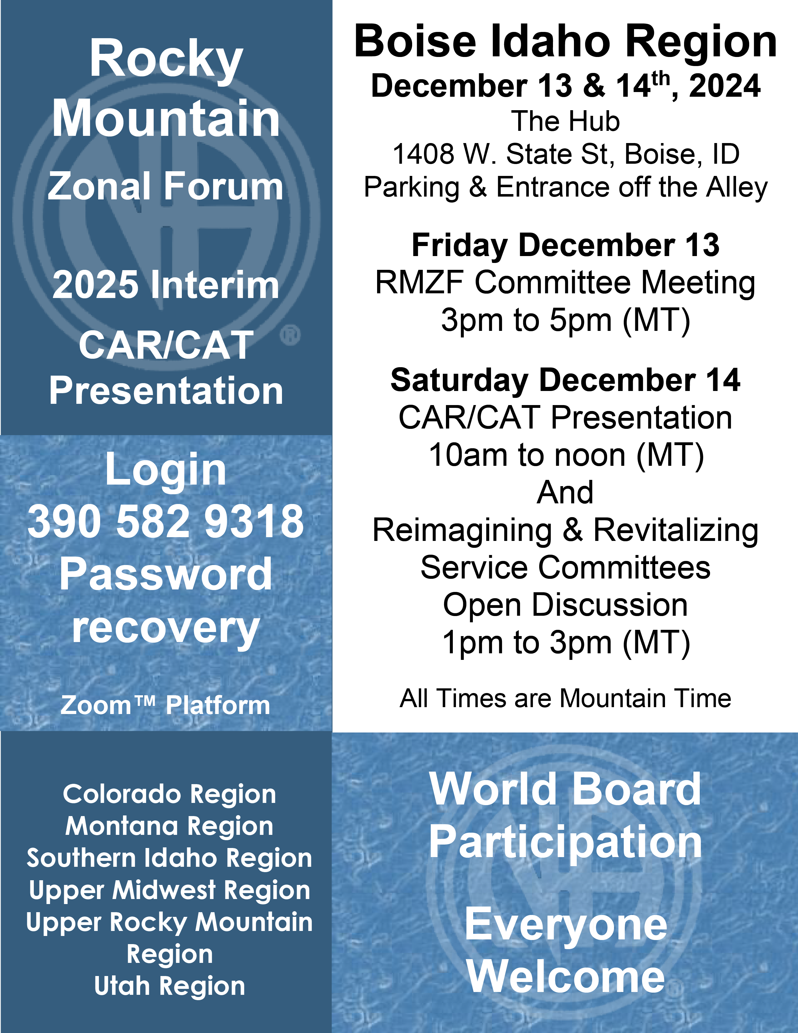



Trusted Servants wanted for the CRRMCO planning committee

First Planning meeting: Jan. 11th at 3:00 pm via zoom

The zoom link is on the calendar at nacolorado.org

Service work while surrounded in Colorado mountain glory – It just doesn’t get better. There is plenty of work to get done, many hands make light work.

Colorado Regional Rocky Mountain Campout

(CRRMCO)

June 6th – 8th at Turquoise Lake near Leadville CO.

